Unit 9 – Kinetics and Equilibrium Review Sheet

- Collision Theory: in order for a chemical reaction to occur, effective collision of molecules must occur. Both the energy of the collision and the angle of the collision are important. The more collisions, the faster the rate of reaction.
  - Concentration: an increase will increase rate of reaction
  - Temperature: an increase will increase rate of reaction
  - Surface area: increasing SA will increase rate of reaction
  - Nature of compound: Ionic will react faster than covalent
  - Catalyst: increases rate of reaction by decreasing activation energy which is the energy required for a reaction to start.

- Potential Energy Diagram: (Must know how to label and draw in a catalyst)

- ∆H = H_{product} - H_{reactant}
- ∆H = Heat of Reaction (Enthalpy)
- If ∆H is (+) then it is an endothermic reaction
- If ∆H is (-) then it is an exothermic reaction

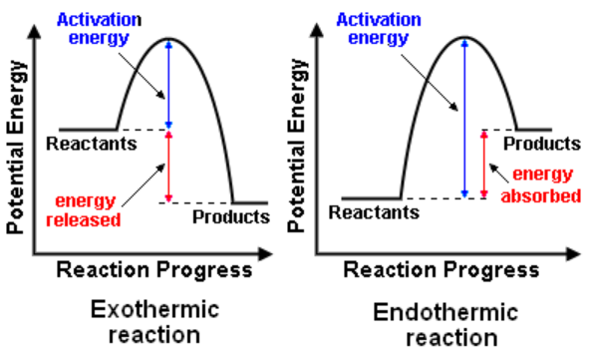

- Enthalpy
  - Table I: Shows a list of reactions and their delta H values. From this you will be able to determine how
    - If the reaction in the question matches Table I exactly…just use the ΔH value given
    - If the reaction in the question is OPPOSITE of Table I…change the sign of ΔH
    - If the reaction in the question shows double the amount of each part of the reaction…double ΔH
    - If the reaction in the question shows HALF the amount of each part of the reaction…half ΔH

  - A reaction is exothermic if…
    - It releases heat
    - Heat is produced
    - ΔH is negative
    - Heat is written as a product
  - A reaction is endothermic if…
    - It absorbs heat
    - Heat is added
    - ΔH is positive
    - Heat is written as a reactant

- 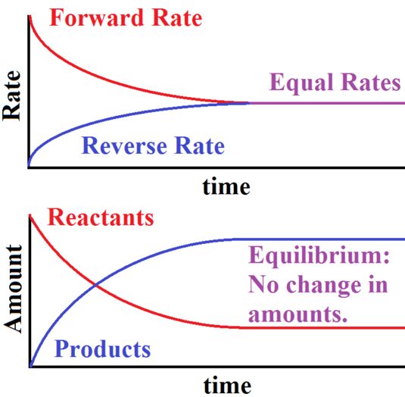Entropy
  - A measure of randomness or disorganization
  - Nature favors high entropy and low energy
    - Favors exothermic reactions
  - Entropy increases when…
    - Number of moles of substances increases
    - Solid liquid gas
- Equilibrium
  - Phase Equilibrium: Melting/Freezing & Evaporation/Condensation (plateaus on the heating curve) – look for same compound, but in different phases
  - Solution Equilibrium: This is a SATURATED SOLUTION. Means that the rate of dissolving is equal to the rate of settling out – look for same compound as a solid and in aqueous solution
  - Chemical Equilibrium:
    - This is a reversible reaction, can go in the forward and reverse direction.
    - When the rate of the forward and the reverse reactions are EQUAL!!
    - The concentrations are CONSTANT
    - Look for different compounds on either side of the arrow

- Le Châtelier’s Principle: When a reaction is stressed, it will move in the direction to relieve the stress. Must be able to determine which side the stress is on, what direction the reaction will shift (left or right), and what will occur to the reactants and products of the reaction.
  - Factors that can stress a reaction:
  - Concentration (may increase or decrease)
  - Temperature (may increase or decrease): notice which side the heat is being released, and that will be the side that is affected by the temperature increase or decrease.
  - Pressure (ONLY HAS AN EFFECT ON GASES): must look at the number of moles on each side of the reaction and if there is a difference is # of moles, than pressure will have an effect on the side with more moles. If the number of moles is the same, then pressure has NO EFFECT on the reaction.
  - Catalyst: DOES NOT STRESS THE REACTION; a catalyst will increase the rate of the forward and reverse reaction equally by decreasing the activation energy of the reaction.
  - Shifts and Responses
    - Add to left, shift to right
    - Add to right, shift to left
    - Remove from left, shift to left
    - Remove from right, shift to right
    - If increase pressure, shift to the side with less gas molecules
    - The side in which the reaction shifts is the side whose amount increases; and the other side’s amount decreases.
    - Add Away Take Toward
      - Shift AWAY from the side you ADD to
      - Shift TOWARD the side you TAKE from

