**Unit 8: Thermochemistry Review Sheet**

Things you need to know:

* Heating & Cooling Curves (diagrams on back)
  + Phases of matter at each interval
  + Energy changes at each (potential/kinetic energy)
    - Remember:
      * Only one energy can change at a time
      * Law of Conservation of Energy – energy cannot be transferred or destroyed – it just changes forms
  + The higher the boiling point, the stronger the intermolecular forces
    - Solids have stronger IMF compared to gases at the same temperature
    - Melting and boiling points can be found on Table S
    - Melting temperature = freezing temperature
      * Melting = heat added & freezing = heat removed
    - Boiling temperature = condensation temperature
      * Boiling = heat added & condensation = heat removed
* Heat Flow
  + Heat moves from the warmer system to the cooler system
* Heat Calculations (3 equations all of which are on Table T)
  + q = mcΔT
    - Used when temperature changes (a slant on a heating or cooling curve)
    - q = heat [unit = joules (J) or kilojoules (kJ)]
      * a positive q = heat was absorbed (endothermic)
      * a negative q = heat was released (exothermic)
    - m = mass [unit = grams (g)]
    - c = specific heat [unit = J/gC] (joules per gram degree)
      * The energy needed to raise 1 gram of a substance 1 degree Celcius
      * The value for water is 4.18 J/gC (found on Table B)
    - ΔT = change in temperature (Tfinal = Tinitial = ΔT)
      * It is ok to have a negative temperature, that means the substance was cooled
  + q = mHf
    - Used when going from solid to liquid of vice versa
      * Hints to use this equation:
        + Melt, freeze, goes from solid to liquid, goes from liquid to solid
    - q = heat [unit = joules (J) or kilojoules (kJ)]
    - Hf = heat of fusion
      * The value for water is 334 J/g (joules per gram)
  + q = mHv
    - Used when going from liquid to gas of vice versa
      * Hints to use this equation:
        + Boil, vaporize, condense, gas to liquid, liquid to gas
    - q = heat [unit = joules (J) of kilojoules (kJ)]
    - Hv = heat of vaporization
      * The value for water is 2260 J/g (joules per gram)

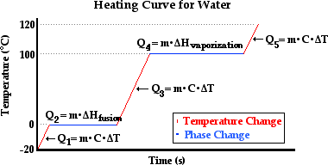

* Particle Diagrams
  + A = pure solid
  + B = melting/freezing – mix between liquid and water
  + C = pure liquid
  + D = vaporization/condensation = mix between liquid and gas
  + E = pure gas

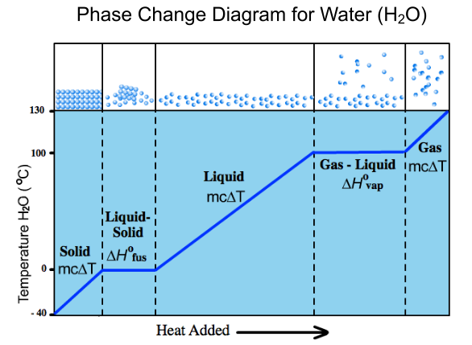

A B C D E

* Sample Heating/Cooling Curves

