Unit 6: Fiber and Textile Analysis
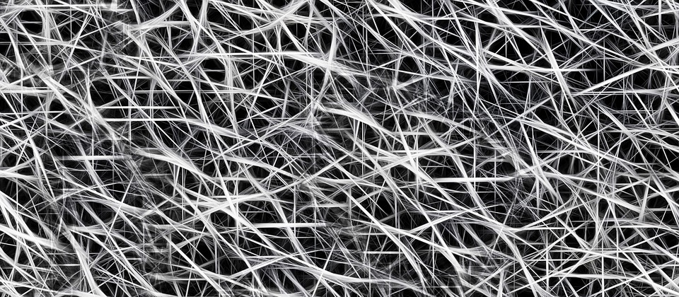

By the end of this unit, you will be able to:
- Identify and describe common weave patterns of textile samples
- Compare and contrast various types of fibers through physical and chemical analysis
- Describe the principle characteristics used to identify common fibers
- Apply forensics science techniques to analyze fibers

Unit Vocabulary
- Direct transfer:
______________________________________________________________________________
- Secondary transfer:
______________________________________________________________________________
- Natural fibers:
______________________________________________________________________________
- Man-made (synthetic fibers):
______________________________________________________________________________
- Polymers:
______________________________________________________________________________
- Animal fibers:
______________________________________________________________________________
- Plant fibers:
______________________________________________________________________________
- Mineral fibers:
______________________________________________________________________________
- Yarns:
______________________________________________________________________________
- Thread count:
______________________________________________________________________________
- Fire burn analysis: ______________________________________________________________________________
Introduction
- ________________ are used in forensic science to create a link between _____________ and _________________
- Through normal activities
  - We ___________ fibers
  - We _________________ fibers
- Very small fibers are classified as _______________________
- Collecting fibers within 24 hours is critical
- ________________________________ - fibers may be transferred directly from victim to suspect or suspect to victim.
- ________________________________ - If a victim has fibers on his person that he picked up and then transferred to a suspect

How Forensic Scientists Use Fibers
- ____________________________ – composition, uniqueness, and so on.
- _____________________ – often key to matching techniques.
- ________________________ – usually the more found the easier the match.
- ___________________________ – can you place the suspect at the scene?
- __________________________ – carpet, upholstery, car, and so forth.
- _________________________ – several types of fibers can be more conclusive.
- ______________________________ – can be the key to fiber transfer (possibility of violence)
- _______________ between crime and fiber discovery – passage of time greatly reduces the effectiveness of fiber evidence.

Type of Fibers
- ___________________________ are derived in whole from animal or plant sources.
  - Examples include wool, mohair, cashmere, furs, and cotton.
- __________________________________________ fibers are manufactured.
  - Regenerated fibers are manufactured from natural raw materials and include rayon, acetate, and triacetate.
  - Produced solely from synthetic chemicals
  - Examples include nylons, polyesters, and acrylics.
- ______________________, or macromolecules, are ________________________________ composed of a large number of atoms arranged in repeating units known as monomers.

Fiber Classification – Natural Fibers
- ______________________ (made of proteins):
  - Wool and cashmere from ________________
    - Wool is the ______________________________ animal fiber
  - Mohair from ________________
  - Angora from _______________
  - Hair from alpacas, llamas, and camels
  - Silk from _______________________________ (longer fiber does not shed easily)
- Plant fibers (made of the polymer ______________________):
  - Absorb ______________
  - ________________________ in water
  - Very _______________________ to damage from harsh chemicals
  - Dissolvable only by _____________________________
  - Becomes _______________ over time
- Plant fibers:
  - _________________________ - most common textile plant fiber
  - Coir from coconuts is __________________
  - Hemp, jute, and flax from _________________ grow in bundles
  - Manila and sisal from leaves deteriorate more quickly
- Mineral Fibers:
  - ____________________________ - a fibrous form of glass
  - ____________________ - a crystalline structure

Fiber Classification – Synthetic Fibers
- __________ of fabrics are _______________________ produced
  - Examples:
    - Rayon
    - Acetate
    - Nylon
    - Acrylic
    - Polyester
- Regenerated Fibers (derived from cellulose):
- __________________
  - Most common in this group
  - _________________ natural fibers, but ________________
- Celenese®
  - Cellulose chemically combined with acetate
  - Found in many _________________
- Polyamide ________________
  - Cellulose combined with three acetate units
  - Breathable and ________________________
  - Used in ______________________ clothing

Fiber Classification – Synthetic Polymer Fibers
- Petroleum base
- Very different from other fibers
- ________________ join to form _________________
- Fibers are spun together into yarns
- No internal structures
- Uniform diameters
- Polyester
  - “Polar fleece”
  - _________________________________
  - ____________ easily broken down by light or concentrated acid
  - Added to natural fibers for ________________
- Nylon
  - _____________ broken down by light and concentrated acid
  - Otherwise similar to ____________________
- Acrylic
  - ________________________
  - Tends to “ball” easily
  - Substitute for artificial wool or fur
- Olefins
  - High performance
  - ___________________________
  - Resistant to wear

Comparison of Natural and Synthetic Fibers

- Visual Diagnostics of Some Common Textile Fibers under Magnification
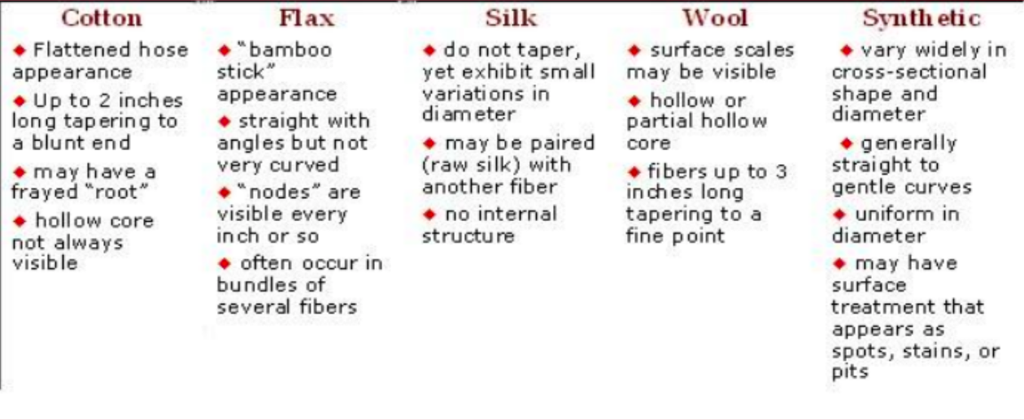
- Under magnification, all synthetic fibers have very _________________________.
- Hairs have ___________________.

Yarns, Fabrics, and Textiles Oh My!
- _________________ - fibers (of any length, thick or thin, loose or tight) twisted or _____________________________________
  - Any given yarn will have a ______________________.
  - Forensic scientists will identify the twist direction as part of their identification.
- Blending fibers meets different needs (e.g., resistance to wrinkling)
- Fibers are woven into fabrics or textiles
  - Threads are arranged side by side (__________________)
  - More threads (_________________) are woven back and forth crosswise through the warp

Weave Patters
- ______________________________ - The number of threads that are packed together for any given amount of fabric
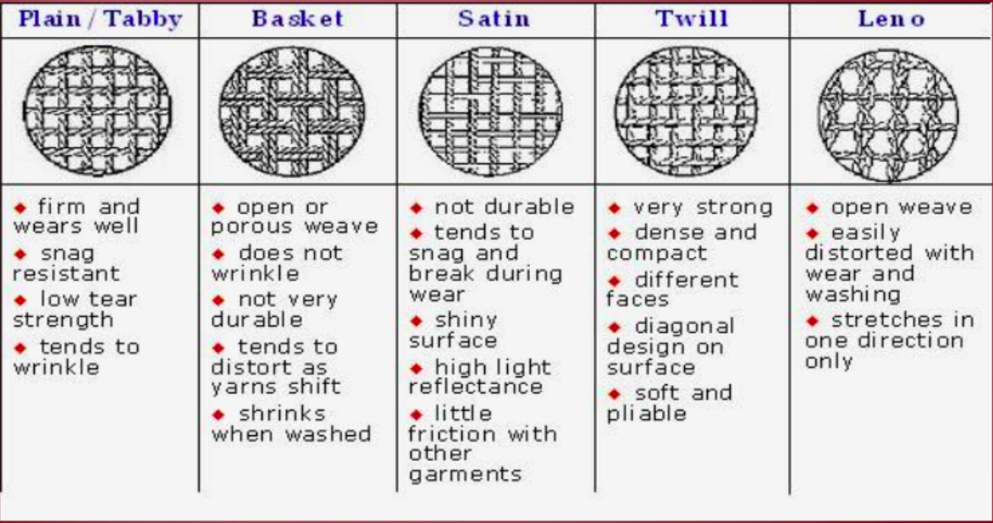
Fiber Evidence
- Quality depends on the _____________________ of the criminalist to identify:
  - the ________________ of the fiber
  - narrow the __________________________ to a limited # of sources
- Obviously, if the examiner is presented with fabrics that can be ___________________ ____________________________ at their torn edges, it is a virtual certainty that the fabrics were of _____________________
- _________________________ comparisons
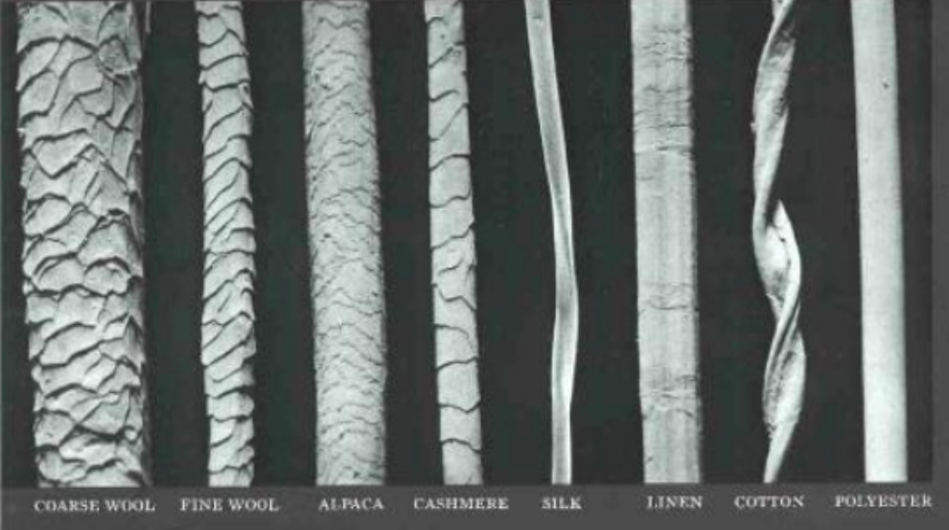
  - Between questioned and standard/reference fibers
  - Initially taken for ______________ and ___________________ characteristics, using a comparison microscope.
- Other _________________________________________ that could be important in comparing fibers are:
  - Lengthwise striations on the surface of the fiber.
  - The presence of delustering particles that reduce shine.
  - The cross-sectional _____________ of the fiber.
- Compositional ___________________________ may exist in the dyes that were applied to the fibers during the manufacturing process.

Sampling and Testing
- ____________________ evidence
  - Special vacuums
  - Sticky tape
  - _____________________
- Nondestructive Analysis
  - ___________________________ – reveal characteristic shapes and markings
  - Polarizing light microscopy – uses specific wavelengths
  - Infrared spectroscopy - reveals ___________________________________ to differentiate similar fibers
- Destructive Analysis
  - __________________ fibers
  - _______________________ fibers in various liquids
- Compare fibers found on different suspects with those found at the crime scene
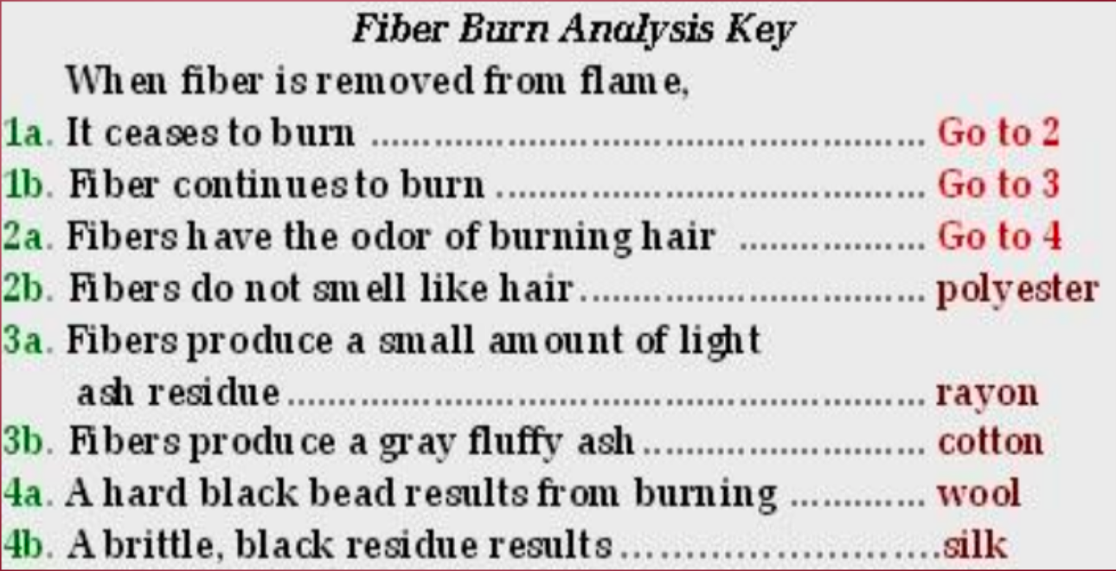
Collection and Preservation
- The investigator’s task of looking for minute strands of fibers often becomes one of ______________________ and _______________________ potential “_________________” of fiber evidence.
- Relevant articles of ____________________ should be packaged carefully in separate paper bags.
- If it is necessary to remove a fiber from an object, the investigator must use clean forceps, place it in a small sheet of paper, ___________________________________, and place the paper packet __________________________________.

Summary
- Fibers are a form of ______________ evidence.
- Fibers are a form of __________________ evidence.
- Fibers are spun into _____________ having specific characteristics.
- Yarns are woven, with different ____________________, into clothing or textiles.
- Fiber _______________________ is gathered using different techniques.
- Fibers are analyzed using _______________________, tests for ___________________ in different solutions, polarized light microscopy, or infrared spectroscopy.
- Fibers are classified as ____________________ or ____________________.
- Natural fiber __________________ include:
  - Animal hair
  - Plant seeds, fruit, stems, or leaves
  - Minerals

