Ultimate Thermochemistry Review
Part 1: Analyze It!
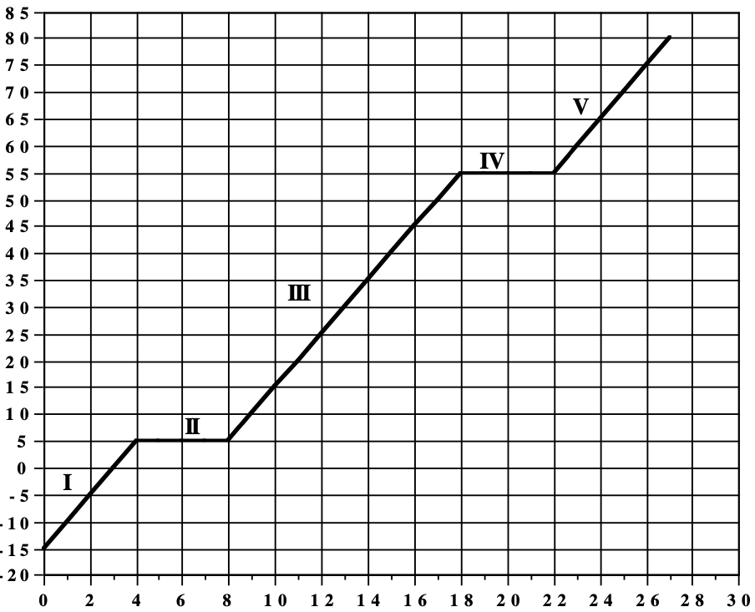
Directions: Students in a chemistry lab conducted the following experiment. They started with a mysterious compound in the solid phase. They placed the solid substance in a beaker and placed it on a hot plate. They measured the temperature of the contents every 2 minutes. Below is a graph of their data. Answer the following questions based on their data and graph.
Temperature (C)
Heating Curve of Mysterious Substance X

- What is the melting point of the substance?

- At what time does the substance begin to melt?

- How long does it take for the substance to completely melt?
Time (minutes)

- How many phases are present between 0 min and 4 min? What phase(s) is/are present?

- What happens to the potential and kinetic energy between 0 min and 4 min?

- How many phases are present between 4 min and 8 min? What phase(s) is/are present?

- What happens to the potential and kinetic energy between 4 min and 8 min?

- What is the total amount of time a liquid is present according to the graph?

- How many phases are present between 8 min and 18 min? What phase(s) is/are present?

- What happens to the potential and kinetic energy between 8 min and 18 min?

- At what time does the gas phase first appear?

- How many phases are present between 18 min and 22 min? What phase(s) is/are present?

- What happens to the potential and kinetic energy between 18 min and 22 min?

- How long is this substance only a gas?

- What is the boiling point of the substance?

- How many phases are present between 22 min and 27 min? What phase(s) is/are present?

- What happens to the potential and kinetic energy between 22 min and 27 min?

- What happens to heat as time progresses on the graph? Is it added or removed?

- If this was a cooling curve, sketch what it would look like in the box to the right.

- On a cooling curve, what happens to the potential and kinetic energy on the flat plateaus on the graph?

- On a cooling curve, what happens to the potential and kinetic energy on the declining slants on the graph?

- How is a cooling curve different from a heating curve in terms of heat?

- Could this substance be water? Explain

Part 2: Calculate It!
Directions: Answer the following questions using your knowledge of chemistry as well as your Chemistry Reference Table. Show all your work.
- How many joules of heat energy are absorbed when 13 grams water are heated from 15 °C to 95°C?

- How many joules of heat energy are released when 52 grams water are cooled from 85 °C to 25°C?

- What is the mass of a sample of ice if 1821 joules of heat was needed to completely melt it?

- How much energy is needed to vaporize 10 grams of water at its boiling point?

- Based the following questions on the information provided. A student has a 5 gram sample of water and a 10 gram sample of water. Both samples are heated from 10°C to 50°C.
  - Predict: Do you think one sample will require more energy to heat than the other? Which sample do you think will require more energy?

  - Support your prediction with evidence. Show your work below.

  - Was your prediction supported by your calculation?

- Based the following questions on the information provided. A student has multiple 5 gram samples of pure water.
  - Predict: Which phase change will require more energy, melting or vaporization?

  - Support your prediction with evidence. Show your work below.

  - Was your prediction supported by your calculation?

