**Neutralization Reactions**

Types of Reaction Review

* What type of reaction is this?
  + Zn + 2HCl 🡪 ZnCl2 + H2 ________________________________
  + 3MgCl2 + 2AlBr3 🡪 2AlCl3 + 3MgBr2 ________________________________

Neutralization Reactions

Copy Example Below

* When Mg(OH)2 and HCl react, a neutralization reaction occurs.
* A neutralization reaction is a reaction in which an acid and a base in an aqueous solution react to produce a salt and water.
* A salt is an ionic compound made from the cation from a base, and an anion from an acid.
* Neutralization is a double replacement reaction.
* Neutralization occurs when:
  + an Arrhenius acid and an Arrhenius base react to form WATER and a SALT (both neutral)
  + # of H+ ions = # of OH- ions (equivalent or equal amounts)
* You don’t always get a completely neutral solution!
  + Strong acid + strong base = pH 7 (neutral)
  + Weak acid + weak base = pH 7 (neutral)
  + Strong acid + weak base = pH < 7 (acidic)
  + Weak acid + strong base = pH > 7 (basic)
* Make sure your equations are balanced!

Practice

1. ___ HCl + ___ KOH 🡪 ___ ___________ + ___ ___________

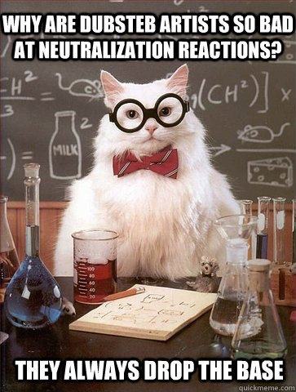

1. ___ HNO3 + ___ NaOH 🡪 ___ ___________ + ___ ___________
2. ___ H2SO4 + ___ KOH 🡪 ___ ___________ + ___ ___________
3. ___ H2CO3 + ___ Ca(OH)2 🡪 ___ ___________ + ___ ___________
4. ___ H3PO4 + ___ LiOH 🡪 ___ ___________ + ___ ___________

More Practice

1. HCl + NaOH 🡪 ___________ + ___________
2. HBr + Ca(OH)2 🡪 ___________ + ___________
3. ___________ + ___________ 🡪 CaSO4  + __________
4. ___________ + ___________ 🡪 BaBr2 + ___________