Acid Base Indicators

pH Indicators: Table M
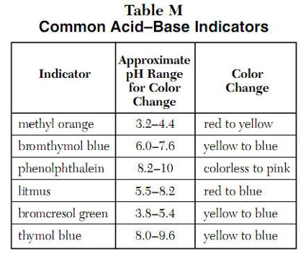
- An indicator is a valuable tool for __________________________ because its __________ form and ____________ form have _____________________________ in solution.

`pH Indicators: Methyl Orange

- Red: _______________________
- Yellow: _______________________

pH Indicators: Phenolphthalein

- Colorless: ______________________
- Pink: ______________________

pH Indicators: Litmus

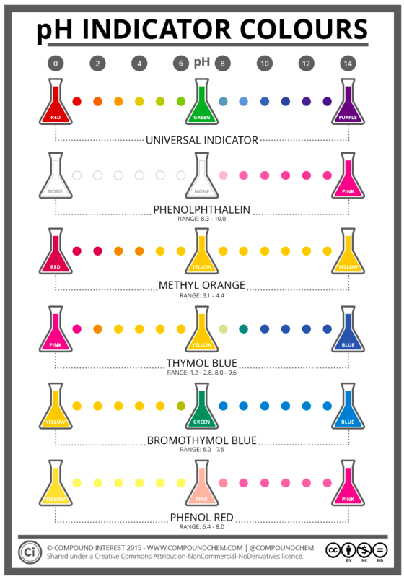
- ___________ paper turns _________ for ____________ solutions
- ___________ paper turns _________ for ____________ solutions

pH Indicators: Bromcresol Green

- Yellow: ______________________
- Blue: ______________________

pH Indicators: Thymol Blue

- Yellow: ______________________
- Blue: ______________________

Using More Than One Indicator
- If you put bromcresol green in a solution and the solution turns blue, the pH is 5.4 or more.
- If you put bromthymol blue in another test tube with the same solution and it turns yellow, the pH is 6.0 or less
- Conclusion: the solution has a pH between 5.4 and 6.0

- Mystery solution #1 turns litmus red and is yellow when methyl orange is added.

- Mystery solution #2 is pink when phenolphthalein is added but turns litmus paper blue.

Summary
Acids  - pH __________________  - Litmus ________  - Phenolphthalein _____________  - Bromthymol blue _______________  - Methyl orange ________________ | Bases  - pH __________________  - Litmus ________  - Phenolphthalein _____________  - Bromthymol blue _______________  - Methyl orange ________________

Summary Questions
- If an aqueous solution turns blue litmus red, which relationship exists between the hydronium ion and the hydroxide ion concentration?

  - [H₃O⁺] > [OH⁻]
  - [H₃O⁺] < [OH⁻]
  - [H₃O⁺] = [OH⁻] = 10⁻⁷
  - [H₃O⁺] = [OH⁻] = 10⁻¹⁴

- In which 0.01M solution is phenolphthalein pink?
  - CH₃OH_{(aq)}
  - Ca(OH)_{2(aq)}
  - CH₃COOH_{(aq)}
  - HNO_{3(aq)}

- The results of testing a colorless solution with three indicators are shown below
Test – Result
Red litmus – blue
Blue litmus – blue
Phenolphthalein - pink
Which formula could represent the solution tested?
  - NaOH_{(aq)}
  - HCl_{(aq)}
  - C₆H₁₂O_{6(aq)}
  - C₁₂H₂₂O_{11(aq)}

- Three samples of the same solution are tested, each with a different indicator. All three indicators, bromthymol blue, bromcresol green and thymol blue, appear blue if the pH of the solutions is
  - 4.7
  - 6.0
  - 7.8
  - 9.9

- Which statement correctly describes a solution with a pH of 9?
  - It has a higher concentration of H₃O⁺ than OH⁻ and causes litmus to turn blue
  - It has a higher concentration OH⁻ than H₃O⁺ and causes litmus to turn blue.
  - It has a higher concentration of H₃O⁺ than OH⁻ and causes methyl orange to turn yellow
  - It has a higher concentration of OH⁻ than H₃O⁺ and causes methyl orange to turn red.

