Intro to Acids and Bases
Acids
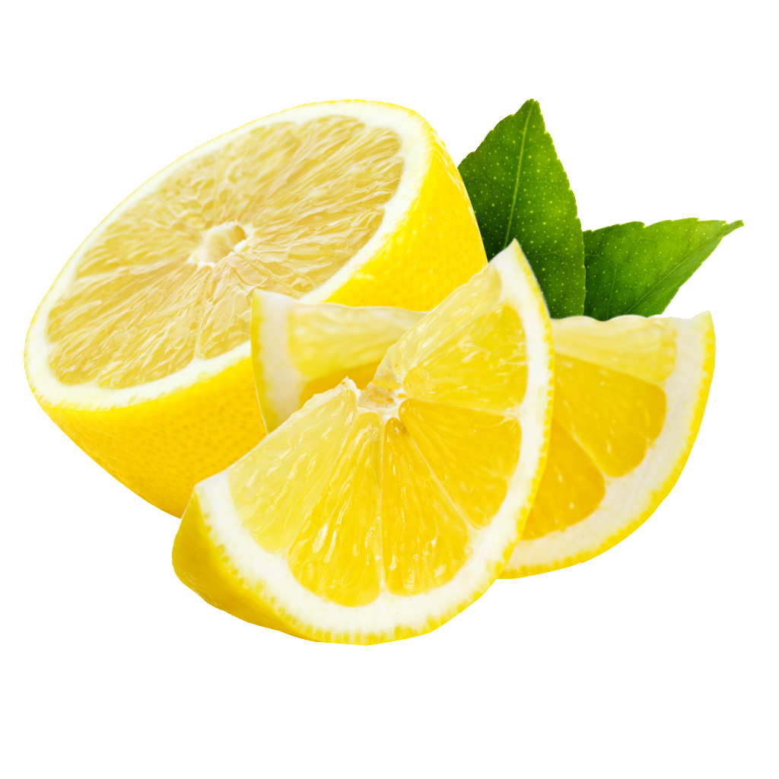
- Acids can be strong or weak ___________________________ in aqueous solutions.
- Acids (example HCl) react with certain metals to produce H₂(g)
- Acids cause color changes in acid-base indicators:
  - Blue litmus paper turns ________________ in an acid
  - Phenolphthalein is ___________________ in an ___________________.
- Acids have a ___________________ taste.
- Table ___________ has a list of common acids and bases

Bases
- Bases can be strong or weak electrolytes in aqueous solutions.
- Bases cause color change in acid-base indicators.
  - ___________ paper turns blue in a base.
  - Phenolphthalein is _______________ in a base.
- Bases feel _______________ and taste____________.
- Table _______ has a list of common bases

Arrhenius Acid
- An Arrhenius acid ____________________________________ in aqueous solutions.
- Example: _______, __________, _______________.
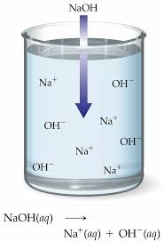
- The H⁺ in solutions attaches to H₂0 to form ____________ (_______________________)
- ____________________________________________________________

Arrhenius Base
- An Arrhenius base has ________ and ____________________ (hydroxide ions) in an aqueous solution.
- Example: ___________, ___________, ___________
- Group 1 metals react with water to produce ___________________.
- _____________________________________________________________

Check Point Questions
- Which substance can be classified as an Arrhenius acid?

  - HCl
  - NaCl
  - LiOH
  - KOH

- Which substance can be classified as an Arrhenius base?

  - HCl
  - NaOH
  - LiNO₃
  - KHCO₃

- According to the Arrhenius theory, a substance that is classified as an acid will always yield

  - H⁺_{(aq)}
  - NH⁺_{4(aq)}
  - OH⁻_{(aq)}
  - CO₃²⁻_{(aq)}

Bronsted-Lowry Acids and Bases
- An acid is an ________________ proton donor).
- A base is an _______________ (proton acceptor)

HCl(g) + H₂O(l) H₃O⁺(aq) + Cl-(aq)

- HCl is an _____________because it ______________an _________ to the H₂O.

NH₃(aq) + H₂O(l) NH₄⁺(aq) + OH⁻(aq)

- NH₃ is a _____________ because it _____________ from the H₂O.
- Water can either be an ________________ (acid ) or ________________ ( base) , water is ____________________.

Check Point Questions
- According to the Bronsted-Lowry theory, a chloride ion (Cl⁻), acts as a base when it combines with

  - An OH⁻ ion
  - A K⁺ ion
  - An H⁻ ion
  - An H⁺ ion

- According to the Bronsted-Lowry theory, an acid is

  - A proton donor, only
  - A proton acceptor, only
  - A proton donor & proton acceptor
  - Neither a proton donor nor a proton acceptor

Conjugate Acids and bases

NH₃(aq) + H₂O(l) NH₄⁺(aq) + OH⁻(aq)

- A conjugate __________ is what is remaining after the __________ gives up _______.
- A conjugate ___________ is what is formed when a base accepts a __________.

Conjugate Acid-Base Pairs Practice
- For each pair label acid, base, conjugate acid, conjugate base

NH_{3(aq)} + H₂O_{(l)} NH₄⁺_{(aq)} + OH⁻_{(aq)}

HCl_{(g)} + H₂O_{(l)} H₃O⁺_{(aq)} + Cl⁻_{(aq)}
Summary
- Acids
  - ____________________
  - ________________________________
  - _____________________
  - ________________________________

- Bases
  - ____________________
  - ________________________________
  - _____________________
  - _______________________________

