Titration Calculations
YOYO: Using Table K and L, write the complete neutralization reaction for the following reactants

1. Carbonic acid and potassium hydroxide.

2. Phosphoric acid and sodium hydroxide

Types of Acids and Bases
- HCl produces _____ hydrogen and is called __________________________
- H₂SO₄ produces_____ hydrogens and is called ________________________
- H₃PO₄ produces _____ hydrogens and is called _______________________
- 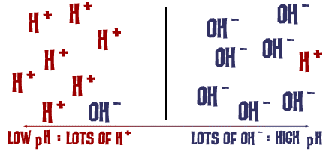NaOH has ______ hydroxide group and is called ______________________
Concentration: Molarity (Table T)
- 1 M of HCl gives off ____ mole H+/ liter
- 2 M of HCl gives off _____ moles H+/ liter
- 1 M of H₂SO₄ gives off ____ moles of H+/liter
- 2 M of H₂SO₄ gives off ____ moles of H+/ liter
You try
- 1 M NaOH gives off ____ mole of OH-/ liter
- 2 M NaOH gives off _____ mole of OH-/ liter
- 2 M Ca(OH)₂ gives off _____mole OH- liter
Titration
- Titration is used to find the ________________ of an unknown acid or base.
- ______________________________
- This is done by _________ measured volumes of an acid or base of known molarity to a base or acid of unknown molarity until neutralization occurs
- Neutralization is when the number of _______ and ______ are equal and the pH is ______, this is also known as ____________________ point.
- An acid-base indicator is used to show when _____________ has occurred.
- The point of __________ is the endpoint of the titration.
Sample Titration Problems
Sample #1: What is the concentration of a 30 ml sample of HCl if it can be neutralized by 50 ml of 1.2 M of NaOH? | Sample #2: How many milliliters of 3.0 M of H₂SO₄ are needed to neutralize 50 ml of 1.2 M Al(OH)₃?

Practice
- Determine the concentration of H₃PO₄ if a 90. ml sample is neutralized by 30. ml of 0.9 M Ca(OH)₂. | - How much 6.0 M HNO₃ is needed to neutralize 39 ml of 2.0 M KOH?
- How much 3.0 M NaOH is needed to neutralize 30 ml of .75 M H₂SO₄? | - What is the concentration of 20 ml of LiOH if it is neutralized by 60 ml of 4 M HCl?
- What is the concentration of 60 ml of H₃PO₄ if it is neutralized by 225 ml of 2 M Ba(OH)₂? | - How much 2 M HBr is needed to neutralize 380 ml of 0.1 M NH₄OH?
- You have 50 mL of 1.0 M H₂SO₄(aq). What volume of 0.5 M NaOH would be required to neutralize the acid? | - A acid has an H+ concentration of 0.1 M and a volume of 100 mL. What volume of a base with a 0.5 M [OH-] will be required to neutralize the reaction?
