Unit 7: Impression Evidence:
Tire Treads

By the end of this section of the unit, you will be able to:
- Describe the features of tire impressions and skid marks used to help identify tire(s) or a vehicle’s wheelbase, track width, and/or turning diameter.
- Compare and contrast skid marks, including how they are produced, when they are produced, what they look like, and how they can be used to reconstruct events leading to a collision.
- Analyze impression evidence to determine if it is consistent with evidence from a crime scene.
Unit Vocabulary
- Tire tread: ____________________________________________________________________
- Ribs: _________________________________________________________________________
- Grooves: _____________________________________________________________________
- Patent print: __________________________________________________________________
- Plastic print: __________________________________________________________________
- Axle: _________________________________________________________________________
- Track width: __________________________________________________________________
- Wheelbase length: ____________________________________________________________
- Turning diameter: _____________________________________________________________
- Skid marks: ___________________________________________________________________
- Yaw marks: ___________________________________________________________________
- Tire scrub: ____________________________________________________________________

Tire Treads and Impressions
- Tire treads
  - ridges and grooves channel __________________________________________
- Made of Ribs and Grooves
  - ______________ – the “ridges”
  - ____________________ – the “valleys”
- Can be ________________________________________
- Tread patterns can indicate the type of vehicle that left the mark
- Link a suspect or victim to a crime scene
- Reveal events that took place at the scene

Recording Tread Impressions
- Count ridges and grooves across the tire width
- Note unique characteristics—wear or pebbles embedded in the grooves
- Create a print of the suspect’s tire impressions through one revolution
- Compare impressions from the crime scene and suspect’s tire

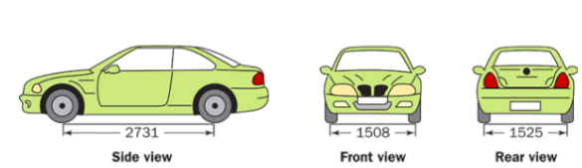
Identifying a Vehicle
- _____________________________
  - From center of tire to center of tire
- _____________________________
  - From center of front axle to center of rear axle

- Turning diameter
  - The space needed to turn the car in a complete circle
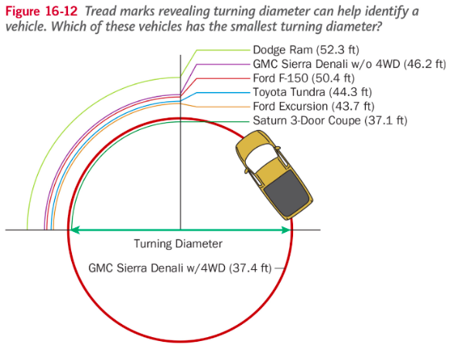

Real-Life Vehicle Measurements
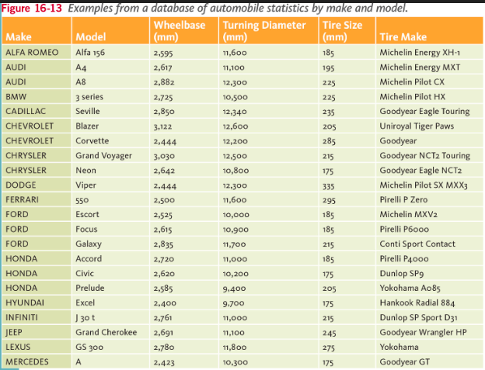

Types of Treads
- ___________________ – most common design
- ___________________ – better traction in wet and wintery weather but wears unevenly
- ___________________ – moves water and slush away efficiently if put on correctly

Need New Tires? Ask Abe
- The Penny Test
  - In the United States, tire tread depth is measured in ________ of an inch
  - New tires typically come with __________ or ___________ tread depths
    - Some truck, SUV and winter tires may have deeper tread depths than other models
  - The U.S. Department of Transportation recommends replacing tires when they reach ___________ and many states legally require tires to be replaced at this depth.
Tired Tires
- Just like shoes, the wear patterns can tell you a lot about the tire

