Tire Tracks Lab

Objectives: Students can create and examine prints from known vehicle tires and measure their tire track width, wheelbase distance, and any tire tread patterns; doing so will enable students to identify the unknown vehicle.
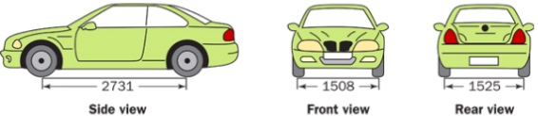
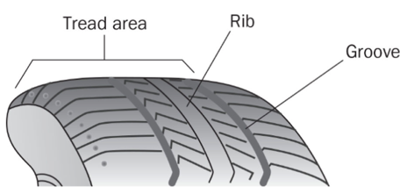
Introduction: Many crimes involve a motor vehicle. Investigators carefully search a crime scene for clues left by vehicles. Sometimes, the only evidence left at a crime scene is a tire track (an impression or print path made by a vehicle’s tires). Tire tracks can indicate the direction of travel and any changes in that direction. Careful measurements the front track width and/or back track width may indicate which vehicle was connected to the crime (the front track width is measured from the center of one wheel to the center of the opposite wheel; same method is done to measure the back track width). Another important measurement to make on a suspected vehicle is its wheelbase distance (wheelbase distance is measured from the center of the front axle to the center of the rear axle). Depending on the wheelbase distance, the turning diameter can vary which may help investigators determine if a suspected vehicle was at the crime scene. Tire track examinations will show specific unique and detailed impressions from the tire treads (the detailed design patterns on a tire). Since tire treads often show unique wears which may be different for each wheel on a vehicle, careful analysis should be done on all four tire prints. Overall, tire tracks can provide vital information to forensic investigations.

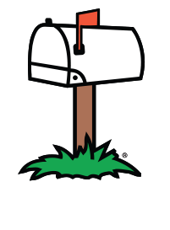
Background Information: Someone has run over Ms. McCabe’s mailbox for the third time. Even though she is a patient woman, she has had enough and decided to call the police so that they may investigate. This third incident occurred about 2:00 a.m. Saturday. As soon as she heard the familiar crash, she ran to her front porch to get a glimpse of the offending car and its license plate number. Unfortunately, Ms. McCabe could not determine the make, model, or color of the car, but she was able to see that the right side of the rear bumper had a familiar sticker which read “Forest Hills High School – Home Of The Rangers.” When the police arrived, Ms. McCabe had told them exactly what had happened. The police noticed, on both sides of the crushed mailbox, the distinctive set of tire tracks. The police then collected all of the physical evidence and was able to make a print of the tire tracks at the crime scene. For the next few days, the police created a list of vehicles that had a bumper sticker on the same spot mentioned by Ms. McCabe. Upon obtaining a warrant, the police had seized 8 cars that could have committed the crime.

Materials: per group - 1 car, 1 unknown tire print, 2 hand lens, 2 rulers, 1 ink pad, baby wipes,
paper towels.

Procedure:
1) Examine the print from the car that ran over Ms. McCabe’s mailbox.
2) An estimate of the unknown vehicle’s wheelbase distance has been recorded on
Data Table 1.
3) Using the unknown print, measure the front track width (in millimeters) and record it on
Data Table 1.
4) Using the unknown print, measure the rear track width (in millimeters) and record it on
Data Table 1.
5) Using the unknown print, look for any unique marks on the tire treads and record it on
the last column in Data Table 1 (you may also make other important notes here).
6) For each suspect car (1-8), write the name of the car on Data Table 1 in the box that has
the suspect’s number (the name of each car is on the bottom of the vehicle).
7) For each suspect car (1-8), measure the wheelbase distance (in millimeters) and record
it on Data Table 1.
8) On Data Table 2, make tire prints of suspect cars 1 through 8 (to make a car’s print,
roll each tire forward on the ink pad, then make the print by moving the car forward on
the space provided in Data Table 2).
9) Using the prints you made in Data Table 2, measure the front track width (in millimeters)
for each car; enter this information for each car in Data Table 1.
10) Using the prints you made in Data Table 2, measure the rear track width (in millimeters)
for each car; enter this information for each car in Data Table 1.
11) Using the prints you made in Data Table 2, look for any unique marks on the tire treads
for each car; enter this information in Data Table 1 (you may also take other notes and
measurements in Data Table 1).
12) Answer the post-lab questions.

Unknown Vehicle Tire Track Prints

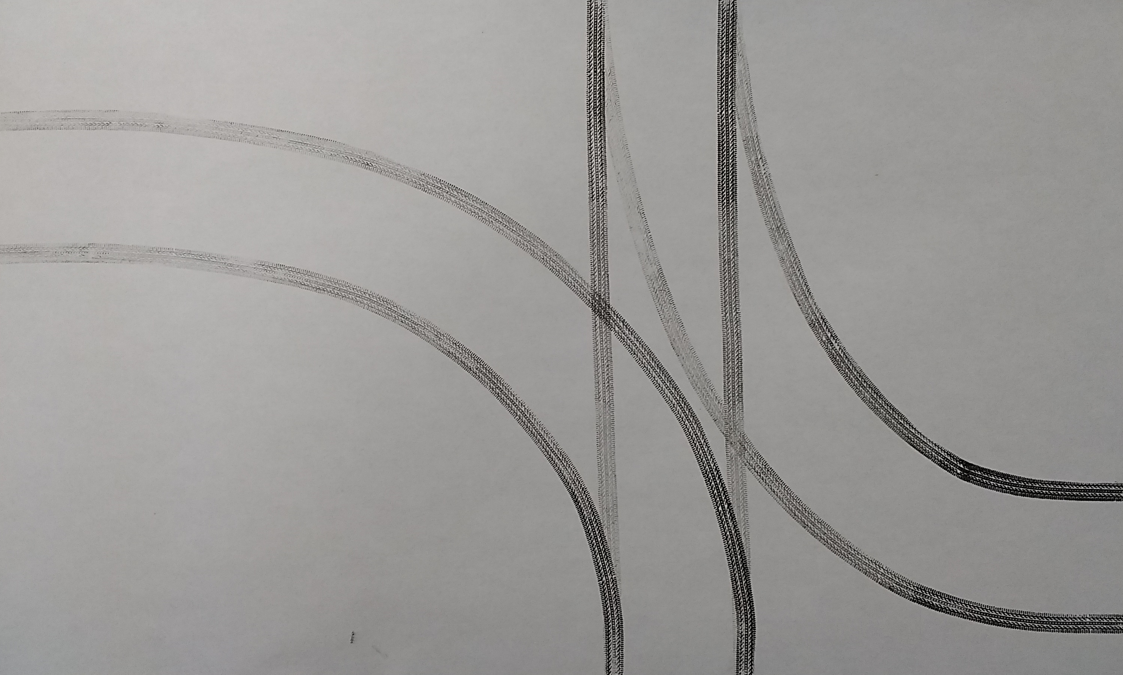

These tire track were made by the rear tires

These tire track were made by the front tires

These tire track were made by the rear tires

DATA TABLE 1: Vehicle Information
Vehicle Number and Name | Wheelbase Distance (mm) | Front Track Width (mm) | Rear Track Width (mm) | Unique Marks on the Tire Treads, Notes, and Any Other Additional Measurements
Unknown Car | Approx.  73 + 3
Suspect Car #1
Suspect Car #2
Suspect Car #3
Suspect Car #4
Suspect Car #5
Suspect Car #6
Suspect Car #7
Suspect Car #8

1
DATA TABLE 2: Known Tire Track Prints
2
3
4

5
DATA TABLE 2: Known Tire Track Prints
6
7
8

Post-Lab Questions: Answer the following questions after completing Data Table 1 and 2.

- Which cars have a wheelbase distance that falls outside of the range given for the unknown car?

- Which cars have a different width between their front tire tracks and rear tire tracks?

- Which cars have front tire track widths that are more than 3 mm above or below the unknown car?

- Which cars have rear tire track widths that are more than 3 mm above or below the unknown car?

- Which cars have tires with different tread widths between their front and rear tires?

- Which cars have tire tread patterns that are different than the unknown car?

- Explain why you could not have identified the car based only on tread patterns.

- Which car possibly ran over Ms. McCabe’s mailbox? ______________________________________
- How do you know (be specific)?

- Even though you probably identified the car that could have made the tracks, prosecuting with only the evidence above may not be possible. Why not?

- Besides the different pieces of evidence mentioned in this lab, what other piece of evidence might convict the driver (and why)?

TEACHER KEY: (note: give students a +1.0 mm leeway on all measurements)

DATA TABLE 1: Vehicle Information
Vehicle | Wheelbase Distance (mm) | Front Track Width (mm) | Rear Track Width (mm) | Unique Marks on the Tire Treads, Notes, and Any Other Additional Measurements
Unknown Car | Approximately 73 + 3 | 41 | 41 | Notes may vary from student to student
Suspect Car #1 | 75 | 51 | 50 | Notes may vary from student to student
Suspect Car #2 | 73 | 46.5 | 48.5 | Notes may vary from student to student
Suspect Car #3 | 82 | 45.5 | 45.5 | Notes may vary from student to student
Suspect Car #4 | 71.5 | 41 | 41 | Notes may vary from student to student
Suspect Car #5 | 72 | 40.5 | 33.5 | Notes may vary from student to student
Suspect Car #6 | 74 | 39.5 | 39.5 | Notes may vary from student to student
Suspect Car #7 | 72.5 | 44.5 | 44.5 | Notes may vary from student to student
Suspect Car #8 | 63 | 47.5 | 49.5 | Notes may vary from student to student

