Name___________________________________________________ Period______ Date_____

Tire Marks and Impressions
Guided Notes

Use the information presented in the slides to complete the notes.

•What is a tire impression: _________________marks that reflect the tread design and

dimensional features of tire

•What is a tire track? The ____________________ ________________________between two or more

tires of a vehicle.

•Why do we care about this type of evidence? To help prove a _________________vehicle

was present at the crime scene and to _________________________events/lead to other evidence.

Background Information on Tires

•Tires come in _________________________________ of designs and numerous sizes.

•Tires on new vehicles are known as ___________________ _____________________ (OE) tires.

Importance: the same make and model vehicles will have the same tire size and brand

•Tires purchased to replace worn down or damaged tires are called

_______________________tires. Importance: replacement tires are usually_________ the same

design as OE . . . so a vehicle with 3 or 4 replacement tires, each of different design, creates

a _____________________ situation.

Tire construction:

•Tires are made of various compounds of ________________________, steel and __________________.

•The tire is constructed without any design first (green tire). Then placed in a mold where

tread and sidewall ______________________________ are added.

Tire tread and sidewall components:

•Tread design components—can be associated with a brand name and ______________________.

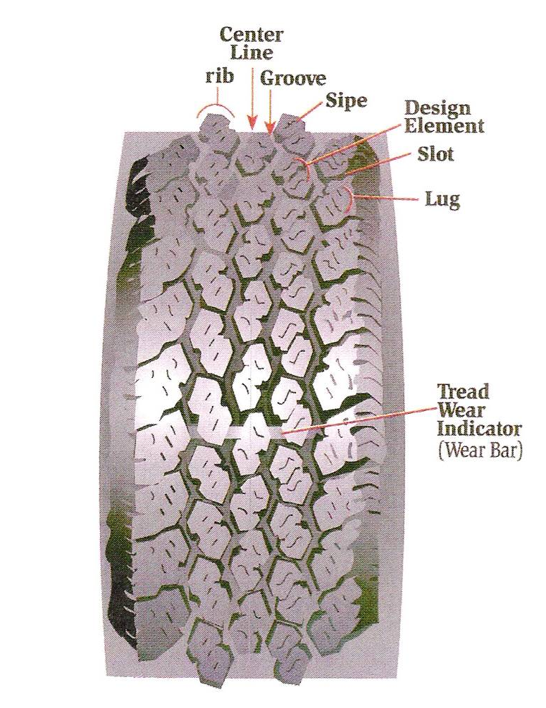

Sidewall components:
➢label side (face outward)
➢serial side (face inward)
Information important to investigators
•Tire ___________________ and style name (both sides): Ex. Michelin XM+S 244
•Tire _______________ (both sides): Ex. P195 75/R15
•Department of Transportation (DOT) Number (serial side)
•Begins with DOT
•Next: _______________________ for manufacturer and plant code (where made)
•Next : 3 or 4 numbers that represent week and year tire manufactured (ex. 4901 = 49th week of 2001)
•NOTE: some tires are retread. These tires will have a DOTR number.
Noise Treatment
•As tires rotate the design elements vibrate and produce noise.
•If all elements were the same size (which relates to pitch), the noise would be very loud.
•Noise treatment = tire industry creating tire designs that vary the size of the design elements around the tire.

Tread Wear Indicators
•Wear bars—indicate when tire should be replaced

Importance in forensics: can be ______________________ in 3-D impressions.

Tire Track Evidence

•Includes tire track ___________________, __________________________dimensions, and turning diameter.
•Tire track width: measurement made from center of ______________ wheel or impression to center of the opposite (NOTE: many vehicles can share the same).
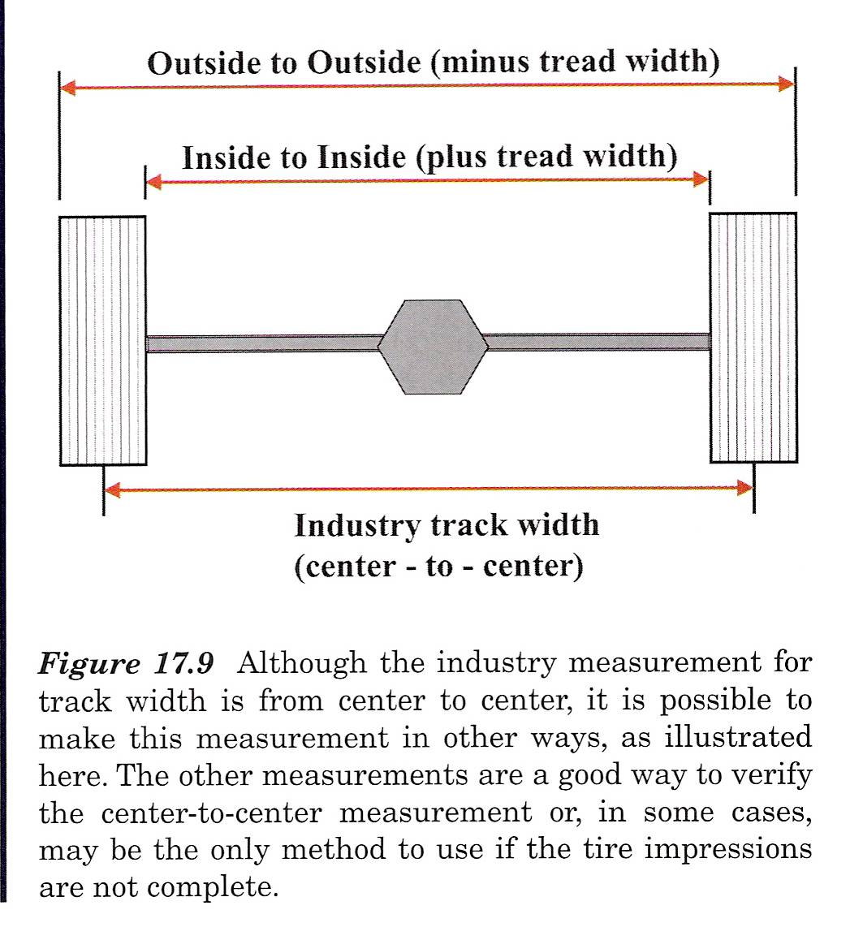

•Wheelbase dimensions = the measurement between the centers of the hubs of the front wheels to the center of the hubs of the rear wheels. (NOTE: rarely is enough info detail retained at scene to determine this measurement).
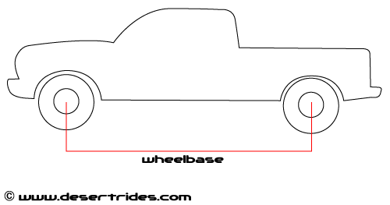

•Turning diameter: ______________________ of the circle a vehicle makes when steering wheel is fully turned. (NOTE: can only be used to eliminate vehicles that cannot turn at least that sharply).

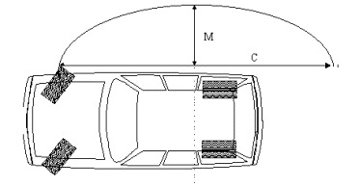

Recovery of Tire Track Evidence
•First: general crime scene____________________________ (lots from many angles), and notes (number of tracks, ________________________ to one another, direction of travel)
•Then: examination quality photograph
. . . this is done in same manner as _____________________evidence. EXCEPT for longer tire impressions . . . longer impressions taken as sequentially overlapping photos.
(NOTE: all photos should be taken with ruler or other size reference device placed next to, NEVER within, the impression)

Tire Evidence Examination
•First the treads will be compared with . . .
•Known tires
•Suspect vehicles . . .seize tires from vehicle, noting _______________________ on car
•Elimination ____________________ (vehicles known to have been at the scene, i.e. police car) . . . a picture of tire is usually all that is needed
***tire design most useful to rule out tires
•Then if similar design . . . the tires must be __________________ further to make a match.
•To do so, will need to make a test impression with suspect tire(s)
*** usually done on clear material so can be superimposed on impression from scene.
Analysis includes:
•Closer look at tread design elements, _______________________, and sipes
•Tread dimension and track characteristics
(NOTE: Tread Design Guide and Who Makes it and Where lists issued yearly as reference material as well as a database to store wheelbase, track width, and turning radius can help create lists of possible vehicles)
•Noise treatment and wear features—useful to significantly narrow down the possible number of tires. Also, wear bars and noise treatment can be used in _________________________ to locate or _______________________ the areas of the tire that have made the scene impression.
•Random individual characteristics or distinguishable marks—includes stones, glass, nails, cuts and if present on both impression and suspect tire, this can allow for positive ID
•Multiple tires of different designs—when found on one vehicle, the likelihood of finding another vehicle with the same combination of tire designs is small or nonexistent.

