Solubility Curves and Table G
YOYO: Use Table F to determine if a compound is soluble (S) or insoluble (I).

- MgCl_{2 __________}
- CaCrO_{4 __________}
- Ca(ClO₃)_{2 __________}
- Barium sulfate _______
- Calcium hydroxide ________
- Ammonium phosphate ________

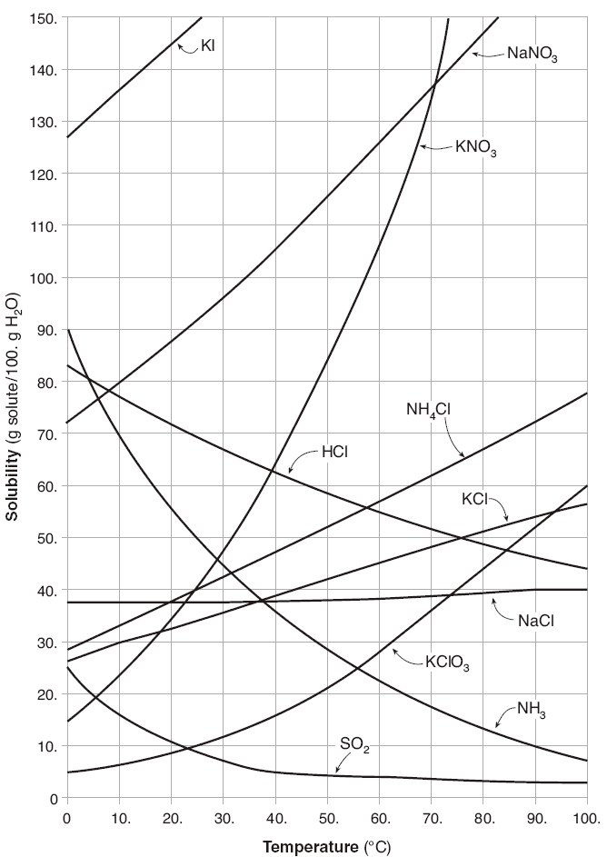
Temperature
- Refer to Table G of your Reference Tables for Chemistry
  - The solubility of most solids ___________________ with an ___________________ in temperature
  - The solubility of gases _____________________ with an _____________________ in temperature

Temperature & Solubility
- Notice that the solubility of the gases decreases with an increase in __________________
- The solubility of most _________________ (those on the table) increases with an increase in temperature
- The solubility is given in grams of solute per _________ grams of water
- ___________________________ are gases (their curve decreases as temperature increases)

Solution Conditions
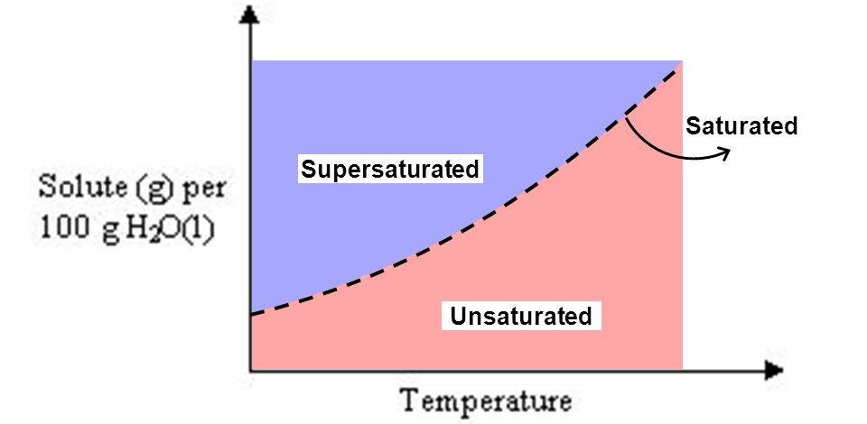
Solution Types
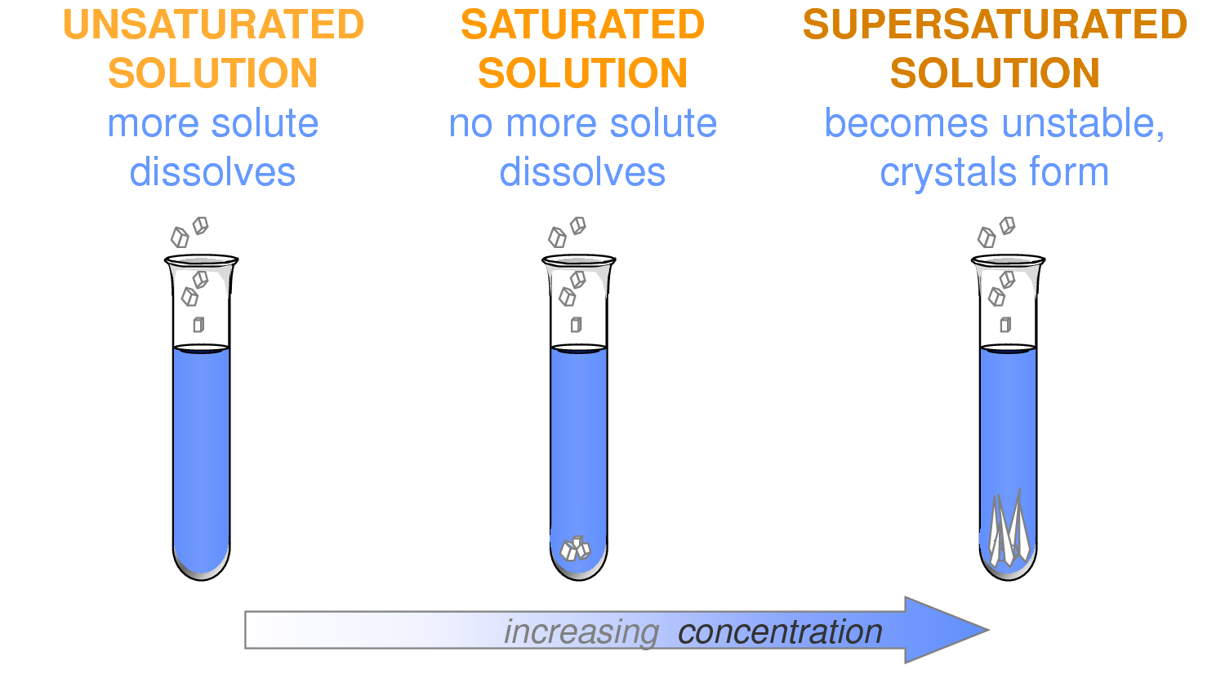
- _______________________________ - the solution can dissolve more solute in the solvent at the specified temperature
- _______________________ - the solution is holding as much solute as it can hold at the given temperature (the rate of solution equals the rate of dissolution).
- __________________________ - the solution is holding more solute than it normally can hold at the specified temperature. These solutions are unstable and will seek to reach saturation when disturbed and the excess solute will precipitate out.

Reading Table G Practice
Directions: Answer the questions below referring to Table G.

- The compound which is the most soluble at 20°C is ___________________.
- The compound which is the least soluble at 10°C is ___________________.
- The compound which is the least soluble at 80°C is ___________________.
- The number of grams of potassium nitrate needed to saturate 100 mL of water at 70°C is ___________________.
- The formulas of the compounds which vary inversely with the temperature are ___________________, ___________________ and ___________________.
- One hundred mL of a sodium nitrate solution is saturated at 10°C. How many additional grams are needed to saturate the solution at 50°C? ___________________
- One hundred mL of a saturate KCl solution at 80°C will precipitate 10 grams of salt when cooled to what temperature? _____________________________.
- The two salts that have the same degree of solubility at 70 °C are ____________ and ____________.
- The salt with a solubility is least affected by a change in temperature is ___________________.
- The salt that has the greatest increase in solubility in the temperature range between 30°C and 50°C is. ___________________
- The number of grams of sodium nitrate that must be added to 50 mL of water to produce a saturated solution at 50°C is ______________________________________.
- A saturated solution of potassium chlorate is made at 10°C by dissolving the correct mass of salt in 100 mL of water. When the solution is heated to 90°C, how many grams must be added to saturate the solution? ___________________
- At what temperature do saturated solutions of sodium chloride and potassium chloride contain the same mass of solute per 100 mL of water? ______________________________________.
- A saturated solution of potassium nitrate is prepared at 60°C using 200 mL of water. If the solution is cooled to 30°C, how many grams will precipitate out of the solution? ______________________________________.
- How many more grams of ammonia can be dissolved in 100 mL of water at 10°C than at 90°C? ___________________.
- A saturated solution of sodium nitrate in 100 mL of water at 40°C is heated to 50°C. The rate of increase in solubility grams per degree is. ___________________________.
- Thirty grams of KCl is dissolved in 100 mL of water at 45°C. The number of additional grams of KCl that would be needed to make the solution saturated at 80°C is ______________________________________

