Shoe Size vs. Height Lab
INTRODUCTION
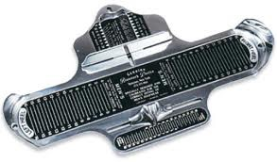
We have discussed in class that footprints can be considered a type of impression evidence, a type of evidence where two objects come in contact with one another with enough force to create an impression of the object. Other examples of impression evidence include tire tracks and bite marks. Not only can forensic scientists determine the brand of shoe worn by a suspect, it is also possible to estimate the height of a suspect. In this lab, you will have the opportunity to explore the relationship between height and shoe size.

METHODS
- With a partner, measure your height in centimeter using the meter sticks provided
- Record your data in the appropriate section in the chart below
- Record your data in the chart on the white board
- Talk to other groups and share data – you need AT LEAST 7 data points in each section on the table
- Be sure to record female height and shoe sixe on the LEFT side of the chart
- Be sure to record male height and shoe sixe on the RIGHT side of the chart

DATA TABLE
Female |  |  | Male
Height (cm) | Shoe Size |  | Height (cm) | Shoe Size

GRAPH

YOUR GRAPH MUST INCLUDE – Check off when complete
Key
- Graph title
- X-axis title

- Y-axis title
- Evenly spaced x-axis
- Evenly spaced y-axis
- All data must be plotted and spaced out
- USE AS MUCH OF THE GRAPH AS YOU CAN
- A key to show the different lines
- A line of best fit to clearly show the relationship

ANALYSIS AND QUESTIONS
- What is impression evidence?

- Why are shoe prints considered to be a type of impression evidence?

- What general trend do you see in the graph?

- How does the line showing male shoe size and height compare to the line showing female shoe size and height (what seminaries and differences do you see in the two lines)?

- How do you think this information can be used in forensic investigation?

- Do all of your data points create a perfectly straight line? Explain why or why not.

QUESTIONS 7-9 are on the following page!

Use the line of best fit on the graph below to answer questions 7-9

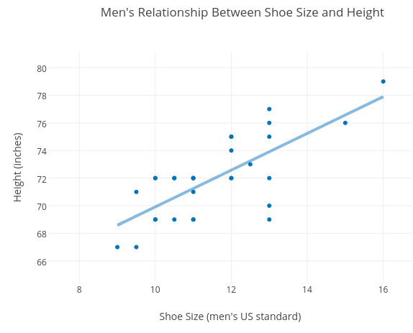

- If a man has a shoe size 12, his height is most likely ____________
    - Explanation:

- If a man is 70 inches tall, his shoe size is most likely ____________
    - Explanation:

- If a man had a show size 18, his height is most likely ____________
    - Explanation:

Challenge Yourself: Convert the answers to questions 5 and 7 to centimeters.

