Real World Combined Gas Law Applications Poster Assignment
Directions: Below are 6 real world applications of the gas laws discussed in class. Your task is to create a poster (8.5 in. x 11 in.) explaining one of these scenarios. Your poster MUST INLCUDE:
- The scenario (either rewrite the question, or summarize it)
- All relevant work, with units, needed to solve the question.
- Complete explanations for the written part of the question (make sure you answer IN TERMS OF whatever the question is asking)
- A hand-drawn diagram/image describing the scenario.

Scenario #1: SCUBA Diving Injury
SCUBA divers are warned to “never hold your breath.” When a diver inhales air from a SCUBA tank, the air that enters the diver's lungs is at ambient pressure. If a diver inhales from the tank on the surface, the pressure in her lungs will be at 1 atm. If she inhales air from her tank at a depth of 70 m (~230 ft), the pressure in her lungs will be 8 atm (for every 10 meters below the water, pressure increases by 1 atm). Assume the diver's lung volume is 1 L.

If a diver at 70 m has 1 L of air at a pressure of 8 atm in her lungs and ascends to the surface (1 atm) while holding her breath, what happens to the diver’s lungs? (FYI: total lung capacity is 6.0 L)

Explain what is going on, in a molecular level inside the diver’s lungs, in terms of collisions, volume, and pressure.

Scenario #2: Snow Classico
March 22, 2013, the United States men’s national soccer team played Costa Rica in a World Cup qualifying game. This is was a match like no other and was even nicknamed ‘Snow Classico.’ At the start of the match, there was a dusting of snow on the pitch and the field temperature was a frigid 17 °F (-8.3 °C). The snow continued to fall the entire match and was even shoveled away during half time only to come back during the second half. FIFA (Federacio Internationale de Football Association) law states that the air pressure of a regulation ball must be between 8.5 psi and 15.6 psi (psi = pounds per square inch, a unit of pressure).

If the extra soccer balls that were kept on the pitch had a pressure of 9.2 psi outside, what would happen to the balls if they were brought into the 70 °F (21.1 °C) locker room during halftime?

Explain what is going on, in a molecular level inside the soccer ball as it moves from the pitch to the locker room, in terms of average kinetic energy, collisions, volume, and pressure.

Scenario #3: Turkey Time
You have probably eaten some form of turkey in your life, but have you ever cooked a turkey? Turkeys come with pop-up thermometers to tell you when the turkey is done. As the turkey is in the oven, the pressure is held constant, and obviously the temperature changes (as long as the oven is turned on). Inside the pop-up thermometer is a small amount of air (2 mL).

If the starting temperature of the turkey was 15 °C and the directions say the turkey is done if it reaches an internal temperature of 74 °C, what is the new volume of the pop-up thermometer?

Explain what is going on, in a molecular level inside the pop-up thermometer, in terms of average kinetic energy, collisions, volume, and pressure.
Scenario #4: The Imploding Train
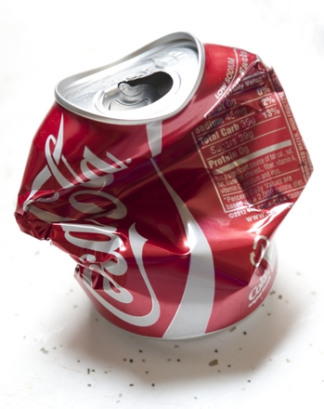Legend has it that there was a railroad tank car that when left unattended one night imploded on itself. The myth has been tested on the popular show MythBusters but can also be demonstrated on a smaller scale using a hot plate, ice water, and a can. Picture a can with a small amount of water siting on a hotplate slowly heating up. The pressure in and around the can is 1 atm. The temperature of the inside of the can is 100 °C. The can is then placed upside down in a bucket of ice water 0 °C and implodes on itself. Volume can be omitted from this question.

Calculate the new pressure inside of the can showing all work.

If the pressure outside of the can is still 1 atm, explain why the can implodes on itself in terms of average kinetic energy, pressure inside the can, and pressure outside the can. Then, using the same thought process, explain why the tanker supposed imploded when after it was washed, and all openings were sealed, and the inside of the tanker cooled down.

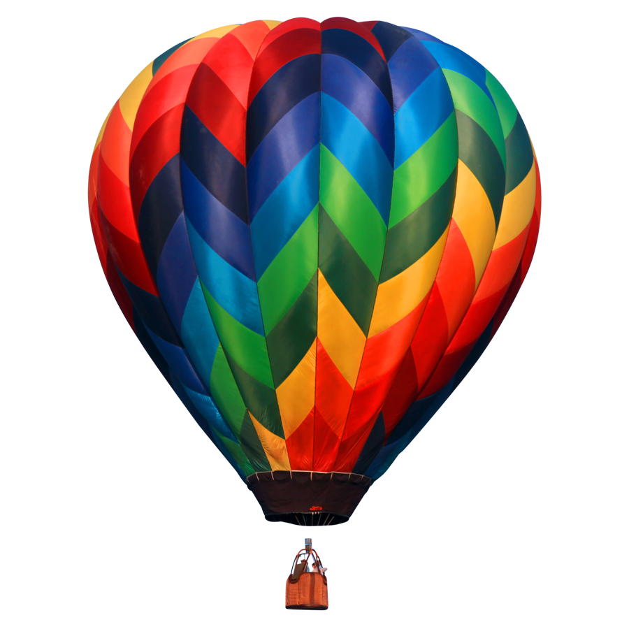Scenario #5: Up Up & Away
Hot air balloons may not be the most efficient way of travel, but they are very interesting and have quite a history. Using information dating way back to 200 BC, the first practical hot air balloon was built in 1783. Currently, the fastest manned balloon was recorded to reach speeds of 245 mph. The name hot air balloon comes from the fact that air is heated which eventually causes the balloon to rise.

If the starting volume of a hot air balloon is 55,500 m³and the initial temperature is 21 °C, what is the temperature inside the balloon is the final volume is 74,000 m³.

Explain why the volume of the balloon increases when temperature is increased in terms of average kinetic energy, collisions and volume. Explain how the balloon is actually able to lift off the ground in terms of density. (Useful info: density of hot air is 0.946 kg/m³ and the density of normal (ambient air) is 1.2 kg/m³.)

Scenario #6: Out of Breath
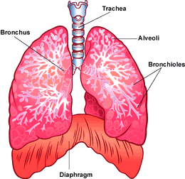As you are well aware, you are required to breathe. Breathing is a lot more complicated than you might think. It involves pressure and volume changes. The human body works hard to maintain a constant 37 C temperature. When the diaphragm, a muscle that aids in breathing, is moved down, it decreases the pressure inside the lungs allowing for air to enter the lungs, which then causing the lung volume to increase. When the diagram moves up, the volume decreases, which causes pressure to increase which forces the air out of the lungs. This process repeats forever.

If the pressure decreases from 1 atm to 0.8 atm, and the starting lung volume is 4.5 L, what is the total amount of air that was inhaled on that breath? (Hint: You need to figure out where you end before you can calculate change.)

Explain what is going on, in a molecular level inside the person’s lungs, in terms of collisions, volume, and pressure.

