Introduction to Properties of Water and Solubility Guidelines
YOYO: Which mixture can be separated by using the equipment shown to the right? Explain your answer!

A) NaCl(aq) and SiO₂(s) B) NaCl(aq) and C₆H₁₂O₆(aq)
C) CO₂(aq) and NaCl(aq) D) CO₂(aq) andC₆H₁₂O₆(aq)

The correct answer is _________ because…. ___________________________
___________________________________________________________________
___________________________________________________________________

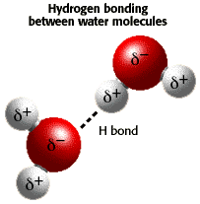
Water and Hydrogen Bonding

- Many properties of water are a result of _______________________________.
- Hydrogen bonding happens ___________________ two _________________ molecules.
- _______________________________________________
- _______________________________________________
- _______________________________________________

Surface Tension
- A property of a surface of a liquid that _____________________________________________________
__________________________.

Vapor Pressure
- Water has a ________________ due to the strong __________________ between ______________
________________________.
- Since attraction between water molecules is __________________, more ____________ is required to be absorbed ______________________ in order to _________________________.

Water in the solid state

- Density of ice is ____________ than _____________________________________ due to the _________________ of the _____________.

What is a solution?
- A solution is _______________________________________________________________________________
___________________________________________________________________________________________
- All ________________________ are solutions
- Solutions can exist in any _______________.
- Liquid solutions must be clear __________ must be able to _____________________________________.

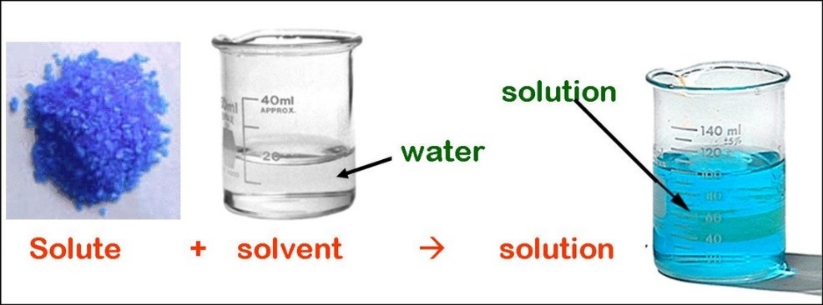
What is an aqueous solution?
- An __________________________ is one that _____________________________________________.
- A solution is made up of
- _________________ and ________________
- Solvent: __________________________________________
- Solute: ________________________________________________

Electrolytes and Nonelectrolytes
- An electrolyte ______________________________________________________________________________ ___________________________________________________________________________________________
- All ionic compounds are ____________________________.
- Strong electrolytes are ______________ conductors of ______________________.
- Weak electrolytes are ______________ conductors of _______________________.
- Non- electrolytes __________________________________________________________________________.
Label each picture strong, weak or non-electrolyte.
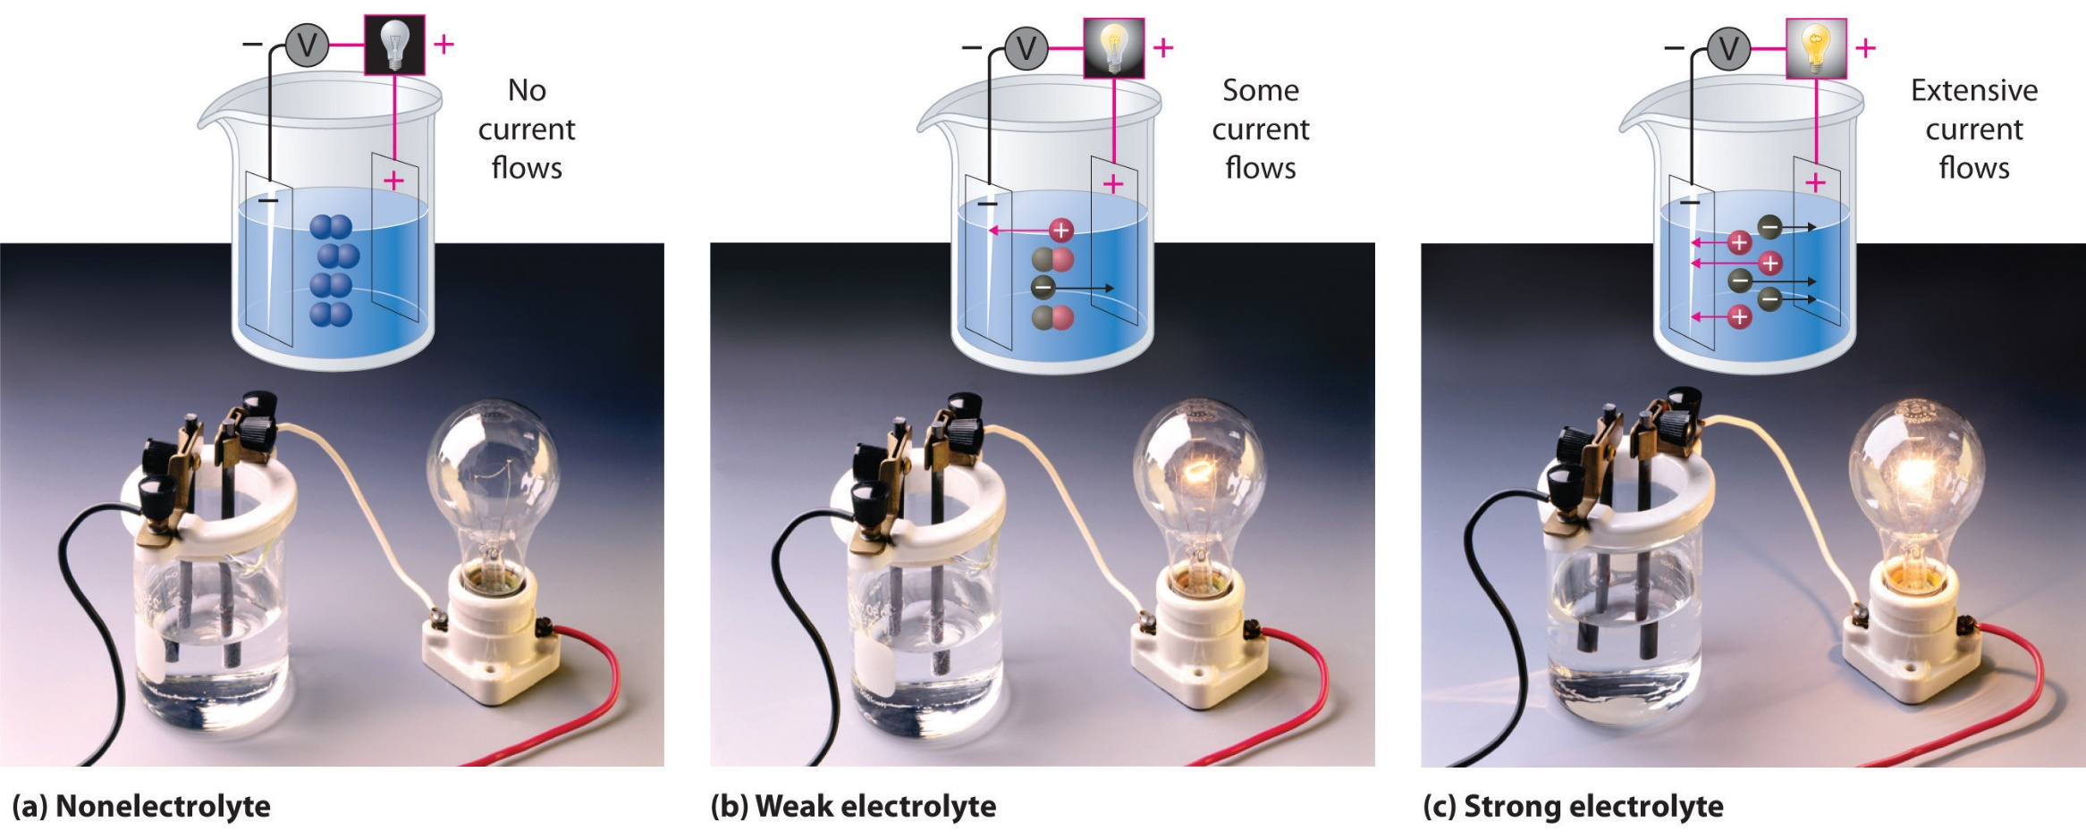

What is solubility?
- Solubility is the _________________________________________________________________________________________________________________________________________________________________________________________________________________________________________________________________________________
- Dissociation is the ______________________________.
- For example, ____________________________________________________.
- Miscible: ________________________________________________________
- Immiscible: ______________________________________________________

Soluble vs Insoluble
- Soluble means ____________________________________________________________________________.
- Insoluble means __________________________________________________________________________.

Solubility guidelines using Table
- The solubility of ionic compounds in aqueous solutions is wide and varied
- _____________________________________________________(e.g. NaCl), some compounds are moderately soluble (e.g. SnI2) and some compounds are highly insoluble (e.g., AgCl)
- Strong electrolytes ______________________________.
- Weak electrolytes ________________________________
- When an insoluble substance (precipitate) is formed,_______________________________________________________________________________________________________________________________________________________________________________
- A soluble solute _________________________________________________________________________.
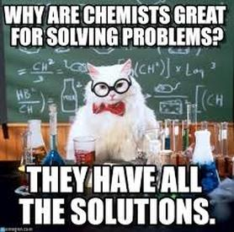
Use Table F to indicate if each substance is soluble or insoluble?

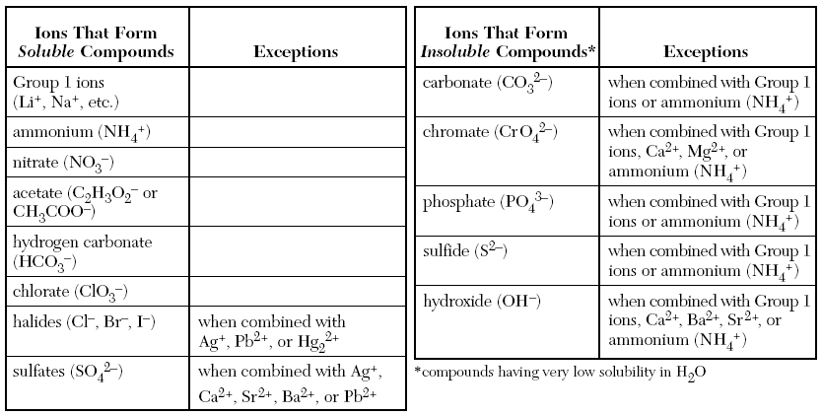

Na₂CO₃(aq) + CaCl₂(aq) 2NaCl(aq) + CaCO₃(s)

