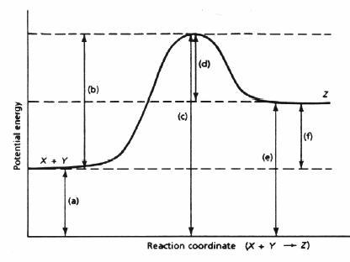
Potential Energy Diagrams

150 kJ

100 kJ

50 kJ

0 kJ

- Which of the letters a–f in the diagram represents the potential energy of the products? _____
- Which letter indicates the potential energy of the activated complex? ________
- Which letter indicates the potential energy of the reactants? ________
- Which letter indicates the activation energy? _____
- Which letter indicates the heat of reaction? ______
- Is the reaction exothermic or endothermic? __________________________________
- Which letter indicates the activation energy of the reverse reaction? ________
- Which letter indicates the heat of reaction of the reverse reaction? _________
- Is the reverse reaction exothermic or endothermic? __________________________________
- The PE of the reactants of the forward reaction is about ___________ kilojoules
- The PE of the products of the forward reaction is about ___________ kilojoules
- The PE of the activated complex of the forward reaction is about ___________ kilojoules
- The activation energy of the forward reaction is about ___________ kilojoules.
- The heat of reaction (∆H) of the forward reaction is about _________ kilojoules.
- The forward reaction is ___________________________________ (endothermic or exothermic).
- The PE of the reactants of the reverse reaction is about ___________kilojoules.
- The PE of the products of the reverse reaction is about ___________ kilojoules.
- The PE of the activated complex of the reverse reaction is about ___________kilojoules.
- The activation energy of the reverse reaction is about ____________kilojoules.
- The heat of reaction (∆H) of the reverse reaction is about ________________ kilojoules.
21. The reverse reaction is _________________________________ (endothermic or exothermic)
- What is the activation energy of a reaction, and how is this energy related to the activated complex of the reaction?

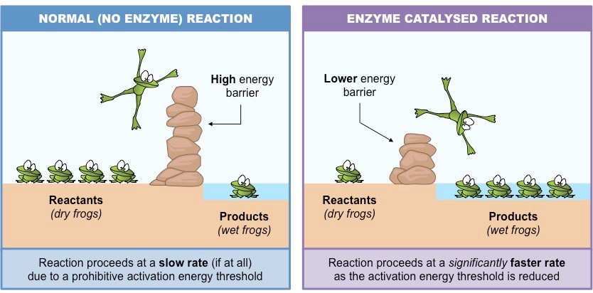
- What happens when a catalyst is used in a reaction?

- Draw an energy diagram for a reaction. (label the axis) Potential energy of reactants = 350 KJ/mole Activation energy = 100 KJ/mole Potential energy of products = 250 KJ/mole

- Is the reaction in # 27 exothermic or endothermic? Explain.

- How could you lower the activation energy for the reaction in #27?

