**Potential Energy Diagrams**

**YOYO:** Compare and contrast the two images below. What similarities do you see? What differences do you see? Turn and Talk with your neighbor and share your list. Add things you may have missed.

**Image A Image B ________________________________**

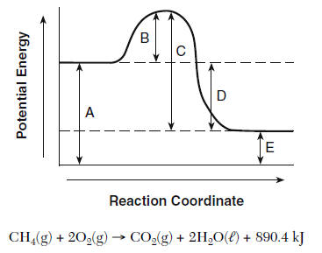**________________________________________________________________________________________________________________________________________________________________________________________________**

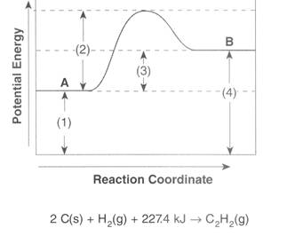

Below is a conversation between Jon, Daenerys, Sansa, Arya, and Bran. They are part of a study group and are working on a homework assignment together.

* **Jon**: So this chem homework tonight makes no sense. How are we supposed to label these things? They just look like roller coasters. I might freak out and panic! I know nothing.
* **Daenerys:** Never freak out and panic. Maybe we should look in the text book first and read up on these roller coaster like pictures.
* **Sansa**: According to the book, these are called potential energy diagrams and are used to show the stored energy in both the products and the reactants.
* **Jon**: Oh that makes sense. We already learned how potential energy is stored energy and kinetic energy is the energy of motion.
* **Sansa**: Right, but here we are only focused on the stored, or potential energy.
* **Arya**: The book says that you are able to determine if a reaction is endothermic or exothermic just by looking at it.
* **Jon**: I understand the y-axis where it says potential energy, but what does it mean when it says “reaction coordinate” on the x-axis.
* **Bran**: That just shows the progression of the reaction.
* **Jon**: Oh so the reactants, or what you start with, is at the start of graph, and the products, the things that are produced, are at the end of the graph.
* **Bran**: Exactly!
* **Arya**: So we know endothermic reactions absorb energy, so the products would have to be higher than the reactants, and exothermic reactions release energy, so the products would have to lower than the reactants, but what is that peak in the middle?
* **Sansa**: Right, if you were to calculate ΔH, it would be the energy of the products (the final conditions) minus the energy of the reactants (the initial conditions). If that number is positive, we know it is endothermic, and if it is negative, we know it is exothermic. That peak is known as the activated complex.
* **Daenerys**: The activated complex is the phase before the products, but after the reactants. The pieces of the reaction are in transition, and are sort of a mix between the two. If you think of the reaction as yellow 🡪 blue, the activated complex would be a mix between the two colors, so green.
* **Bran**: Another thing to point out is that in order for any reaction to happen, energy needs to be absorbed. The reactions need a push to get started. That energy needed to start, or activate the reaction, is called the activation energy.
* **Jon**: Finally a name that actually makes sense. Unlike hydrogen bonds which aren’t bonds, but actually strong intermolecular forces.
* **Sansa**: Exactly! We are never going to make that mistake again.
* **Arya**: Going back to activation energy though, the book says to think of pushing a rock up and over a hill. The rock won’t move up the hill on its own. Someone needs to push it.
* **Bran**: If you don’t push hard enough and give the rock enough energy, it will just roll back down where you started. You need to push it enough to make it to the top. Once it is there, it can roll down on its own. That is how the reactions work.
* **Daenerys**: If they don’t have sufficient energy to reach the top of the curve, the reaction won’t happen.
* **Arya**: The book also mentions a way to speed up reactions. They say it is something called a catalyst.
* **Jon**: Ooo I remember that from Living Environment. A catalyst speeds up a reaction. But how?
* **Sansa**: It says that with the presence of a catalyst, the activation energy is lowered. Nothing else is affected. It just takes less energy to reach the peak, so the peak would be lower than the original.
* **Jon**: I think we have read enough to label these diagrams now. Let’s do it!

Potential Energy Diagram #1 – Together!

10 kJ

5 kJ

0 kJ

**Questions:**

1. Circle one: This is an (exothermic / endothermic) it shows that heat is being (absorbed / released)
2. Circle one: ΔH is calculated by determining the difference between the energy of the products (Hproducts) and the energy of the reactants (Hreactants). In this case, ΔH is (positive / negative)
3. (A) is showing the ______________________________________________ and the value is ____________.
4. (E) is showing the ______________________________________________ and the value is ____________.
5. (B) is showing the ______________________________________________ and the value is ____________.
6. (D) is showing the ______________________________________________ and the value is ____________.
7. (C) is showing the ______________________________________________ and the value is ____________.
8. Circle one: This is an (exothermic / endothermic) it shows that heat is (absorbed / released).
9. List all the things affected when a catalyst is added. ____________________________________________
10. In the diagram above, draw in the what it would look like if a catalyst was added.

**Directions**: Turn and talk with your neighbor to answer the following questions based on Potential Energy Diagram #2.

(B)

10 kJ

0 kJ

5 kJ

(D)

(C)

(A)

(E)

Reaction Coordinate 🡪

1. Circle one: This is an (exothermic / endothermic) it shows that heat is being (absorbed / released)
2. Circle one: ΔH is calculated by determining the difference between the energy of the products (Hproducts) and the energy of the reactants (Hreactants). In this case, ΔH is (positive / negative)
3. (A) is showing the ______________________________________________ and the value is ____________.
4. (E) is showing the ______________________________________________ and the value is ____________.
5. (B) is showing the ______________________________________________ and the value is ____________.
6. (D) is showing the ______________________________________________ and the value is ____________.
7. (C) is showing the ______________________________________________ and the value is ____________.
8. Circle one: This is an (exothermic / endothermic) it shows that heat is (absorbed / released).
9. List all the things affected when a catalyst is added. ____________________________________________
10. In the diagram above, draw in the what it would look like if a catalyst was added.