Organic Reactions
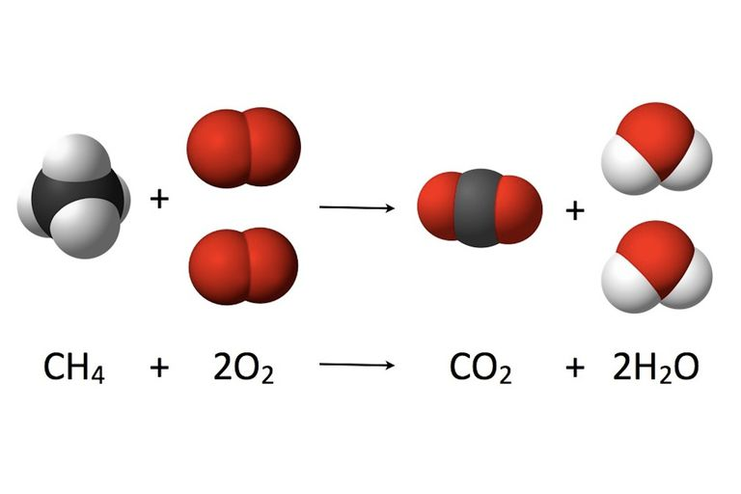

Reaction #1: Combustion
- Organic compound is burned in the presences of oxygen to produce ___________ and _____________
- O₂ is always a _____________________
- Example: CH₄ + 2O₂ CO₂ + 2H₂O
  - Question 1: Which reaction best represents the complete combustion of ethene?

    - C₂H₄ + HCl C₂H₅Cl
    - C₂H₄ + Cl₂ C₂H₄Cl
    - C₂H₄ + 3O₂ 2CO₂ + 2H₂O
    - C₂H₄ + H₂O C₂H₅OH

  - Question 2: When C₃H₈ burns completely in an excess of oxygen, the products formed are

    - CO and H₂O
    - CO₂ and H₂O
    - CO and H₂
    - CO₂ and H₂

Reaction #2: Substitution
- ____________________________ atoms are replaced by __________________ atom(s)
- Only happens in __________________
- Results in _____________ products
- One H is switched with one _________________ (group 17)
  - Question 3: Given the equation representing a reaction:
What type of reaction is represented by this equation?

    - Addition
    - Esterification
    - Polymerization
    - Substitution

  - Question 4: Given the balanced equation CH₃CH₂CH₃ + Br₂ CH₃CH₂CH₂Br + HBr. This organic reaction is best classified as

    - An addition reaction
    - An esterification reaction
    - A polymerization reaction
    - A substitution reaction

Reaction #3: Addition
- Adding one or more atoms at a _______________ or ______________________ bond
- Happens in ______________ or _____________________

  - Question 5: Which equation represents an addition reaction?

    - C₃H₈ + Cl₂ C₃H₇Cl + HCl
    - C₃H₆ + Cl2 C₃H₆Cl₂
    - CaCl₂ + Na2CO3 CaCO₃ + 2NaCl
    - CaCO₃ CaO + CO₂

  - Question 6: Given the balanced equation for an organic reaction C2H2 + 2Cl2 C2H2Cl4. This reaction is best classified as

    - Addition
    - Esterification
    - Fermentation
    - Substitution

Reaction #4: Fermentation
- Enzymatic breakdown of ___________________ into ____________________ (ethanol) and CO₂
- Identify alcohol and CO₂ as a product
- Example: C₆H₁₂O₆ 2C₂H₅OH + 2CO₂
  - Question 7: What are the two main products of a fermentation reaction?

    - Ethanol and carbon dioxide
    - Ethanol and water
    - Sugar and carbon dioxide
    - Sugar and water

  - Question 8: Which equation represents fermentation?

    - C₂H₆ + Cl₂ C₂H₆Cl + HCl
    - C₆H₁₂O₆ 2 C₂H₅OH + 2 CO₂
    - CH₃COOH + CH₃OH CH₃COOCH₃ + H₂O
    - nC₂H₄ (C₂H₄)_{n}

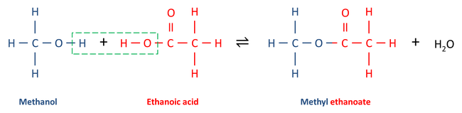Reaction #5: Esterification
- The formation of a ester by reacting an ________________________________ and an _____________________
- Esters are used in synthetic flavors, perfumes, and cosmetics
- Possible scents: bananas, wintergreen, and pineapples
  - Question 9: A reaction between an alcohol and an organic acid is classified as

    - Esterification
    - Fermentation
    - Saponification
    - Substitution

  - Question 10: Given the reaction:
This reaction is an example of

    - Fermentation
    - Saponification
    - Hydrogenation
    - Esterification

Reaction #6: Polymerization
- Small molecules called ________________________ bond together to form ___________________
- Can be natural (proteins) or artificial (plastics)
  - ___________________ – long chains of sugars
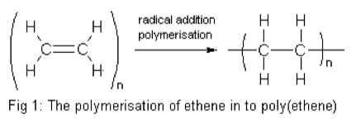
  - ___________________ – long chains of amino acids
  - ___________________ – made of repeating units of sugar
- Addition Polymerization
  - Adding small ______________________ together by breaking the double bond, to create a large chain
  - 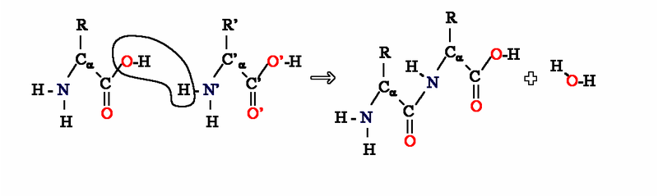Identify by “n” which represents a large number
- Condensation Polymerization
  - Joining _____________ molecules by removing ________________ (dehydration synthesis)
  - Question 11: The process of joining many small molecules into larger molecules is called

    - Neutralization
    - Polymerization
    - Saponification
    - 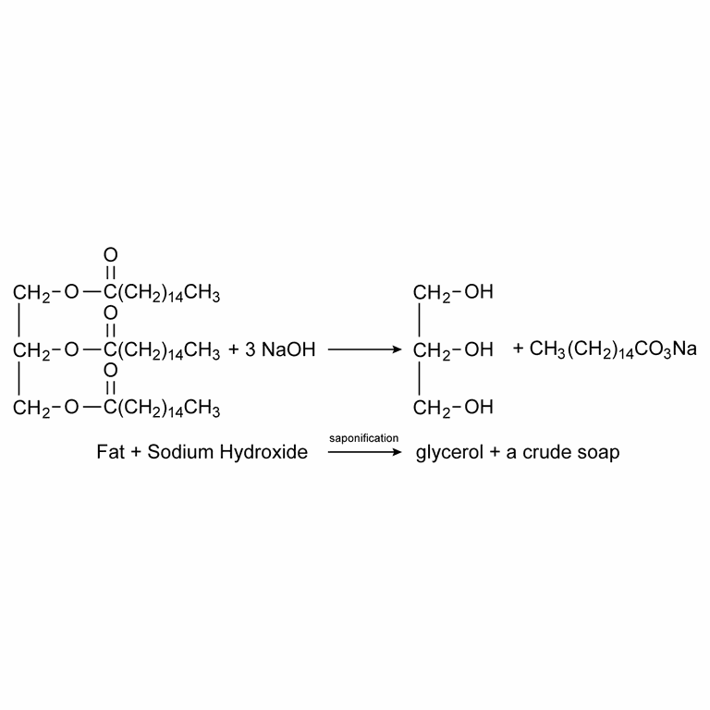Substitution

  - Question 12: Given the equation:
Which type of reaction is represented by this equation?

    - Combustion
    - Esterification
    - Polymerization
    - Substitution

Reaction #7: Saponification
- Ester breaking down into acid and alcohol
- ______________________________________
- Produces __________________
- Fat + strong base soap + glycerol
  - Question 13: In which reaction is soap a product?

    - Addition
    - Substitution
    - Saponification
    - Polymerization

  - Question 14: The hydrolysis of a fat by a base is called

    - Saponification
    - Esterification
    - Polymerization
    - Neutralization

