A Case Study on Ocean Acidification

By
Sindia M. Rivera-Jiménez, Ph.D.
Department of Natural Science, Santa Fe College, Gainesville Fl

Directions: Please read the following abstract of an article from the journal Nature Letters and prepare a short written response addressing the questions at the end.

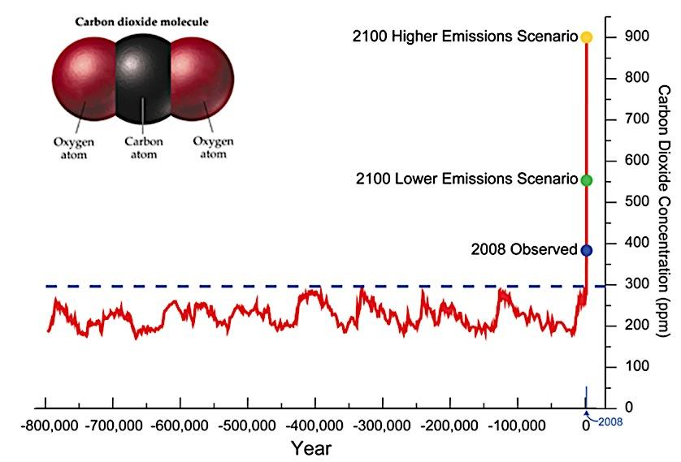
One of most important topics for scientists is to understand what are the economical, sociological, and environmental aspects that may alter the sustainability of all species on Earth. The traditional definition of sustainability calls for policies and strategies that meet society’s present economic, social and environmental needs without compromising the ability of future generations to meet their own needs¹.
Figure 1: Data showing increase of CO₂ in the ocean
Groups of marine and environmental scientists have being studying ocean acidification for years. Recent literature suggests that the concentration of carbon dioxide (CO₂) will almost certainly be double that of pre-industrial levels by 2100 and will be considerably higher than Figure 1. Data showing increase of CO₂ in the ocean at any time during the past few million years (Figure 2). The oceans are a principal sink for CO₂ coming from human activity where it is estimated to have caused a 30% increase in the concentration of H⁺ (or H₃O⁺) in ocean surface waters since the early 1900s and may lead to a drop in seawater pH of up to 0.5 units by 2100.
Ocean acidification may affect humans through a variety of socio-economic connections, potentially beginning with reduced harvests of commercially important species². The total primary value of US commercial harvests from US waters and at-sea processing was nearly $4 billion in 2007. Of that total primary value³, mollusks provided 19%, crustaceans yielded 30% , and finfish generated 50% (greens). Around 24% of total US primary value revenue was from harvesting fish that prey directly on calcifiers (coral reef). Different groups dominate regional revenues; mollusks are more important in the New England and mid to south Atlantic regions, crustaceans contribute greatly to New England and Gulf of Mexico fisheries, and predators dominate the Alaskan, Hawaiian, and Pacific-territory fisheries.
Ocean acidification's impact is not yet known for every commercially and recreationally valuable species, but emerging data suggest that the number or quality of many high-value, aragonite-forming mollusks could decrease, and declining economic revenues in that fishery sector may follow. This possibility is supported by findings such as decreased mollusk populations in acidified ecosystems, malformation of juvenile oyster shells in aragonite-undersaturated laboratory studies, and decreased survival of oyster larvae in upwelling Oregon seawater with decreased pH and altered biogeochemistry.
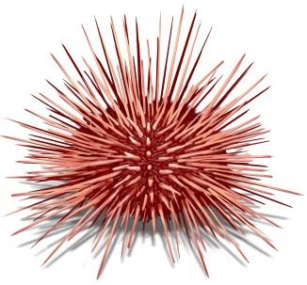
Mollusks and crustaceans comprise the bottom or middle trophic levels of many ecosystems, implying that acidification- related damage to either of these groups also may negatively impact their primary and secondary predators. Effects of prey losses on predator numbers are poorly quantified at present, however, and the total ecosystem impact will depend on whether alternative prey species are available and whether predators can switch among prey. Currently, predictions of ex-vessel losses from declining mollusk harvests must depend on translating laboratory experiments showing damage to individual organisms into population losses in nature⁴. Substantial revenue declines, job losses, and indirect economic costs may occur if ocean acidification broadly damages marine habitats, alters marine resource availability, and disrupts other ecosystem services.
A marine scientist, Jason M. Hall-Spencer, from the Marine Biology and Ecology research Center at University of Plymouth recently published: “Our understanding of how increased ocean acidity may affect marine ecosystems is at present very limited as almost all studies have been in vitro, short-term, rapid perturbation experiments on isolated elements of the ecosystem” ⁵. The scientist and his research group started a series of experiments in order to show the effects of acidification on benthic ecosystems at shallow coastal sites where volcanic CO₂ vents lower the pH of the water column. Between 18 April and 9 May 2007, surface and bottom water samples were regularly taken for measurements of the spatial and temporal variability in pH (in total scale), total alkalinity and salinity in various weather conditions.
Figure 2: Sea urchin
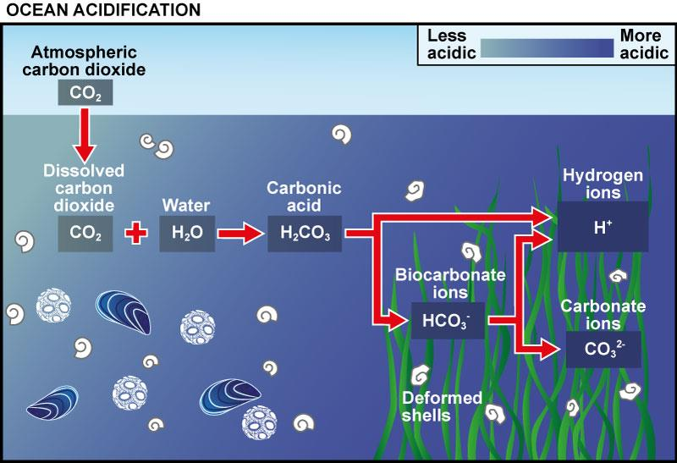
They found that along gradients of normal pH (8.1–8.2) to lowered pH (mean 7.8–7.9, minimum 7.4–7.5), typical rocky shore communities with abundant calcareous organisms shifted to communities lacking scleractinian corals with significant reductions in sea urchin and coralline algal abundance. Hall-Spencer’s group commented: “To our knowledge, this is the first ecosystem-scale validation of predictions that these important groups of organisms are susceptible to elevated amounts of CO_{2.}” They found that sea-grass production was highest in an area at mean pH of 7.6 where coralline algal biomass was significantly reduced and gastropod shells were dissolving due to periods of carbonate sub-saturation. The species populating the vent sites comprise a suite of organisms that are resilient to naturally high concentrations of pCO₂ and indicate that ocean acidification may benefit highly invasive non- native algal species. Their results provide the first in situ insights into how shallow water marine communities might change when susceptible organisms are removed owing to ocean acidification.

Figure 3: Chemistry of Ocean Acidification

A Case Study on Ocean Acidification Questions
Directions: Answer the following questions base on the case study above and your knowledge of chemistry.
- Observe Figure 1.
  - Which axis is the dependent variable found on? What is the label on the dependent variable axis?

  - Which axis is the independent variable found on? What is the label on the independent variable axis?

  - Please explain in your own words, what is the relationship between the years and the concentration of CO₂ in the ocean.

  - In your opinion, do you think there is something we need to worry about? Please explain.

- State in concise terms the problem being investigated.

- Please list one socio-economic connection that can be affected by ocean acidification. Explain how they are connected.

- Observe Figure 3.
  - What happens to the pH when dissolved CO₂ reacts with water?

  - How is carbonic acid formed?

  - What are the two ions that are formed when H₂CO₃ dissociates?

  - What happens to the H⁺ concentration when more CO₂ is introduced to the water?

  - Describe the relationship between pH and H⁺ concentration.

  - Explain in terms of H⁺ why H₂CO₃ is considered to be an acid.

  - According to the Bronsted-Lowry theory, does the bicarbonate ion act as an acid or a base? Explain in terms of H⁺.

- Describe any pertinent results that original form the study.

- What specific conclusions can you draw from this study? Who might find the findings of this research study to be important or relevant?

- Is this your first time hearing about sustainability? Explain.

- Write at least one question you would to ask the research team to further your knowledge on this topic.

Optional At Home Demo: Egg shells are made of calcium carbonate just like the shells of many ocean dwelling creatures. Place a hard boiled egg in vinegar for a few days and observe what happens.

Acknowledgments and References:
Acknowledgment: “This work was supported by the National Socio-Environmental Synthesis Center (SESYNC) under funding received from the National Science Foundation DBI-1052875.”

¹http://www.sustainability.org;http://www.epa.gov/sustainability/;http://www.acs.org/content/acs/en/sustainability/acsandsustainability.html

²http://www.st.nmfs.noaa.gov/st1/index.html

³NMFS statistics, accessed October 2013. NMFS statistics and Andrews et al 2008.
⁴Cooley S.R., and Doney S.C. (Anticipaing ocean acidification’s economic consequences for commercial fisheries. Environ. Res. Lettt. (2009).

⁵Hall-Spencer, et. al. Volcanic carbon dioxide vents show ecosystem effects of ocean acidification. Nature Letters (2008).

