**Nuclear Decay Modes**

What is nuclear chemistry?

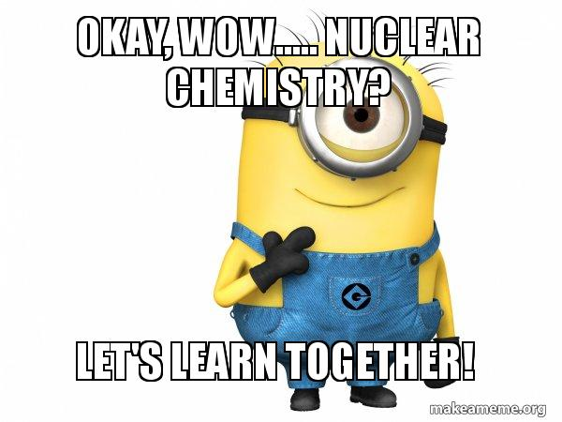

* Nuclear chemistry deals with changes in or transformations of the \_\_\_\_\_\_\_\_\_\_\_\_\_\_\_\_\_\_\_\_\_\_\_\_\_\_\_\_\_\_\_\_\_
* Four types of decay
  + \_\_\_\_\_\_\_\_\_\_\_\_\_\_\_\_\_\_\_\_\_\_\_\_\_\_\_\_\_\_\_\_
  + \_\_\_\_\_\_\_\_\_\_\_\_\_\_\_\_\_\_\_\_\_\_\_\_\_\_\_\_\_\_\_\_
  + \_\_\_\_\_\_\_\_\_\_\_\_\_\_\_\_\_\_\_\_\_\_\_\_\_\_\_\_\_\_\_\_
  + \_\_\_\_\_\_\_\_\_\_\_\_\_\_\_\_\_\_\_\_\_\_\_\_\_\_\_\_\_\_\_\_

Nuclear Reactions vs. Chemical Reactions

|  |  |
| --- | --- |
| **Chemical Reactions** | **Nuclear Reactions** |
| 1. Atoms are rearranged by the \_\_\_\_\_\_\_\_\_\_\_\_\_\_\_\_\_ \_\_\_\_\_\_\_\_\_\_\_\_\_\_\_\_\_\_\_\_\_\_\_\_\_\_\_\_\_\_\_\_\_\_\_\_\_\_\_\_\_\_\_\_\_\_\_  2. Only \_\_\_\_\_\_\_\_\_\_\_\_\_\_\_\_\_\_\_ are involved in the breaking or forming of bonds.  3. \_\_\_\_\_\_\_\_\_\_\_\_\_\_ amounts of energy are absorbed or released  4. Rates of reaction \_\_\_\_\_\_\_\_\_ influenced by temperature, concentration , pressure, and catalysts. | 1. \_\_\_\_\_\_\_\_\_\_\_\_\_\_\_\_\_\_\_\_\_\_\_\_\_\_\_\_\_\_\_\_\_\_ from one type to another.  2. \_\_\_\_\_\_\_\_\_\_\_\_\_\_\_\_\_\_\_\_\_\_\_\_\_\_\_\_\_\_\_\_\_\_\_\_\_\_\_\_\_\_\_\_\_ \_\_\_\_\_\_\_\_\_\_\_\_\_\_\_\_\_\_\_\_\_\_\_\_\_\_\_\_\_\_\_\_\_\_\_\_\_\_\_\_\_\_\_\_\_ are involved.  3. \_\_\_\_\_\_\_\_\_\_\_\_\_\_\_\_\_\_ amounts of energy are absorbed or released.  4. Rates \_\_\_\_\_\_\_\_\_\_\_\_\_\_\_\_\_\_\_ affected by temperature, pressure, or catalysts. |

Radioisotopes

* The nuclei of some unstable isotopes, called **\_\_\_\_\_\_\_\_\_\_\_\_\_\_\_\_\_\_\_\_\_\_\_\_\_\_\_\_\_\_\_\_\_\_\_\_\_\_\_\_\_\_\_\_\_\_\_\_\_** or **\_\_\_\_\_\_\_\_\_\_\_\_\_\_\_\_\_\_\_\_\_\_\_\_\_\_\_\_\_**, split up forming atoms with a different number of protons and releasing radiation.

Note: when an atom loses an alpha particle, the atomic number is lowered by two and the mass number is lowered by four.

* This process is called **\_\_\_\_\_\_\_\_\_\_\_\_\_\_\_\_\_\_\_\_\_\_\_\_\_\_\_\_\_\_\_\_\_\_\_\_\_\_\_\_.**
* \_\_\_\_\_\_\_\_\_\_\_\_\_\_\_\_\_\_\_\_\_\_\_\_\_\_\_\_\_\_\_\_\_\_ is the release of energy and matter that results from changes in the nucleus of an atom

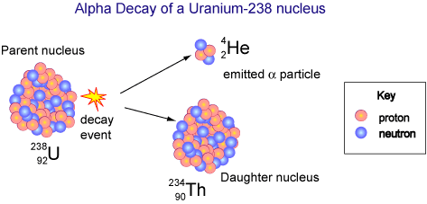

Alpha Radiation

* An **\_\_\_\_\_\_\_\_\_\_\_\_\_\_\_\_\_\_\_\_\_\_\_\_\_\_\_** is a positively charged particle identical to the helium nucleus
* Alpha decay occurs when the nucleus of an atom gives off an alpha particle—\_\_\_\_\_\_\_\_\_\_\_\_\_\_\_\_\_\_\_ and \_\_\_\_\_\_\_\_\_\_\_\_\_\_\_\_\_\_.
* http://upload.wikimedia.org/math/0/7/8/078bebdb795cc4581ffa6b1a74c18321.pngNote: when an atom loses an alpha particle, the atomic number is lowered by two and the mass number is lowered by \_\_\_\_\_\_\_\_\_\_\_.

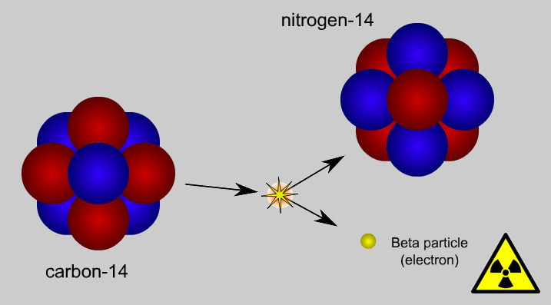Beta Radiation

* Beta-minus decay occurs when a \_\_\_\_\_\_\_\_\_\_\_\_\_\_\_ is converted to a \_\_\_\_\_\_\_\_\_\_\_\_, and in the process, emits an \_\_\_\_\_\_\_\_\_\_\_\_\_\_\_.
* **\_\_\_\_\_\_\_\_\_\_\_\_\_\_\_\_\_\_\_\_\_\_\_\_\_\_\_\_\_\_** are high-energy electrons whose source is an atomic nucleus
* 🡪 +
* http://www.bbc.co.uk/schools/gcsebitesize/science/images/addgateway_cne.gifNeutron Proton electron (beta particle)
* Note: The atomic mass stays the same, and the \_\_\_\_\_\_\_\_\_\_\_\_\_\_\_\_\_\_\_\_\_\_\_\_\_ increases by \_\_\_\_\_\_\_\_\_\_.

Carbon-14 Nitrogen-14 beta particle

(radioactive) (stable)

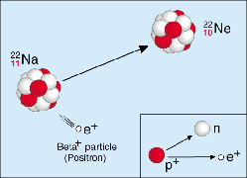Positron Radiation

* Beta-plus decay (also called positron emission) occurs when a \_\_\_\_\_\_\_\_\_\_\_\_\_\_\_\_\_\_ is converted to a \_\_\_\_\_\_\_\_\_\_\_\_\_\_, and in the process, emits a positively charged electron (a positron).
* A **\_\_\_\_\_\_\_\_\_\_\_\_\_\_\_\_\_\_\_\_\_\_** is a particle identical to an electron except that it has a positive charge
* 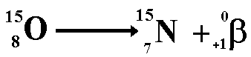Note: atomic number decreases by one and mass number remains the same

Gamma Radiation

* 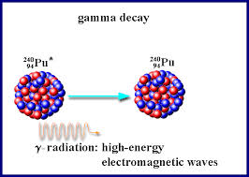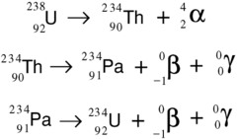A **\_\_\_\_\_\_\_\_\_\_\_\_\_\_\_\_\_\_\_\_\_\_\_\_\_\_\_** is a high-energy photon emitted by a radioisotope. Often are emitted along with alpha and beta particles.
* 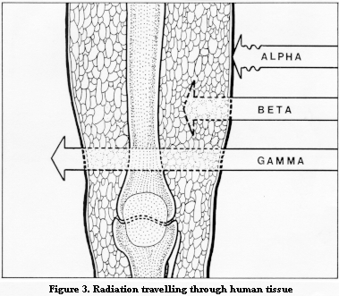Gamma radiation doesn’t have a positive or negative charge. Gamma rays are similar to X-rays, but they have even greater energy. Gamma radiation can only be stopped by a thick layer of lead or concrete.

Penetrating Power

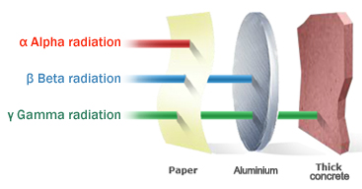

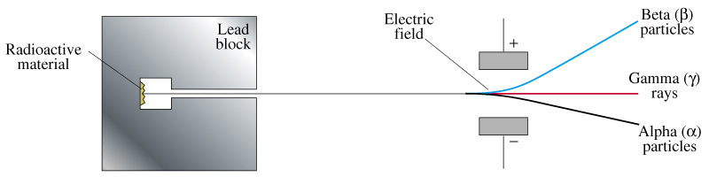Separating Alpha, Beta, and Gamma Particles

* Alpha and beta particles are deflected in opposite directions- alpha particles toward the negative plate and beta particles toward the positive plate. Gamma rays are undeflected.

Balanacing Nuclear Equations

Note: when an atom loses an alpha particle, the atomic number is lowered by two and the mass number is lowered by four.

* What particle is represented by X in the following equation?

+ 🡪 + X

* Step 1: Label known and unknown
  + Known- charge and mass numbers for Al, neutron, and Na
  + Unknown- X=?
* Step 2: Balance charge on both sides of the equation
  + The sum of the charges on the left is 13; therefore, the sum on the right must also be 13. Na accounts for 11, so X must have a charge of 2.
* Step 3: Balance mass numbers on both sides
  + The sum of mass numbers on the right is 28; therefore, the sum on the left should also be 28. Na accounts for 24, so X must have a mass of 4.
  + X is an alpha particle. It has an atomic number of 2 and a mass number of 4

Practice – Use TABLE O to help you



Summary

|  |  |  |  |  |
| --- | --- | --- | --- | --- |
| **Property** | **Alpha Radiation** | **Beta Radiation** | **Gama Radiation** | **Positron Radiation** |
| **Composition** | Alpha particle (helium nucleus) | Beta particle  (electron | High-energy electromagnetic radiation | Positron particle |
| **Symbol** | http://www.chem.wisc.edu/deptfiles/genchem/sstutorial/Text4/Tx45/He.gif |  | ϒ |  |
| **Charge** | 2+ | 1- | 0 | 1+ |
| **Mann (amu)** | 4 | 1/1937 | 0 | 1/1837 |
| **Common Source** | Radium-226 | Carbon-14 | Cobalt-60 |  |
| **Penetrating Power** | Low | Moderate | Very High | Very Low |
| **Shielding** | Paper, clothing | Metal foil | Lead, concrete |  |

Additional Regents Practice – Use Table N and Table O to help you!

1. A sample of which radioisotope emits particles having the greatest mass
   1. 137Cs
   2. 53Fe
   3. 220Fr
   4. 3H
2. Given the equation representing a nuclear reaction in which *X* represents a nuclide:

/var/folders/j7/5s13v6gd0lz3q44fv84z6_qm0000gn/T/com.microsoft.Word/Content.MSO/EBC4C3B8.tmp

Which nuclide is represented by *X*?

1. /var/folders/j7/5s13v6gd0lz3q44fv84z6_qm0000gn/T/com.microsoft.Word/Content.MSO/B394BA86.tmp b. /var/folders/j7/5s13v6gd0lz3q44fv84z6_qm0000gn/T/com.microsoft.Word/Content.MSO/D7A0B084.tmp c. /var/folders/j7/5s13v6gd0lz3q44fv84z6_qm0000gn/T/com.microsoft.Word/Content.MSO/917D5D32.tmp d. /var/folders/j7/5s13v6gd0lz3q44fv84z6_qm0000gn/T/com.microsoft.Word/Content.MSO/FA49E410.tmp
2. Positrons and beta particles have
   1. The same charge and the same mass
   2. The same charge and different masses
   3. Different charges and the same mass
   4. Different charges and different masses
3. Which two radioisotopes have the same decay mode
   1. 37Ca and  53Fe
   2. 220Fr and  60Co
   3. 37K and  42K
   4. 99Tc and  19Ne
4. Which nuclear emission has the greatest penetrating power?
   1. Proton
   2. Beta particle
   3. Gamma radiation
   4. Positron