Naming/Drawing Functional Groups
YOYO: Below is a picture of capsaicin, the molecule responsible for giving chili peppers their spicy taste. Using Table R, circle and label the functional groups. (Each point represents a carbon)

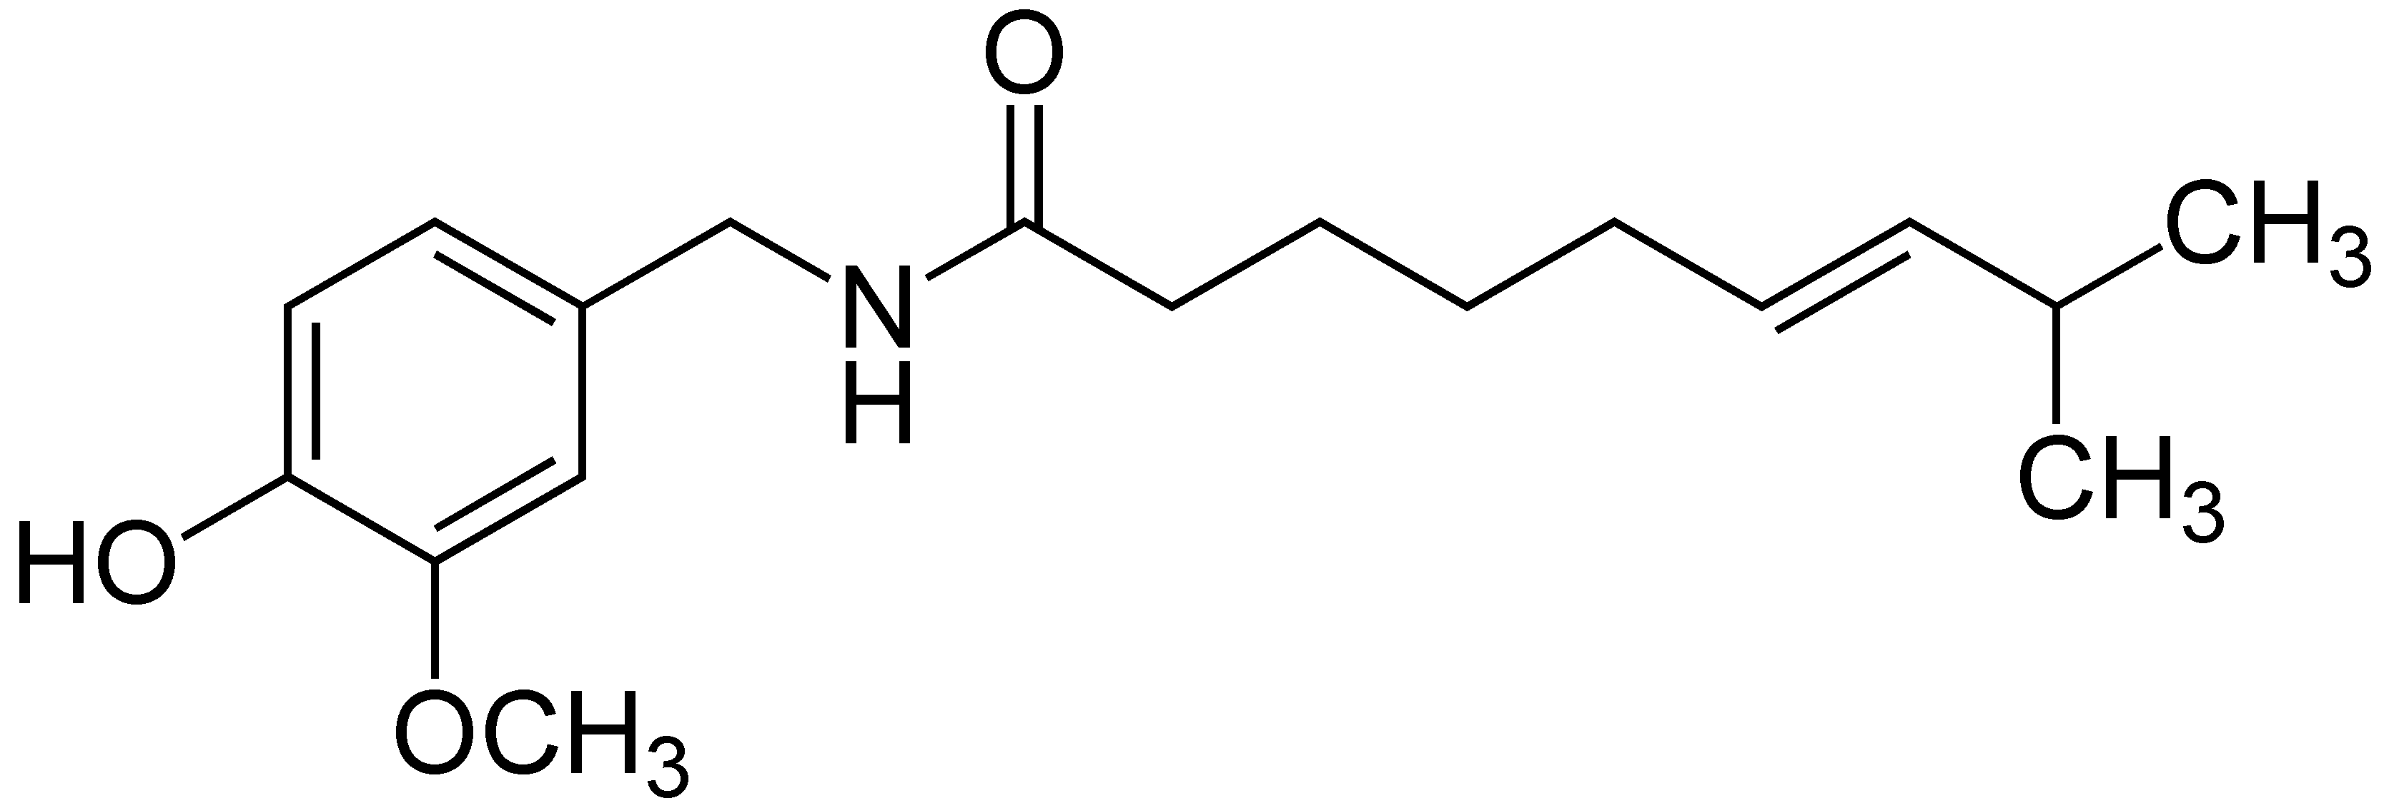
What are Functional Groups?
- Functional groups are a group of moles that are attached to organic molecules. The functional groups give the molecule its properties, regardless of what molecule contains it. Different functional groups have different physical and chemical properties.

Naming Functional Groups
Halides  - Have one or more of the halogens as a branched group  - Naming Rules:  - Name the chain  - Add the halogen prefix  - Add location of the halogen  - Condensed Formula: CH₃CHClCH₂CH₂CH₃  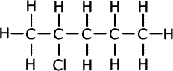  - Name: __________________________________ | Alcohols  - The functional groups is (-OH)  - Naming Rules:  - Name the chain  - Add the –ol ending  - Add the location of the –OH  - Condensed Formula: CH₃CH₂OH  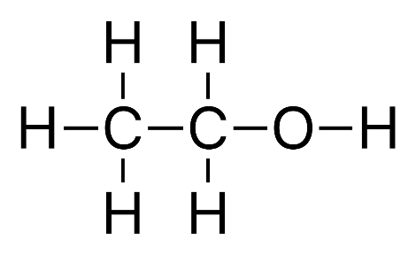  - Name: __________________________________
Ether  - Ethers are made up of two carbon chains connected by an O in the middle  - Naming Rules:  - Identify the two chains and name them separately  - Use Table P for the prefix, and use –yl as the suffix  - Add the word ether at the end  - Condensed Formula: CH₃OCH₂CH₃  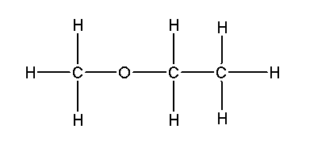  - Name: __________________________________ | Aldehyde  - The aldehyde functional group is a C with a double bond O and an H at the end of the molecule  - Naming Rules:  - Name the chain  - Add –al suffix (this is always at the end of the molecule, there is no need to add the location)  - Condensed Formula: CH₃CH₂CH₂CH₂CH₂CH₂CHO  - Name: __________________________________
Ketones  - Ketones have a C double bonded to an O somewhere in the middle of the compound  - Naming Rules:  - Name the chain  - Add the suffix –one  - Add the location of the functional group  - Condensed Formula: CH₃COCH₃  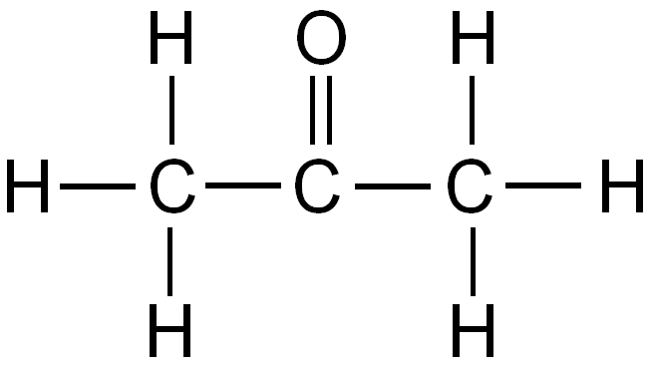  - Name: __________________________________ | Organic Acids  - Organic acids can easily be identified by the –COOH group at the end of the molecule  - Naming Rules:  - Name chain  - Drop the ending and add –oic acid  - Condensed Formula: CH₃COOH  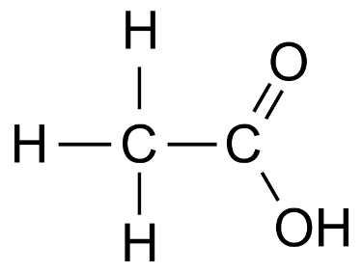  - Name: __________________________________
Amines  - Amines can be identified by a single N somewhere in the compound  - Naming Rules:  - Name the chain  - Add the suffix –amine  - Give the location of the N  - Condensed Formula: CH₃CHN₂CH₂CH₂CH₂CH₂CH₃  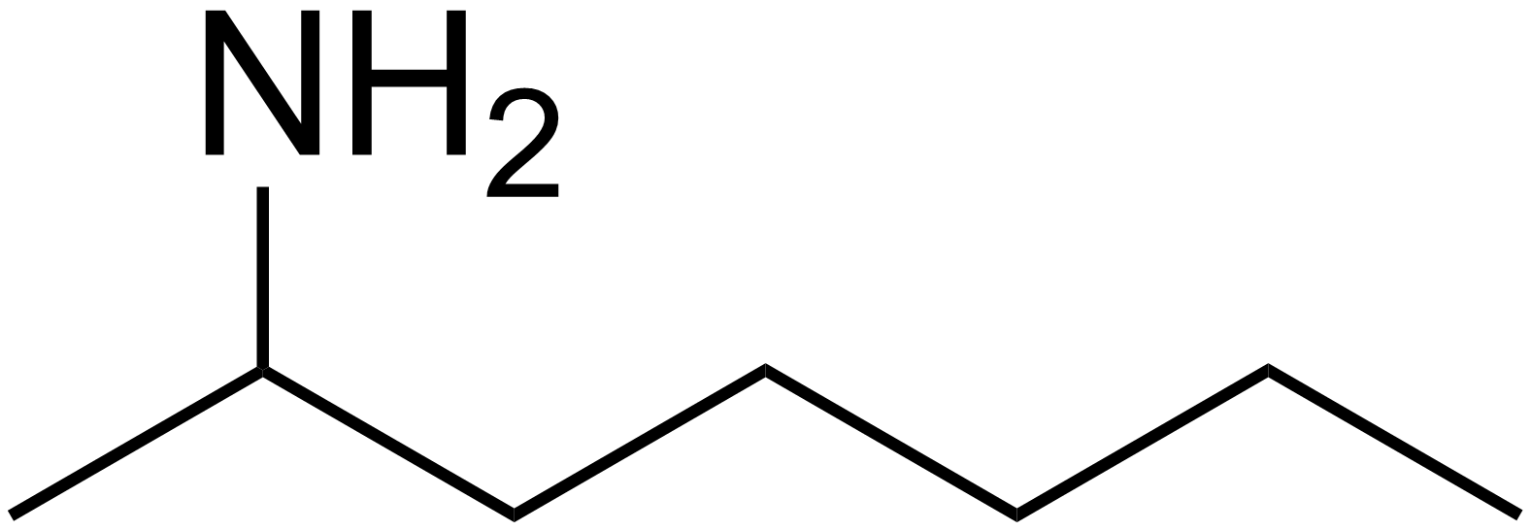  - Name: _________________________________ | Amides  - Amides also have an N, but the N must be connected to an H and a C which is double bonded to an O  - Naming Rules:  - Name the chain  - Add the suffix –amide  - Condensed Formula: CH₃CH₂CH₂CH₂CONH₂  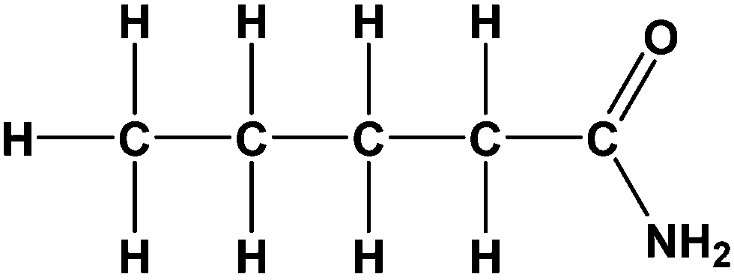  - Name: __________________________________
Esters
- Esters are the products of a reaction between an organic acid and an alcohol
- They can be identified by the C double bonded to an O and another O somewhere in the compound
- Naming Rules:
  - Name the chain bonded to the O first and add the –yl suffix
  - Name the chain with the double bond =O last and add the suffix –oate
- Condensed Formula: CH₃CH₃COOCH₂CH₂CH₃
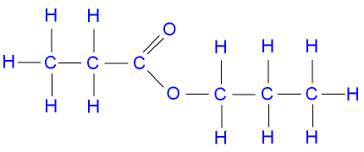

- Name: _______________________________________

