Naming & Drawing Hydrocarbons
YOYO: Answer the following questions.
Which compound is a saturated hydrocarbon?  - CH₂CH₂  - CH₃CH₃  - CH₃CHO  - CH₃CH₂OH | Which represents an unsaturated hydrocarbon?  - C₂H₄  - C₃H₈  - C₄H₁₀  - C₅H₁₂  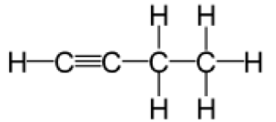 | Which general formula represents the compound CH₃CH₂CCH  - C_{n}H_{n}  - C_{n}H_{2n}  - C_{n}H_{2n-2}  - C_{n}H_{2n+2}

Straight Chain Alkanes
- Also referred to as n-alkanes (“normal” alkanes); example = n-hexane
- General Rule for Naming Straight Chain Alkanes use prefix (Table P) to tell you how many carbon atoms you have then add the suffix “-ane”

Name: Pentane  Chemical Formula:  Structural Formula: | Name: Butane  Chemical Formula:  Structural Formula:

Branched Alkanes
- Branched = not a straight continuous chain; organic molecule that has smaller branches coming off a longer continuous chain
- *How can you tell if it’s “branched”? You can’t run your finger along all the carbons in one “sweep” (you hit dead-ends and have to turn around and retrace part/some of your path); because of this we must establish a “parent chain” or main backbone in order to name the molecule
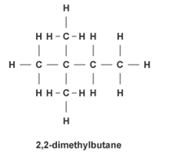
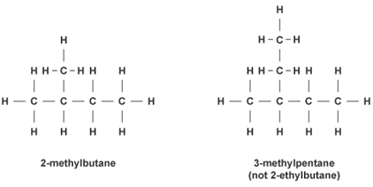

Methyl and Ethyl Groups
- Methyl and ethyl groups are common branches on organic compounds
Methyl Group | Ethyl Group
Naming Branched Alkanes
- Locate the longest possible carbon chain (parent chain) in molecule. Any carbons coming off this chain are the branches. Number the carbons in the parent chain so that the branch(es) fall at the lowest possible number/sum
- Name the branches first (separately, in alphabetical order as per their prefix) along with the # of the C they are on.
  - Prefix based on the # C’s (table P) + suffix –yl
- Branches are named separately unless there are two of the same. If this is the case, lump them into the same branch name (w/ number locations) & add appropriate prefix (di, tri, tetra, etc.) depending on how many C’s in branch.
- The parent chain is stated last in the name (the # carbons in parent chain should agree with the prefix in the last word of the chemical name).

Name:  Structural Formula: | Name:  Structural Formula:
Name:  Structural Formula: | Name: 4-ethyl heptane  Structural Formula:
Name: 2-methyl butane  Structural Formula: | Name: 2-methyl pentane  Structural Formula:
Straight Chain Alkenes
- Number the lowest # carbon where the double bond is located, then add the suffix “-ene” to the name (prefix should refer to the number of C’s)
Name:  Structural Formula: | Name:  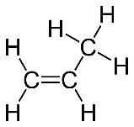  Structural Formula:
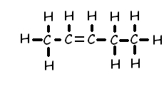  Name: 3-hexene  Structural Formula: | Name: 4-decene  Structural Formula:

Straight Chain Alkynes
- State the lowest carbon # where the triple bond is located then add the suffix “-yne”
Name:  Structural Formula:  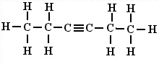 | Name:  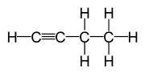  Structural Formula:
Name: 2-pentyne  Structural Formula: | Name: 3-heptyne  Structural Formula:
Practice Regents Short Answer Questions
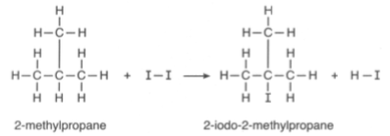
- Base your answer to the following question on the information below
The hydrocarbon 2-methylpropane reacts with iodine as represented by the balanced equation below. At standard pressure, the boiling point of 2-methylpropane is lower than the boiling point of 2-iodo-2-methylpropane. Explain, in terms of bonding, why the hydrocarbon 2-methylpropane is saturated.

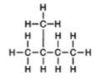

- Base your answer to the following question on the information below.
The formula below represents a hydrocarbon.
Explain, in terms of carbon-carbon bonds, why this hydrocarbon is saturated.

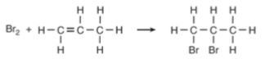
- Base your answer to the following question on the information below.
A reaction between bromine and a hydrocarbon is represented by the balanced equation below.
Write the name of the homologous series to which the hydrocarbon belongs.

- Base your answer to the following question on the information below.
Gasoline is a mixture composed primarily of hydrocarbons such as isooctane, which is also known as 2,2,4-trimethylpentane. Gasoline is assigned a number called an octane rating. Gasoline with an octane rating of 87 performs the same as a mixture that consists of 87% isooctane and 13% heptane.
An alternative fuel, E-85, can be used in some automobiles. This fuel is a mixture of 85% ethanol and 15% gasoline. In the space below, draw a structural formula for a molecule of 2,2,4-trimethylpentane.

