Motorcycle Hit-and-Run

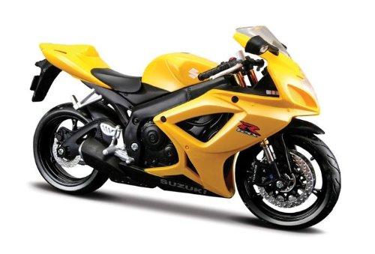
What happened: Tyler was standing in line to order his morning coffee at his favorite coffee truck, when all of a sudden, a motorcycle quickly appeared and stopped short right in front of Tyler. The masked person in the motorcycle stole Tyler’s wallet and zoomed off. Witlessness called the cops. When the cops arrived, they took statements from Tyler and with nearby witnesses. Everyone agreed the thief was riding a yellow motorcycle. Cops looked into all the yellow motorcycles in the town. Good thing there were only four. Police collected tire prints from each of the four motorcycles.

Your task: Analyze the print given to you, and record details about the pattern. Try sketching or tracing the print for your records. Work with your team to gain information on all 4 prints. Once all four tracks are analyzed by your group, send a representative from your team to receive a photo of the print recovered from the scene. Using your forensic investigative skills, determine which bike was at the scene.

Tire Track | Description | Sketch
Suspect #1
Suspect #2
Suspect #3
Suspect #4
Crime Scene

