Mid-Solutions Unit Review

Types of Matter Review

- Questions:
  - Which formula represents a mixture?

    - C₆H₁₂O_{6(l)}
    - C₆H₁₂O_{6(s)}
    - LiCl_{(aq)}
    - LiCl_{(s)}

  - A dilute, aqueous potassium nitrate solution is best classified as a

    - Homogenous compound
    - Homogeneous mixture
    - Heterogeneous compound
    - Heterogeneous mixture

  - Which must be a mixture of substances

    - Solid b. Liquid c. Solution d. Gas

Separation Techniques
Technique | Separates | (What does it separate?) | Based on | Property
Evaporation | separates |  | based on
Filtration | separates |  | based on
Distillation | separates |  | based on
Chromatography | separates |  | based on
- Questions:
  - A mixture of crystals of salt and sugar is added to water and stirred until all solids have dissolved. Which statement best describes the resulting mixture?
    - The mixture is homogeneous and can be separated by filtration.
    - The mixture is homogeneous and cannot be separated by filtration.
    - The mixture is heterogeneous and can be separated by filtration.
    - The mixture is heterogeneous and cannot be separated by filtration.

  - When a mixture of water, sand, and salt is filtered, what passes through the filter paper?

    - Water only
    - Water and sand only
    - Water and salt only
    - Water, sand, and salt

  - When sample X is passed through a filter paper a white residue, Y, remains on the paper and a clear liquid, Z, passes through. When liquid Z is vaporized, another white residue remains. Sample X is best classified as

    - An element
    - A compound
    - A heterogeneous mixture
    - A homogeneous mixture
Factors That Affect Solubility
Factors That Affect Solubility | Effect on Gases | Effect on Solids/Liquids
Increase Temperature
Decrease Temperature
Increase Pressure
Decrease Pressure
Increase Surface Area
Decrease Surface Area
Increase Agitation/Stirring
Decrease Agitation/Stirring
Increase Particle Size
Decrease Particle Size

Nature of Solvent (does the dissolving) |  | Nature of Solute (what gets dissolved)
Ionic | dissolves
Polar | dissolves
Non-polar | dissolves
- Note: nature or solute and solvent, temperature, and pressure, affect how MUCH of something can be dissolved and surface area and stirring affects how FAST something dissolves
- Questions:
  - Under which conditions of temperature and pressure is a gas most soluble in water?
    - High temperature and low pressure
    - High temperature and high pressure
    - Low temperature and low pressure
    - Low temperature and high pressure

  - The solubility of KCl(s) in water depends on the

    - Pressure of the solution
    - Rate of stirring
    - Size of the KCl sample
    - Temperature of the water

  - At room temperature, the solubility of which solute on water would be most affected by a change in pressure?

    - Methanol
    - Sugar
    - Carbon dioxide
    - Sodium nitrate

Table F: Solubility Guidelines for Aqueous Solutions
- Compounds containing alkali metal cations or the ammonium ion (NH₄⁺) are soluble
- Compounds containing nitrate (NO₃⁻), chlorate (ClO₃⁻), and acetate (C₂H₃O₂ ⁻ ) anions are soluble.
- Chlorides, bromides, and iodides are soluble except those containing Ag⁺, Pb²⁺, or Hg₂ ²⁺
- Sulfates are soluble except those containing Hg₂²⁺, Pb²⁺, Sr²⁺, Ca² ⁺, or Ba²⁺
- Hydroxides (OH) are insoluble except compounds of the alkali metals, Ca²⁺, Sr²⁺, and Ba²⁺
- Compounds containing PO₄ ³⁻, S²⁻, CO₃ ²⁻, SO₃ ²⁻ ions are insoluble except those that also contain alkali metals or NH₄ ⁺
- Compounds that are ________________________ (can dissolve) are also __________________________ meaning they can conduct electricity
- Compounds that are ________________________ (cannot dissolve) are also _______________________ meaning they cannot conduct electricity

- 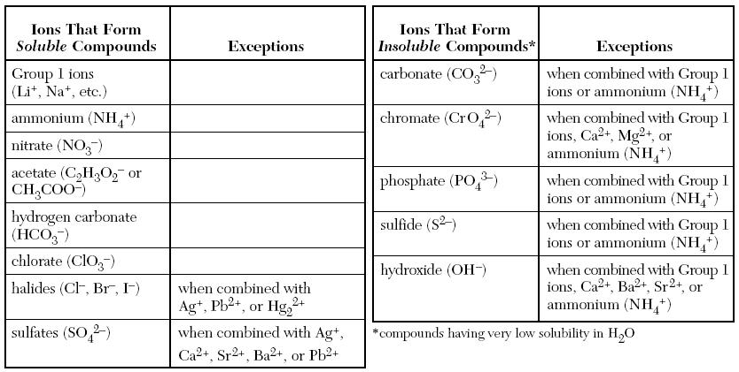Questions:
  - When PbI₂(s) is added to Na₂CO₃(aq), a white precipitate is formed. According to Reference Table F, the white precipitate most likely is

    - KNO₃
    - PbCO₃
    - NaI
    - Na₂CO₃

  - Which precipitate does the reaction Ba(NO₃)_{2(aq)} + Na₂SO_{4(aq)} 2 NaNO_{3(aq)} + BaSO_{4(s),} form?

    - Nitrogen
    - Barium sulfate
    - Barium nitrate
    - Soluble salt

  - Based on Reference Table F, which of these saturated solutions has the lowest concentration of dissolved ions?

    - NaCl_{(aq)}
    - MgCl_{2(aq)}
    - NiCl_{2(aq)}
    - AgCl_{(aq)}

Table G: Solubility Curves at Standard Pressure
- Table G is a graph that shows the solubility of numerous solutes and their ability to dissolve in 100 g of H₂O
        - 1 g H₂O = 1 mL H₂O
- Each curve represents the greatest amount of solute that can dissolve at the given temperature which is known as _________________________
- Measurements below the curve are known as ______________________ because more solute can be dissolved.
- Measurements on the curve are known as ______________________ because no more solute can be dissolved at the given conditions and still be a stable solution.
- Measurements above the curve are known as ______________________ because an unstable solution as formed, and the excess solute will crystallize or precipitate out of solution
- Since the graph is based on 100 g of water, if the question asks about 200 g of water, you must ___________________ your answer.
- Since the graph is based on 100 g of water, if the question asks about 50 g of water, you must ____________________ your answer.
- The amount of substance that precipitates out of solution can be measured by taking data from both temperatures and calculating the difference.
- Questions:
  - Based on the graph, how much KNO₃ can dissolve in 100g of H₂O at 20°C? ________________
  - Based on the graph, how much KNO₃ can dissolve in 50g of H₂O at 60°C? ________________
  - Based on the graph, how much KCl can dissolve in 200g of H₂O at 90°C? ________________
  - In 100g of H₂O, how many grams of NH₄Cl will precipitate out of solution if the temperature decreases from 80°C to 50°C? ________________
  - 72g of NH₄Cl at 90°C represents what type of solution? _____________________________
  - 10g of NH₃ at 70°C represents what type of solution? _____________________________
  - 90g of HCl at 50°C represents what type of solution? _____________________________
  - Based on Reference Table G, what is the maximum number of grams of KCl_{(s)} that will dissolve in 200 grams of water at 50°C to produce a saturated solution?
    - 38 g b. 42 g c. 58 g d. 84 g

  - How many grams of KCl must be dissolved in 200 grams of water to make a saturated solution at 60 ºC?
    - 30 g b. 45 g c. 56 g d. 90 g

  - Which is a saturated solution?
    - 40 g NH₄Cl in 100 g water at 50 ºC
    - 2 g SO₂ in 100 g water at 10 ºC
    - 52 g KCl in 100 g water at 80 ºC
    - 120 g KI in 100 g water at 20 ºC
