Hemoglobin Equilibrium
Read and watch the Videos on the following links
https://fmss12ucheme.wordpress.com/2013/05/04/hemoglobin-equilibrium/
https://fmss12ucheme.wordpress.com/2013/05/07/hemoglobin-equilibrium-2/
http://www.digipac.ca/chemical/mtom/contents/chapter3/altitude.htm
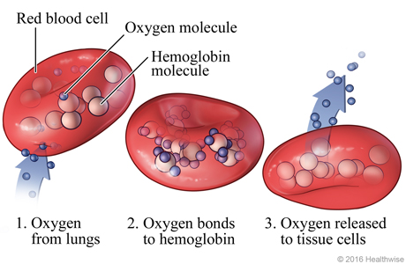
Summary: Blood transports oxygen from your lungs to your muscles. In the lungs, the oxygen combines with the hemoglobin, forming the hemoglobin-oxygen complex. The hemoglobin is able to transport the bound oxygen to tissue cells. At the tissue cells, the oxygen is released from the hemoglobin so the muscles can now do work. The hemoglobin (free of oxygen) is transported back to the lungs and the cycle continues.
Directions: Answer the following questions based on your knowledge of Le Châtelier’s principle and the articles you read.
Hemoglobin (HHb) binds with oxygen gas (O₂) to form hemoglobin-oxygen complex Hb(O₂)₄ to transport oxygen to tissue in muscles. Forward reaction occurs in the lungs, and the reverse reaction is occurs in the tissue of muscles.
HHb(aq) + 4 O₂(g) Hb(O₂)₄ (aq) + H⁺(aq) + energy

- Assuming that there is a constant partial pressure for oxygen, according to Le Châtelier’s Principle which of the following occurs when body temperature decreases during hypothermia?
  - The amount of oxygen will increase.
  - The amount of oxygen will decrease.
  - The amount of oxygen will not change.
Because __________________________________________________________________________________________________ ______________________________________________________________________________________________________________________________________________________________________________________________________________________________________________________________________________________________________
- Predict the ability of hemoglobin to hold the bound oxygen under conditions of increased blood acidity (H⁺ increases)

- Using Le Châtelier’s principle, explain why at high altitudes (lower atmospheric pressure) it is more difficult to obtain oxygenated hemoglobin Hb(O₂)₄ compared to at sea level (higher atmospheric pressure).

- The bond between hemoglobin and carbon monoxide is a lot stronger than the bond between hemoglobin and oxygen. If exposed to carbon monoxide, hemoglobin will bind to carbon monoxide instead of oxygen, causing carbon monoxide poisoning from the production of Hb(CO)₄(aq).

Hb(O₂)₄ (aq) + 4 CO (g) Hb(CO)₄ (aq) + 4 O₂ (g)

Using Le Châtelier’s Principle, explain why people suffering from carbon monoxide poisoning are given pure oxygen to breathe in order to reverse the poisoning?

