Isomers
YOYO: On a separate paper, draw as many different structures using the formula C₅H₁₂. Each compound you draw must have 5 carbons and 12 hydrogens.

What is an isomer?
- Isomers are compounds with the same chemical formula, but different molecular structures.
- A good tip: If you are not sure if something is an isomer, name it. If it has a different name then the original compound, it IS an isomer. If the name is the same, it is NOT and isomer. Some things may looks like isomers but aren’t actually.

Are These Isomers?
Compound 1 | Compound 2 | Are these isomers? Explain.
Formula:  _______________________________  Name: _______________________________ | Formula:  _______________________________  Name: _______________________________

Compound 1 | Compound 2 | Are these isomers? Explain.
Formula:  _______________________________  Name: _______________________________ | Formula:  _______________________________  Name: _______________________________

Check Point Question:
- Are these pictures of Mr. Potato Head Considered to be isomers? Explain in terms of structure.

- Are these pictures of Mr. and Mrs. Potato Head Considered to be isomers? Explain in terms of structure.

Creating Alkane Isomers
- Use the same molecular formula
- Draw a different structural formula
  - If the name of the compound is different but it has the same molecular formula, it is an isomer.
Original Compound | Isomer #1 | Isomer #2
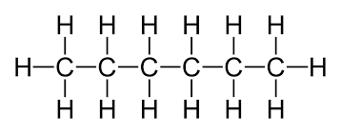  Molecular Formula: ___________  Compound Name:  ______________________________ | Molecular Formula: ___________  Compound Name:  ______________________________ | Molecular Formula: ___________  Compound Name:  ______________________________

Original Compound | Isomer #1 | Isomer #2
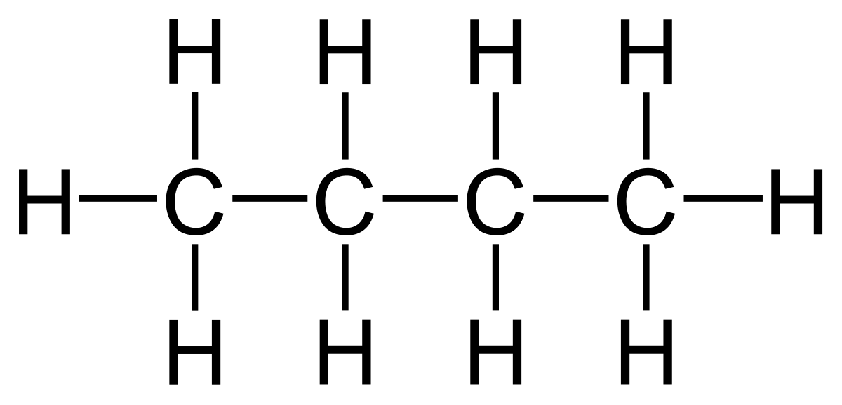  Molecular Formula: ___________  Compound Name:  ______________________________ | Molecular Formula: ___________  Compound Name:  ______________________________ | Molecular Formula: ___________  Compound Name:  ______________________________

Original Compound | Isomer #1 | Isomer #2
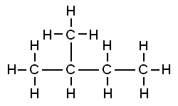  Molecular Formula: ___________  Compound Name:  ______________________________ | Molecular Formula: ___________  Compound Name:  ______________________________ | Molecular Formula: ___________  Compound Name:  ______________________________
Creating Alkene and Alkyne Isomers
- Use the same molecular formula
- Move the location of the double or triple bond
  - NOTE: Be careful not to move it into the same position. Remember you can read compounds left to right or right to left.
- Original Compound | Isomer #1 | Isomer #2
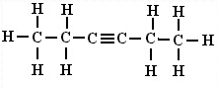  Molecular Formula: ___________  Compound Name:  ______________________________ | Molecular Formula: ___________  Compound Name:  ______________________________ | Molecular Formula: ___________  Compound Name:  ______________________________

Original Compound | Isomer #1 | Isomer #2
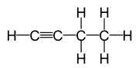  Molecular Formula: ___________  Compound Name:  ______________________________ | Molecular Formula: ___________  Compound Name:  ______________________________ | Molecular Formula: ___________  Compound Name:  ______________________________

Original Compound | Isomer #1 | Isomer #2
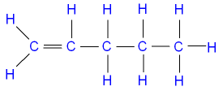  Molecular Formula: ___________  Compound Name:  ______________________________ | Molecular Formula: ___________  Compound Name:  ______________________________ | Molecular Formula: ___________  Compound Name:  ______________________________
Creating Isomers with Functional Groups
- Use the same molecular formula
- Move the location of the functional group (if possible) or shift part of a carbon chain.
- These are a bit more challenging, and only basic isomers with functional groups will be asked.

Original Compound | Isomer #1 | Isomer #2
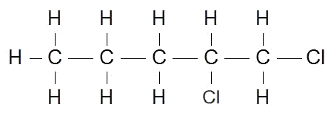  Molecular Formula: ___________  Compound Name:  ______________________________ | Molecular Formula: ___________  Compound Name:  ______________________________ | Molecular Formula: ___________  Compound Name:  ______________________________

Original Compound | Isomer #1 | Isomer #2
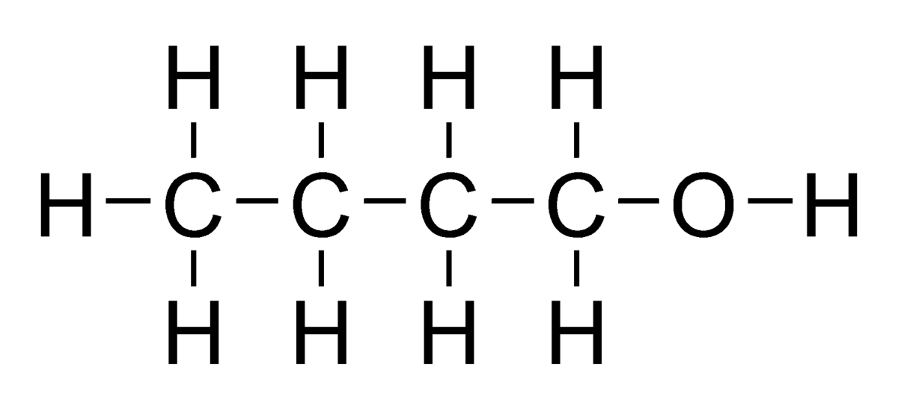  Molecular Formula: ___________  Compound Name:  ______________________________ | Molecular Formula: ___________  Compound Name:  ______________________________ | Molecular Formula: ___________  Compound Name:  ______________________________

Original Compound | Isomer #1 | Isomer #2
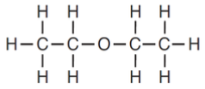  Molecular Formula: ___________  Compound Name:  ______________________________ | Molecular Formula: ___________  Compound Name:  ______________________________ | Molecular Formula: ___________  Compound Name:  ______________________________

