Introduction to Gases
Gases are tremendously compressible, can exert massive pressures, expand nearly instantaneously into a vacuum, and fill every container they are placed in regardless of size. All of these properties of gases are due to their molecular arrangement.

Gases Readily Change Volume
In dealing with gases, we lose the meaning of the word “full.” A glass of water may be 1/4 full or 1/2 full or full, but a container containing a gaseous substance is always full. The same amount of gas will fill a quart jar, or a gallon jug, a barrel, or a house. The gas molecules separate farther from each other and spread out uniformly until they fill whatever container they are in. Gases can be compressed to small fractions of their original volume and expand to fill virtually any volume. If gas molecules are pushed together to the point that they touch, the substance would then be in the liquid form. One method of converting a gas to a liquid is to cool it and another method is to compress it.

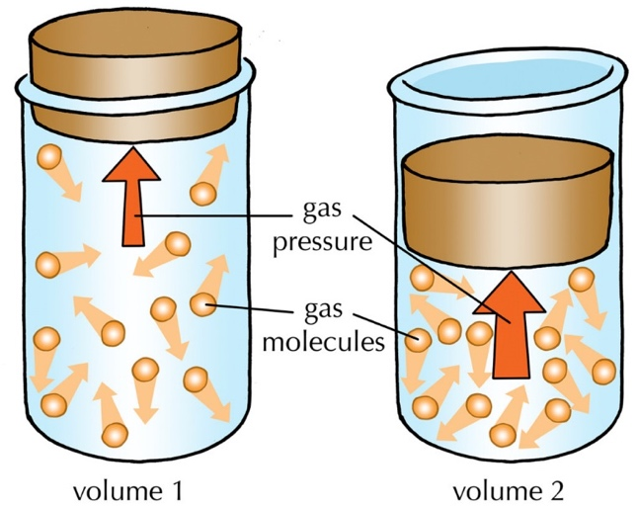
Gases Exert Pressure
The constant random motion of the gas molecules causes them to collide with each other and with the walls of their container. These collisions of gas molecules with their surroundings exert a pressure on the surroundings. The more collisions, or the greater the frequency of the collisions, increases the pressure exerted by the gas. When you blow up a balloon, the air particles inside the balloon push against the elastic sides, the walls of the balloon are pushed outward and kept firm. This pressure is produced by air molecules pounding on the inside walls of the balloon.
Atmospheric pressure results from the collisions of atoms and molecules in the air with objects. The atmosphere is always applying a pressure on us. Units of pressure include Pascal (Pa), atmosphere (atm), and millimeters of mercury (mmHg).

Gas Temperature and Kinetic Energy
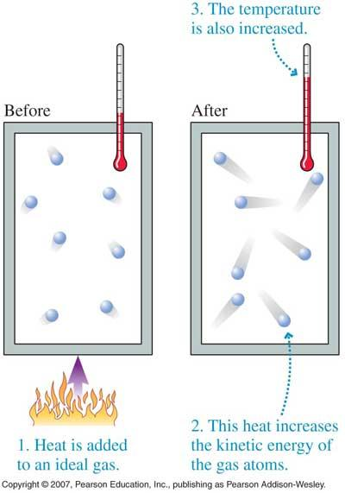
Kinetic energy is the energy of motion and therefore, all moving objects contain kinetic energy. The mathematical formula for calculating the kinetic energy of an object is KE=1/2mv². This physics formula applies to all objects in exactly the same way whether we are talking about the moon moving in its orbit, a baseball flying toward home plate, or a gas molecule banging around in a bottle. All of these objects have kinetic energy and their kinetic energies can all be calculated with the same formula. As you can see from the formula, the kinetic energy is dependent on both the mass of the object and the velocity of the object. You should note that if the mass of an object is doubled while its velocity remains the same, the kinetic energy of the object would also be doubled. If, on the other hand, the velocity is doubled while the mass remains the same, the kinetic energy would be quadrupled because of the square in the formula.

It was mentioned at the beginning of this lesson that the molecular motion of molecules is related to their temperature. If you think of the average kinetic energy of a group of molecules and temperature measured in degrees Kelvin, the relationship is a direct proportion. When you measure the temperature of a group of molecules, what you are actually measuring is their average kinetic energy. They are the same thing but expressed in different units. When a substance is heated, the average kinetic energy of the molecules increases. Since the mass of the molecules cannot be increased by heating, it is clear that the velocity of the molecules is increasing. If the temperature of the molecules increases, the kinetic energy increases, and so does the velocity of the molecules.

It is absolutely vital that you keep in mind that the mathematical relationship between the temperature and the average kinetic energy of molecules only exists when the temperature is expressed in the Kelvin scale.
K = ºC + 273

Lesson Summary
- Gases are composed of tiny particles called molecules.
- Molecules of a gas are so far apart, on average, that the volume of the molecules themselves in negligible compared to the volume of the gas.
- Gas molecules are in constant, random, straight-line motion that is constantly interrupted by collisions with other molecules or with container walls.
- Molecular collisions with container walls cause the gas to exert pressure.

Questions
Directions: Answer the following questions below and submit for a grade.
Carbon dioxide
- Draw a particle diagram to represent at least 5 molecules of CO₂ in the gas phase. Use a solid sphere to represent the carbon atom, and a white sphere to represent the oxygen atom.

- Based on your knowledge of chemistry, explain why the following statement is true; “The same amount of gas will fill a quart jar, or a gallon jug, a barrel, or a house.

- Define gas pressure.

- What is kinetic energy?

- Define temperature.

- State the relationship between:
  - Kinetic energy and velocity of a gas:

  - Kinetic energy and temperature of a gas:

  - Temperature and velocity of a gas:

- Predict and explain the effect of temperature on gas pressure. If a gas is heated, how will the pressure exerted on the walls of a fixed container be effected?

