**Introduction to Organic Chemistry**

What is Organic Chemistry?

* Organic Chemistry: the study of compounds that contain __________ and _____________

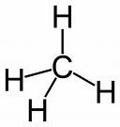

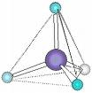Why is carbon so special?

* Carbon has ________________________________
* These four single bonds spread out evenly to create a ____________ molecule (like a tripod)
* Carbon atoms ____________ with other carbon atoms, forming ___________________________, ____________, and ________________
* Two adjacent carbon atoms can share up to ____________________
* 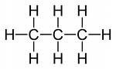Each shared pair of electrons is represented by a _______________

What are hydrocarbons?

* Hydrocarbons – organic molecules that contain only ___________ & ____________
* Saturated Hydrocarbons - all _______________________ between carbons
  + 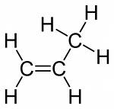 _____________ number of ________________ attached (the same way a saturated solution holds the maximum amount of solute)
  + Single dash line (______) 🡪 _______________________ ____________________/____________ make up bonds (______)
* Unsaturated Hydrocarbons - at least one ___________________ in carbon chain
  + Two dash lines(______) 🡪 _______________________
    - 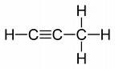____________________/____________ make up bonds (______)
      * Example:
  + Three dash lines (______) 🡪 _______________________
    - ____________________/____________ make up bonds (______)

Properties of Organic Compounds

* Bonding: ______________ 🡪 _____________ + _____________
* Solubility: most are _____________ in water (generally ____________) *___________________________________
* Conductivity: mostly _____________________ (s), (l), & (aq) states *Only __________________________ in solution = __________________
* Melting/boiling points: _____________ 🡪____________________
* Reactivity Rate: react ________________________; more bonds to break

Types Of Chemical Formulas

* Molecular Formula: shows the ______________ of each _________ in a compound; least informative formula
* Structural Formula: shows the ______________ of each _________ AND the _____________ of the _______; most informative formula
* Condensed Formula = each carbon is written with its constituent hydrogens followed by the proper subscript

Open-Chained (Aliphatic)

|  |  |  |  |
| --- | --- | --- | --- |
| Structural Formula |  |  |  |
| Condensed Formula |  |  |  |
| Molecular Formula |  |  |  |

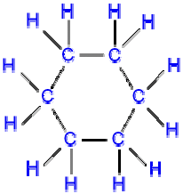

Closed-Chained (Aromatic)

* When drawing organic compounds you MUST always have 8e- around each atom! ** EXCEPTION: Hydrogen (H) achieves its “octet” with only 2e- around it.

Table Q: Homologous Series of Hydrocarbons

* Homologous series: a group of ______________________ in which each member differs from the one before it by _________________
* Note (above): there are always 4 bonds (8 electrons) around carbon & H can only have one bond around it (2 electrons)

Drawing Alk*anes*

* An organic compound ending in “-ane” represents a simple hydrocarbon chain with single bonds
* Use Table P to correctly match the number of carbons and the proper prefix

Drawing Practice: Determine the molecular formula, condensed formula, and structural formula

|  |  |
| --- | --- |
| Structural Formula:  Compound Name:______________________________  Condensed Formula: ___________________________  Molecular Formula: C4H10 | Structural Formula:  Compound Name: Hexane  Condensed Formula: ___________________________  Molecular Formula: ________________ |
| Structural Formula:  Compound Name:______________________________  Condensed Formula: CH3CH2CH2CH2CH3  Molecular Formula: ________________ | Image result for methaneStructural Formula:  Compound Name:______________________________  Condensed Formula: ___________________________  Molecular Formula: ________________ |