Introduction to Electrochemical Cells
In redox reactions, there is a chemical reaction and an exchange of electrons between the particles being oxidized and reduced. One practical use of such a reaction is in an electrochemical cell. An electrochemical cell involves a chemical reaction and a flow of electrons.
There are two common types of electrochemical cells. A voltaic cell is an electrochemical cell in which a spontaneous chemical reaction produces a flow of electrons (chemical energy is converted to electrical energy-electricity). An electrolytic cell requires an electric current to force a nonspontaneous chemical reaction to occur (electrical energy – electricity- is converted into chemical energy).
Electrochemical cells have two surfaces called electrodes that conduct electricity. An electrode is the site at which oxidation or reduction occurs. The electrode at which oxidation occurs is called the anode. The electrode at which reduction occurs is called the cathode.
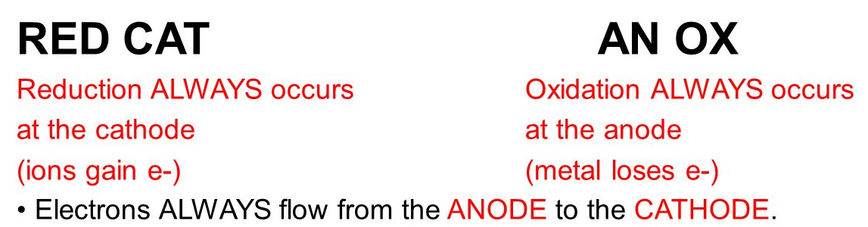
Spontaneous Reactions – Voltaic Cells
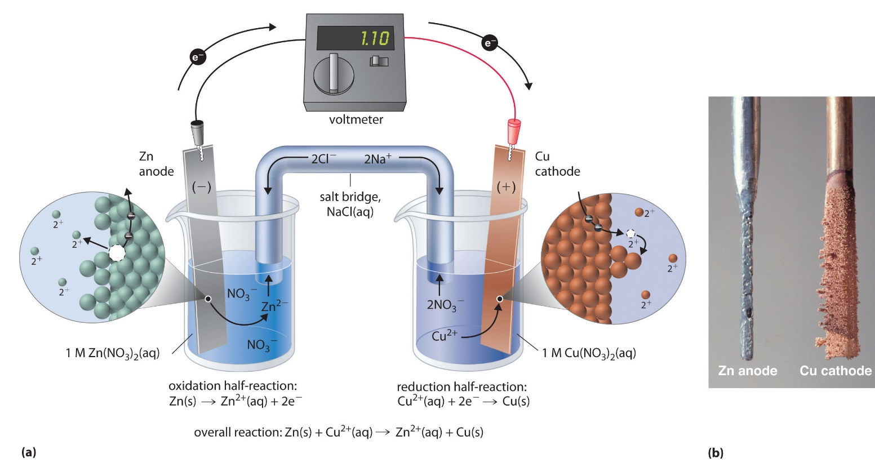
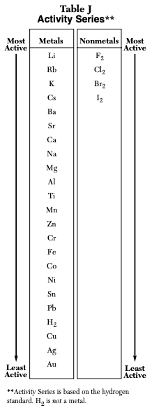
The voltaic cell (see Figure above) consists of two separate compartments. A half-cell is one part of a voltaic cell in which either the oxidation or reduction half-reaction takes place. The left half-cell is a strip of zinc metal in a solution of zinc nitrate. The right half-cell is a strip of copper metal in a solution of copper(II) nitrate. The strips of metal are called electrodes. An electrode is a conductor in a circuit that is used to carry electrons to a nonmetallic part of the circuit. The nonmetallic part of the circuit is the electrolyte solutions in which the electrodes are placed. A metal wire connects the two electrodes. A switch opens or closes the circuit. A salt bridge connects the two containers and provides a path for a flow of ions between the two beakers. This makes a complete circuit and allows the reaction to proceed.
Table J Activity Series can be used to identify the anode and the cathode in a voltaic cell. Identify the two metals shown in the cell, and locate them on the table. The metal that is higher on the chart will be oxidized, and is thus the anode. The lower metal is the site of reduction and will be the cathode. Notice that the cathode itself is not reduced; it is the place where reduction occurs.
The various electrochemical processes that occur in a voltaic cell occur simultaneously. It is easiest to describe them in the following steps, using the above zinc-copper cell as an example.
- Zinc atoms from the zinc electrode are oxidized to zinc ions. This happens because zinc is higher than copper on the activity series (Table J) and so is more easily oxidized.
Zn(s)→Zn²⁺(aq)+2e⁻
The electrode at which oxidation occurs is called the anode. The zinc anode gradually diminishes as the cell operates due to the loss of zinc metal. The zinc ion concentration in the half-cell increases. Because of the production of electrons at the anode, it is labeled as the negative electrode.
- The electrons that are generated at the zinc anode travel through the external wire and register a reading on the voltmeter. They continue to the copper electrode.

- Electrons enter the copper electrode where they combine with the copper(II) ions in the solution, reducing them to solid copper metal.
Cu²⁺(aq)+2e⁻→Cu(s)
The electrode at which reduction occurs is called the cathode. The cathode gradually increases in mass because of the production of copper metal. The concentration of copper(II) ions in the half-cell solution decreases. The cathode is the positive electrode.
- Ions move through the salt bridge to maintain electrical neutrality in the cell. In the cell illustrated above, sulfate ions will move from the copper side to the zinc side to compensate for the decrease in Cu²⁺ and the increase in Zn²⁺.
The 2 half-reactions can again be summed to provide the overall redox reaction occurring in the voltaic cell.
Zn(s)+Cu²⁺(aq)→Zn²⁺(aq)+Cu(s)
When electrons are lost during oxidation at the anode, they travel through the wire to the cathode. At this electrode, the material being reduced gains electrons. As with all redox reactions, the substance being oxidized loses electrons, and the substance being reduced gains them. The electrons lost must be equal to the number of electrons gained.
Introduction to Electrochemical Cells Practice Questions
COMPREHENSION QUESTIONS: Use the reading above to help answer the following questions.
- What is a voltaic cell?

- What is an electrolytic cell?

- Which electrochemical cell is spontaneous? Which electrochemical cell is non-spontaneous?

- What happens when something is oxidized? What happens when something is reduced?

- What occurs at the anode? What occurs at the cathode?

- What is the function of the salt bridge?

- Which way to do the electrons travel to?

- How can Table J be used to determine the anode and cathode?

USING TABLE J: Use Table J to determine which is electrode is the anode and which is the cathode, and determine if it is oxidized or reduced.

- Cu & Zn
  - ________ is the anode and is being ___________________ because electrons are ___________.
  - ________ is the cathode and is being ___________________ because electrons are ___________.

- Pb & Zn
  - ________ is the anode and is being ___________________ because electrons are ___________.
  - ________ is the cathode and is being ___________________ because electrons are ___________.

- Ba & Li
  - ________ is the anode and is being ___________________ because electrons are ___________.
  - ________ is the cathode and is being ___________________ because electrons are ___________.

- Au and Pb
  - ________ is the anode and is being ___________________ because electrons are ___________.
  - ________ is the cathode and is being ___________________ because electrons are ___________.

- Mn and Zn
  - ________ is the anode and is being ___________________ because electrons are ___________.
  - ________ is the cathode and is being ___________________ because electrons are ___________.

- Fe & Zn
  - ________ is the anode and is being ___________________ because electrons are ___________.
  - ________ is the cathode and is being ___________________ because electrons are ___________.

- Co & Ca
  - ________ is the anode and is being ___________________ because electrons are ___________.
  - ________ is the cathode and is being ___________________ because electrons are ___________.

- Co & Ni
  - ________ is the anode and is being ___________________ because electrons are ___________.
  - ________ is the cathode and is being ___________________ because electrons are ___________.

- Cu & Mg
  - ________ is the anode and is being ___________________ because electrons are ___________.
  - ________ is the cathode and is being ___________________ because electrons are ___________.

- Zn & Al
  - ________ is the anode and is being ___________________ because electrons are ___________.
  - ________ is the cathode and is being ___________________ because electrons are ___________.

