**Introduction to Oxidation & Reduction**

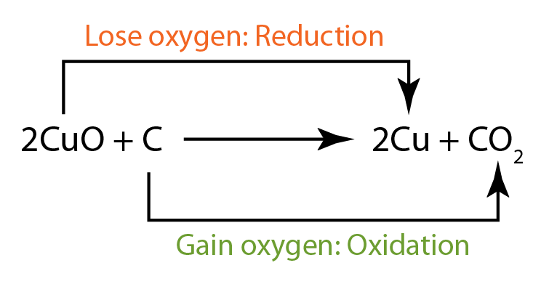

Original Understanding of Redox

* The substance ____________ oxygen is _______________,
* while the substance ___________ oxygen is reduced.

Reduction-Oxidation Reactions (Redox)

* Reactions that involve the ______________________________________; ___________________ ________________________ must happen _______________________________.
* Reduction- _____________________________ by an atom or ion; _________________________________
* Oxidation- ______________________________ by an atom or ion; ________________________________ goes ______________________

How to Remember Redox (mnemonics)



* LEO the lion says GER
  + ________________________________
  + ________________________________
* OIL RIG
  + ________________________________
  + ________________________________

Conservation of charge

* If one atom ________________ electrons, there must be another atom that will ___________________

to conserve charge.

Redox Reactions that Form Ions

* The substance that __________________________ is called the _____________________________

(Substance that is _____________________)

* The substance that ____________________________ is called the ___________________________ (Substance that is ________________________)

Example:

Identifying Oxidation Numbers

* One way that we can begin to ________________________________________________ is to identify the ________________________ from reactant to product side for every element involved in the reaction.
* Oxidation numbers are used to track the ____________________________________ (electron transfer) from reactants to products side of reaction.

Oxidation Number (State)

* _____________, _______________, or _________________________ values that can be assigned to atoms.
* Used to identify how many electrons are being lost or gained by an atom/ion when they __________________________.
* Top listed number on the upper right is the most common oxidation number for that element

Tricks to Identifying Redox Reactions

* Trick 1: _______________________________________________ are always REDOX!

Example: ________________________________________

* Trick 2: ______________________________________________________ are NOT REDOX

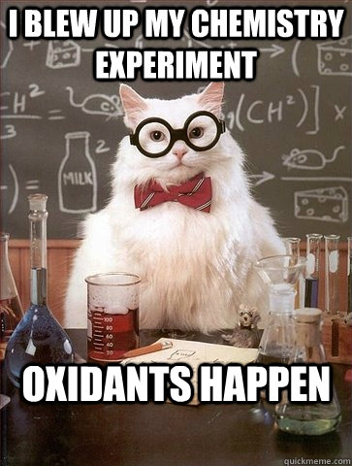Example: _________________________________________

A Reaction is Redox if….

* Oxidation numbers change for 2 elements within a reaction
* Reduction (GER) = _________________________________ by an atom or ion; _____________________ goes _____________________
* Oxidation (LEO)= ___________________________________ by an atom or ion; ________________ number goes

_____________ or _______________.

Rules for Assigning Oxidation Numbers

1. Elements that are free or uncombined will be assigned an oxidation charge of 0, this includes diatomic atoms
   * Ex. Cu: Oxidation number of Cu is 0
   * Ex. H2: Oxidation number of H is the 0
2. The oxidation number of a monoatomic ion = the charge of the monoatomic ion
   * Ex. S2-: Oxidation number is -2
   * Ex. Al3+: Oxidation number is +3
3. Group 1 metals *in compounds* are always assigned an oxidation state of +1
4. Group 2 metals *in compounds* are always assigned an oxidation state of +2
5. Hydrogen (H) has two possible oxidation numbers
   * +1 when bonded to a nonmetal
   * -1 when bonded to a metal
6. Oxygen in compounds are assigned an oxidation state of -2 except when it is a peroxide formula X2O2 (then its -1 which is rare)
7. Fluorine in a compounds always has an oxidation state of -1
8. The sum of the oxidation numbers of all atoms in a polyatomic ion = the charge on the polyatomic ion
9. The sum of the oxidation numbers if all atoms (or ions) in a neutral compound is 0

**Assigning Oxidation Number Practice**

**Part 1:** **Single Elements**

1. Al: _________
2. Cu: ________
3. H2: _________
4. Ar: ________
5. O2: ________
6. Zn: ________
7. Zn+2: _______
8. Cl-1: ________
9. Ca+2: _______
10. Li+1: _______
11. Te-2: _______
12. Ag+1: _______

**Part 2: Elements in Compounds**

|  |  |  |  |  |  |  |  |  |  |  |  |  |  |  |  |  |  |  |  |  |  |  |  |  |  |  |  |  |  |  |  |  |  |
| --- | --- | --- | --- | --- | --- | --- | --- | --- | --- | --- | --- | --- | --- | --- | --- | --- | --- | --- | --- | --- | --- | --- | --- | --- | --- | --- | --- | --- | --- | --- | --- | --- | --- |
| |  |  |  |  | | --- | --- | --- | --- | | CO2 | C | O |  | | Sub | 1 | 1 | | Ox # | +4 | -2 | | Total | +4 | -4 |  |  1. Carbon dioxide (CO2) | |  |  |  |  |  | | --- | --- | --- | --- | --- | | Ca(OH)2 | Ca | O | H |  | | Sub |  |  |  | | Ox # |  |  |  | | Total |  |  |  |  |  1. Calcium hydroxide (Ca(OH)2) |
| |  |  |  |  | | --- | --- | --- | --- | | H2O | H | O |  | | Sub |  |  | | Ox # |  |  | | Total |  |  |  |  1. Water (H2O) | |  |  |  |  |  | | --- | --- | --- | --- | --- | | Mg3(PO4)2 | Mg | P | O |  | | Sub |  |  |  | | Ox # |  |  |  | | Total |  |  |  |  |  1. Magnesium phosphate (Mg3(PO4)2) |
| |  |  |  |  |  | | --- | --- | --- | --- | --- | | NH4Cl | N | H | Cl |  | | Sub |  |  |  | | Ox # |  |  |  | | Total |  |  |  |  |  1. Ammonium chloride (NH4Cl) | |  |  |  |  | | --- | --- | --- | --- | | CO32- | C | O |  | | Sub |  |  | | Ox # |  |  | | Total |  |  |  |  1. Carbonate ion (CO32-) |

**Part 3: Regents Questions**

1. What are the two oxidation states of nitrogen in NH4NO2?
   1. +3 and +5
   2. +3 and -5
   3. -3 and +3
   4. -3 and -3
2. What is the oxidation number of manganese in KMnO4?
   1. +7
   2. +2
   3. +3
   4. +4
3. What is the oxidation state of nitrogen in the compound NH4Br?
   1. -1
   2. +2
   3. -3
   4. +4
4. What is the oxidation number of sulfur in Na2S2O3?
   1. -1
   2. +2
   3. +6
   4. +4
5. Given the balanced equation representing a reaction: 2 KClO3*(s)* 🡪 2KCl*(s)* + 3O2*(g)*. The oxidation state of chlorine in this reaction changes from
   1. -1 to +1
   2. -1 to +5
   3. +1 to -1
   4. +5 to -1
6. What is the oxidation number of chromium in the chromate ion, CrO42-?
   1. +6
   2. +2
   3. +3
   4. +8