How to Use Table H: Vapor Pressure of Four Liquids
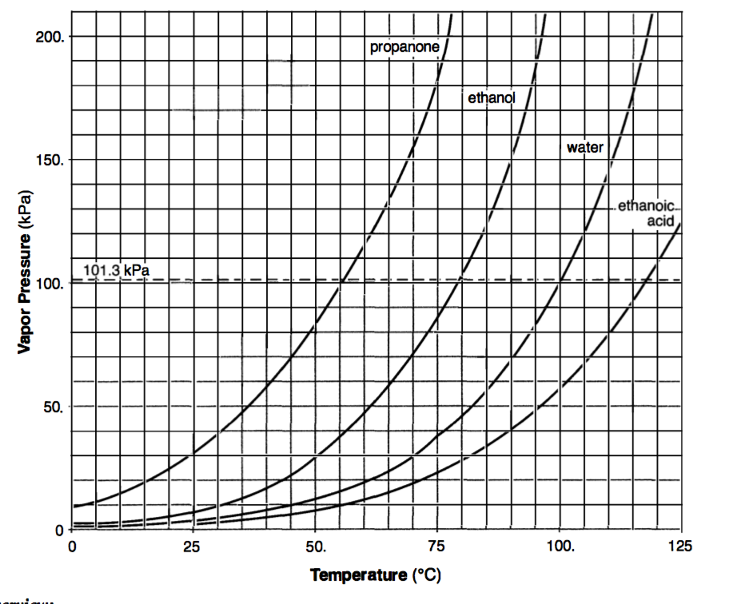

Boiling points of the four liquids

Overview:
A liquid is the form of matter that has definite volume but no definite shape. A liquid takes the shape of the container it is in. Above the surface of a liquid, there is always found the gaseous form of that liquid, called a vapor. The term vapor refers to the gas phase of a substance that is ordinarily a solid or liquid at that temperature. This vapor above the surface of a liquid exerts a characteristic pressure called vapor pressure.

The Table:
This table shows the vapor pressure, in kPa, of four liquids as a function of temperature. The graph shows that propanone has the greatest vapor pressure at any given temperature compared to the other three liquids, while ethanoic acid has the lowest vapor pressure at any given temperature compared to the other three liquids. To determine the vapor pressure of a liquid at a specific temperature, move directly up from the given temperature until you reach the intersection point of the liquid's vapor pressure curve. Reading across to the vapor pressure axis gives the vapor pressure of that liquid at that temperature. The dotted horizontal line labeled 1 0 1 .3 kPa is standard pressure (see Table A).

Temperature vs. Vapor Pressure
As the temperature increases, the vapor pressure increases. This is due to increased amount of vapor and the greater average kinetic energy of the vapor particles. As the pressure on the surface of a liquid increases, the boiling point of the liquid increases. This is caused by the need to reach a higher vapor pressure to equal the increased pressure on the surface of the liquid.

Boiling Point and Vapor Pressure
The boiling point of a liquid is the temperature at which the vapor pressure is equal to the atmospheric pressure on the surface of the liquid. Therefore, when a liquid is boiling, the atmospheric pressure on the liquid can be read from the vapor pressure axis since they are equal to each other. When the atmospheric pressure is equal to standard pressure, the boiling point is called the normal boiling point. Reading from the graph at standard pressure (101.3 kPa), the normal boiling points of propanone, ethanol, water and ethanoic acid are 56°C,79°C, 100°C and 1 17°C, respectively.
Intermolecular Attraction
A higher boiling point for a liquid indicates a greater attraction between the molecules of that liquid. The vapor pressure curves on Table H indicate that propanone has the weakest intermolecular attraction and ethanoic acid has the greatest intermolecular attraction.

Additional Information:
The vapor pressure depends only upon the nature of the liquid and the temperature. It does not depend upon the amount of liquid. If a temperature-pressure point lies on one of the vapor pressure curves, the liquid is boiling, changing from the liquid to the gas phase. If the intersection point of the temperature and atmospheric pressure (read from the vapor pressure axis) of the substance is to the le of its vapor pressure curve, that substance is a liquid. If the intersection point lies to the right of the vapor pressure curve, it is a gas. For example, at 25°C and 150 kPa pressure, propanone is in the liquid phase, while at 25°C and 20 kPa pressure, propanone is in the gaseous phase.

Important Relationships
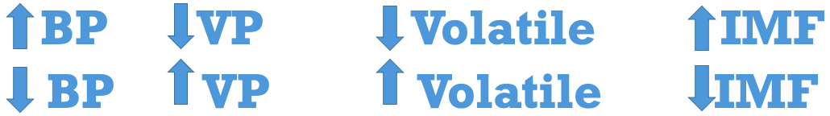
- BP = Boiling Point
  - High BP = a lot of energy is needed to “break up the party” and become a gas/vapor
  - Low BP = less energy is needed to “break up the party” and become a gas/vapor
- VP = Vapor Pressure
  - High VP = substance becomes a vapor very easily
  - Low VP = substance stays a liquid easier
- Volatile = how likely something is to turn into a vapor
  - Highly volatile = becomes a vapor very easily
  - Non/low volatile = stays a liquid easier
- IMF = Intermolecular Forces
  - Strong IMF = the molecules interact with each other a lot, and it takes a lot of energy to “break up the party”
  - Weak IMF = the molecules DON’T interact with each other a lot, and it takes little energy to “break up the party”

Practice Questions
- Which liquid has the lowest vapor pressure at 65 C?

  - Ethanoic acid
  - Ethanol
  - Propanone
  - Water

- Which liquid has the highest vapor pressure at 75 C?

  - Ethanoic acid
  - Ethanol
  - Propanone
  - Water

- Based on Table H, which sample has the highest vapor pressure?

  - Water at 20 C
  - Water at 80 C
  - Ethanol at 50 C
  - Ethanol at 65 C

- Using your knowledge of chemistry and the information in Reference Table H, which statement concerning propanone and water at 50 C is true?
  - Propanone has a higher vapor pressure and stronger intermolecular forces than water
  - Propanone has a higher vapor pressure and weaker intermolecular forces than water
  - Propanone has a lower vapor pressure and stronger intermolecular forces than water
  - Propanone has a lower vapor pressure and weaker intermolecular forces than water

- At which temperature is the vapor pressure of ethanol equal to 80 kPa?

  - 48 C
  - 73 C
  - 80 C
  - 101 C

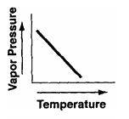
- Which graph best represents the variation in vapor pressure of water as temperature changes?
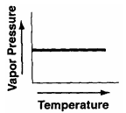
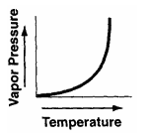
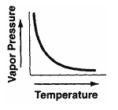

a b c d

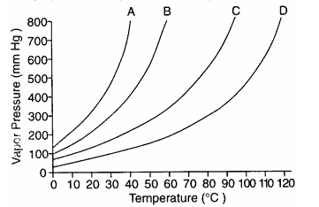

- The graph below represents the vapor curves of four liquids. Which liquid has the highest normal boiling point?

  - A
  - B
  - C
  - D

