Half-Lives of Radioactive Isotopes
Transmutation
- In (natural) transmutation, the nucleus spontaneously decays into a new element.
$${}_{88}^{226}{Ra} → {}_{86}^{222}{Rn} + {}_{2}^{4}{He}$$
- In artificial transmutation, the nucleus is first bombarded with high energy particles, then decays and changes into a new element.
$${}_{13}^{27}{Al}+ {}_{2}^{4}{He} → {}_{15}^{30}P + {}_{0}^{1}n$$
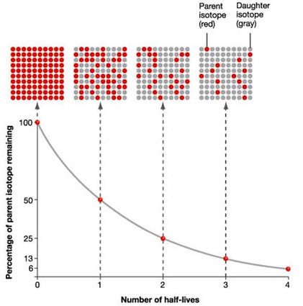
Half-Life
- Every radioisotope has a rate of decay.
- _______________________________________
_______________________________________
_______________________________________
_______________________________________
- __________________________________ lists half-life, decay mode (particles emitted during decay), nuclide (radioisotope, and name of nuclide.
- The half-life of Ra-226 is 1600 years; meaning, in 1600 years half of Ra-226 will decay, and in another 1600 years half of what was remaining will decay.
- After 3200 years, how many half-lives has Ra-226 gone through?

Common Radioisotopes
- Carbon-14 (C-14) has a half-life of 5700 years and is used to date once living (organic) material
- Uranium-238 (U-238) has a half-life 4.5 billion years and is used to determine the age of rock
- Iodine-131 (I-131) has a half-life 8.021 days and is used for treatment of thyroid disorders
- Cobalt-60 (Co-60) has a half-life 5.271years and is used for cancer treatments

Fraction Remaining
- ${}_{53}^{131}I$ has a half-life of 8.07 days. A 10 gram sample was allowed to decay for 32 days. What fraction will remain?

What is the Half-Life?
- 100 grams of a radioisotope decayed to 12 ½ grams after 90.7 years. What was the half-life?

What was the Initial Amount (Original Amount)
- A radioisotope has a half-life of 10 days. 1 gram remains after 40 days. What was the initial amount of the radioisotope?

More - Mixed Half-Life Practice
- How long will it take for 30 g of 222Rn to decay to 7.5 g?

- How many grams of 16N will be left from a 16 g sample after 21.6 s?

- How many half-lives will it take for 50 g of 99Tc to decay to 6.25 g?

- What fraction of a sample of 32P will be left after 42.9 d?

Regents Questions
- Which radioisotopes have the same decay mode and have half-lives greater than 1 hour?

  - Au-198 and N-16
  - I-131 and P-32
  - Ca-37 and Fe-53
  - Tc-99 and U-233

- After decaying for 48 hours, 1/16 of the original mass of a radioisotope sample remains unchanged. What is the half-life of this radioisotope?

  - 3.0 h
  - 9.6 h
  - 12 h
  - 24 h

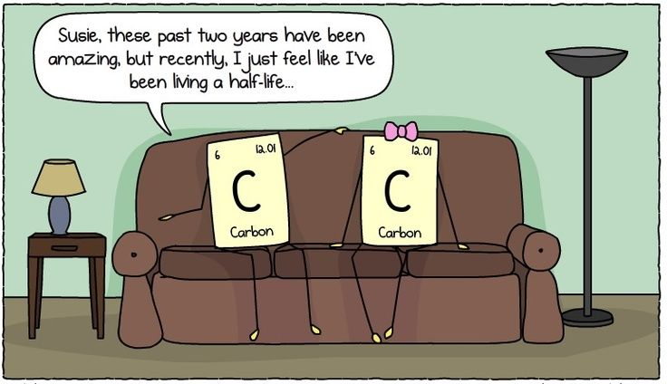
Half Life of a Twizzler (or any other object)

Directions:
- On the graph provided below, label the y-axis “Amount” and the x-axis as “Half-Life,” and title your graph
- Number the x-axis from 0 to 10
- Get 2 twizzlers (or objects that can be cut in half easily
- Place the first whole twizzler at 0 half-lives and mark the top of the piece on the graph
- Cut the 2nd twizzler in half and place one half at Half Life 1 and discard the other half (eat or garbage) and mark off point on graph
- The twizzlers on the graph represent the amount of original material left, and the discard twizzlers represent the decayed material
- Repeat until you can no longer easily divide the twizzlers in half
- Draw a smooth line connecting all your marks

The Graph

Analysis:
- What is the shape of the line on your graph?

- How would you describe what happens to the amount of twizzlers after each step?

- Suppose the units on the x-axis are seconds. What is the half-life of your twizzler?

- Using your graph, determine whether this statement is true or false. Explain your answer. Half-life means that half of a sample decays after one half-life and the rest of the sample decays after the next half-life.

- One reason it is important to know the half-life of a sample is to safely dispose of radioactive waste, which is usually stored for 10 half-lives. If you have 250 g of radioactive waste, how much of the sample would be left after 10 half-lives?

- Radioisotope A has a half-life of 2 minutes. Radioisotope B has a half-life of 2 hours. Which one would have a larger amount left after 5 hours has elapsed?

- Iodine-131 has a half-life of about 8 days. If you had 60 grams of I-131, how much would remain after 24 days? Show your work.

