Hair Identification Lab

Introduction:
During the course of a criminal investigation, many types of evidence are encountered. One of the most common is hair evidence. The identification and comparison of human and animal hairs can be helpful in demonstrating physical contact with a suspect, victim, and crime scene. Hairs can provide investigators with valuable information for potential leads.
Although DNA technologies may add significant information to hair evidence recovered at a crime scene, the first step necessary in the analytical process is the identification and comparison of human and animal hairs.

Basic Structure of Hair
A hair can be defined as a slender, thread-like outgrowth from a follicle in the skin of mammals. Composed mainly of keratin, it has three morphological regions—the cuticle, medulla, and cortex. These regions are illustrated in Figure 1 with some of the basic structures found in them.
Figure 1. Hair Diagram
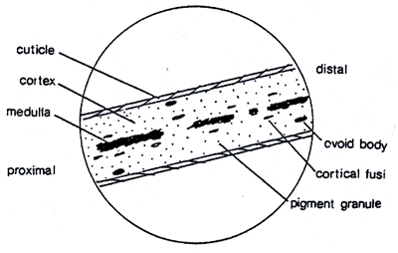
A hair grows from the papilla and with the exception of that point of generation is made up of dead, cornified cells. It consists of a shaft that projects above the skin, and a root that is imbedded in the skin. Figure 2 diagrams how the lower end of the root expands to form the root bulb. Its basic components are keratin (a protein), melanin (a pigment), and trace quantities of metallic elements. These elements are deposited in the hair during its growth and/or absorbed by the hair from an external environment. After a period of growth, the hair remains in the follicle in a resting stage to eventually be sloughed from the body.

Vocabulary: Define these using your notes and other sources
- Distal -

- Proximal –

- Cortex –

- Medulla –

- Cuticle –

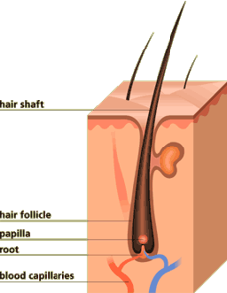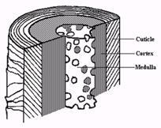

Procedures: Comparing Known and Unknown Samples.
- Complete the table below:
 | Known Sample | Unknown Sample
How long is the hair? Use metric.
What color
is the hair?
Other observations about the hair:
Next, you will examine each hair under the microscope; examine one hair at a time since we do not have a comparison microscope.

Most microscope samples look better if placed under a drop of water. This is called a Wet Mount.

To make a wet-mount slide for hair:
- Use an eye dropper to add 1 droplet of water to an empty slide.
- Place a piece of hair on the water droplet, already on the microscope slide. If your hair is long, you will want to cut it to fit on the slide.
- Place a cover slip over the water droplet and hair; lower it at an angle to avoid air bubbles.
- Observe this hair under the microscope.

Draw what each hair looks like on high-power. *Use colored pencils for all drawings in this lab and Label any visible structures (medulla, cortical fusi, pigment granules, scale pattern, etc.)

Known Sample (High Power) | Unknown Sample (High Power)

- One of these hairs was real, and one was synthetic (fake). Which is which? How could you tell?
_______________________________________________________________________________
_______________________________________________________________________________
_______________________________________________________________________________
_______________________________________________________________________________
_______________________________________________________________________________
_______________________________________________________________________________

Analysis and Discussion:
- What is the main purpose for examining a hair found at the crime scene?

- Can you distinguish a hair that has been bleached or dyed from a natural hair? How or why not?

- What is the approximate growth rate for hair?
Review Questions
- Draw a diagram of hair. Make sure to include the 3 major parts. Label those parts.

- Draw the 5 different types of medullas discussed in class.

- Describe at least 3 differences between human hair and animal hair.

