**Gas Law CER Article**

**Boyle’s Law**

Robert Boyle (1627-1691), an English chemist, is widely considered to be one of the founders of the modern experimental science of chemistry. He discovered that doubling the pressure of an enclosed sample of [gas](https://www.ck12.org/c/physical-science/gas) while keeping its [temperature](https://www.ck12.org/c/earth-science/temperature) constant caused the volume of the gas to be reduced by half. **Boyle’s law** states that the volume of a given mass of [gas](https://www.ck12.org/c/physical-science/gas) varies inversely with the pressure when the [temperature](https://www.ck12.org/c/earth-science/temperature) is kept constant. An inverse relationship is described in this way. As one variable increases in value, the other variable decreases.

Physically, what is happening? The [gas](https://www.ck12.org/c/physical-science/gas) molecules are moving and are a certain [distance](https://www.ck12.org/c/physics/distance) apart from one another. An increase in pressure pushes the molecules closer together, reducing the volume. If the pressure is decreased, the gases are free to move about in a larger volume.

Mathematically, Boyle’s law can be expressed by the equation: P x V = k

The k is a constant for a given sample of gas and depends only on the mass of the gas and the [temperature](https://www.ck12.org/c/earth-science/temperature). **Table** [below](https://www.ck12.org/c/chemistry/boyles-law/lesson/Boyles-Law-CHEM/?referrer=concept_details#x-ck12-MzI3NTRlOWZlYmY5YjNlNWQ1NjUzNTUyZTQ5ODgxN2Q.-ggq) shows pressure and volume data for a set amount of gas at a constant temperature. The third column represents the value of the constant (k) for this data and is always equal to the pressure multiplied by the volume. As one of the variables changes, the other changes in such a way that the product of P×V always remains the same.

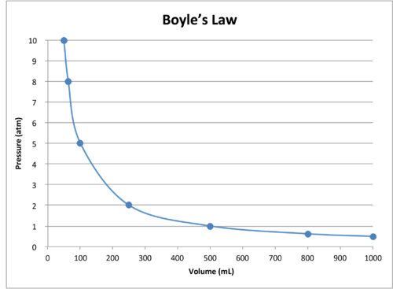

A graph of the data in the table further illustrates the inverse relationship nature of Boyle’s Law (see **Figure** [below](https://www.ck12.org/c/chemistry/boyles-law/lesson/Boyles-Law-CHEM/?referrer=concept_details#x-ck12-OTgwNDUtMTM2MzY5MDU5MS05MS01OC02)). Volume is plotted on the x-axis, with the corresponding pressure on the y-axis.

Boyle’s Law can be used to compare changing conditions for a gas. We use P1 and V1 to stand for the initial pressure and initial volume of a gas. After a change has been made, P2 and V2 stand for the final pressure and volume. The mathematical relationship of Boyle’s Law becomes: P1V1 = P2V2

This equation can be used to calculate any one of the four quantities if the other three are known.

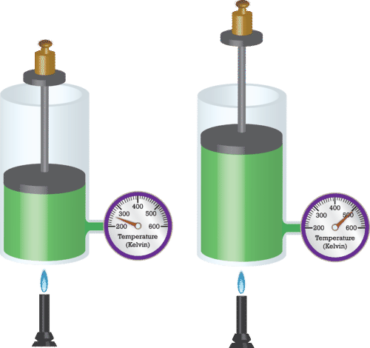**Charles’s Law**

As a container of confined [gas](https://www.ck12.org/c/physical-science/gas) is heated, its molecules increase in [kinetic energy](https://www.ck12.org/c/chemistry/kinetic-energy) and push the movable piston outward, resulting in an increase in volume.

French physicist Jacques Charles (1746-1823) studied the [effect of temperature](https://www.ck12.org/c/chemistry/effect-of-temperature) on the volume of a [gas](https://www.ck12.org/c/physical-science/gas) at constant pressure. **Charles’s law** states that the volume of a given mass of [gas](https://www.ck12.org/c/physical-science/gas) varies directly with the absolute temperature of the gas when pressure is kept constant. The absolute temperature is temperature measured with the Kelvin scale. The Kelvin scale must be used because zero on the Kelvin scale corresponds to a complete stoppage of molecular motion.

Mathematically, the direct relationship of Charles’s law can be represented by the equation: VT = k

As with Boyle’s law, k is constant only for a given gas sample. **Table** [below](https://www.ck12.org/c/chemistry/charless-law/lesson/Charless-Law-CHEM/?referrer=concept_details#x-ck12-MmJhZjZhNWU4OGVlMDlhMjg3MjhiZjUzZmE1ODE2NjI.-1ne) shows temperature and volume data for a set amount of gas at a constant pressure. The third column is the constant for this particular data set and is always equal to the volume divided by the Kelvin temperature.

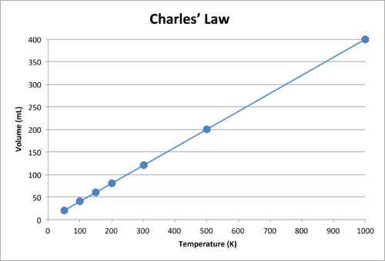

When the data is graphed, the result is a straight line, indicative of a direct relationship, shown to the left.

Notice that the line goes exactly toward the origin, meaning that as the absolute temperature of the gas approaches zero, its volume approaches zero. However, when a gas is brought to extremely cold temperatures, its molecules would eventually condense into the [liquid](https://www.ck12.org/c/physical-science/liquid) state before reaching absolute zero. The temperature at which this change into the liquid state occurs varies for different gases.

Charles’s Law can also be used to compare changing conditions for a gas. Now we use V1 and T1to stand for the initial volume and temperature of a gas, while V2 and T2 stand for the final volume and temperature. The mathematical relationship of Charles’s Law becomes: V1/T1=V2/T­

This equation can be used to calculate any one of the four quantities if the other three are known. The direct relationship will only hold if the temperatures are expressed in Kelvin. Temperatures in Celsius will not work. Recall the relationship that K = °C + 273.

**Gay-Lussac’s Law**

When the [temperature](https://www.ck12.org/c/earth-science/temperature) of a sample of [gas](https://www.ck12.org/c/physical-science/gas) in a rigid container is increased, the pressure of the gas increases as well. The increase in [kinetic energy](https://www.ck12.org/c/chemistry/kinetic-energy) results in the molecules of gas striking the walls of the container with more force, resulting in a greater pressure. The French chemist Joseph Gay-Lussac (1778-1850) discovered the relationship between the pressure of a gas and its absolute temperature. **Gay-Lussac’s law** states that the pressure of a given mass of [gas](https://www.ck12.org/c/physical-science/gas) varies directly with the absolute temperature of the gas, when the volume is kept constant. Gay-Lussac’s law is very similar to Charles’s law, with the only difference being the type of container. Whereas the container in a Charles’s law [experiment](https://www.ck12.org/c/physical-science/experiment) is flexible, it is rigid in a Gay-Lussac’s law experiment.

The mathematical expressions for Gay-Lussac’s law are likewise similar to those of Charles’s law: P/T=k and P1/T1=P2/T2

A graph of pressure vs. temperature also illustrates a direct relationship. As a gas is cooled at constant volume its pressure continually decreases until the gas condenses to a [liquid](https://www.ck12.org/c/physical-science/liquid).

**Combined Gas Law**

To this point, we have examined the relationships between any two of the variables of P, V, and T, while the third variable is held constant. However, situations arise where all three variables change. The **combined gas law** expresses the relationship between the pressure, volume, and absolute [temperature](https://www.ck12.org/c/earth-science/temperature) of a fixed amount of gas. For a combined gas law problem, only the amount of gas is held constant.

P×V/T = k and (P1×V1)/T1=(P2×V2)/T2