Identifying and Naming Organic Compounds w/ Functional Groups
Directions: For each compound, circle the functional group in the compound, write the name of the functional group, and the name of the compound. USE TABLE R TO HELP YOU!

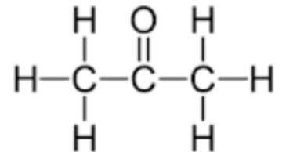  Functional Group: _______________________  Name: _________________________________ | 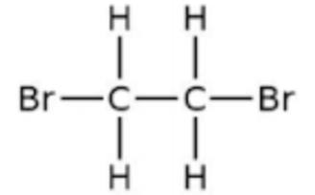  Functional Group: _______________________  Name: _________________________________ | 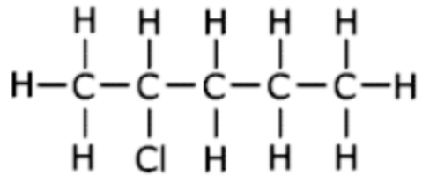  Functional Group: _______________________  Name: _________________________________
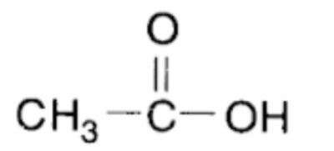  Functional Group: _______________________  Name: _________________________________ | 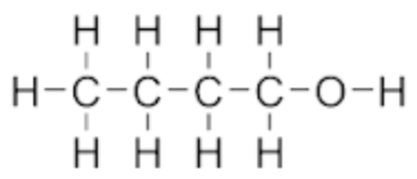  Functional Group: _______________________  Name: _________________________________ | 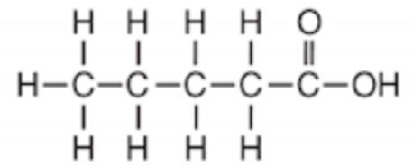  Functional Group: _______________________  Name: _________________________________

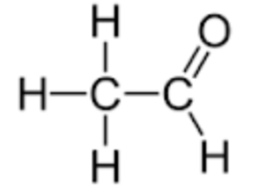  Functional Group: _______________________  Name: _________________________________ | 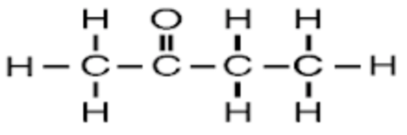  Functional Group: _______________________  Name: _________________________________ | 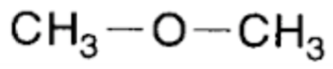  Functional Group: _______________________  Name: _________________________________
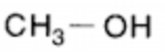  Functional Group: _______________________  Name: _________________________________ | 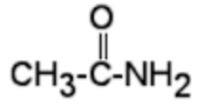  Functional Group: _______________________  Name: _________________________________ | 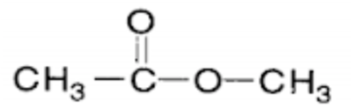  Functional Group: _______________________  Name: _________________________________

