Forensic Footwear and Print Analysis

The analysis of footwear can place a person at a crime scene, either by the tread marks left in a footprint at the scene, or via trace evidence that may have been caught up in the tread of the shoes. A crucial part of investigative footwear analysis for our experts is that the shoe soles indicate a person's unique walking style. For example, those with high arches or those whose feet ‘roll inwards' will have unique wearing pattern on the soles of their shoes.

When analyzing assault cases where a victim has been stamped and kicked by a suspect our forensic footwear experts can identify marks on the victim's body which can give an indication of the type of shoe used and the force involved. If there is blood at the crime scene a footprint can often be taken and used as evidence in court.
What information can scientists determine when analyzing footprints?
Footwear marks are the second most common evidence type left at crime scenes. Forensic Resources use forensic footprint analysis to obtain vital information during specific crime scene investigations. These include the identification of a footwear manufacturer, model and shoe size to help profile witness, suspect and victims at a crime scene. For example, through using forensic footprint analysis our scientists can identify the approximate height and activity that a person was performing when the shoeprint was made.

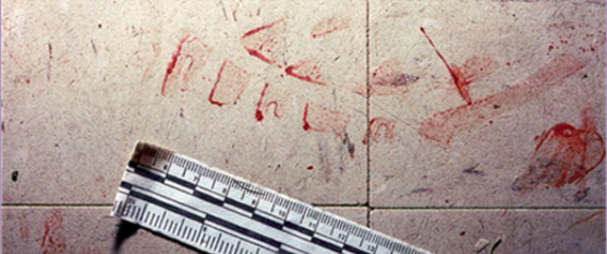
Footwear and tire tracks can be deposited on almost any surface, from paper to the human body. Prints are divided into three types: visible, plastic and latent.

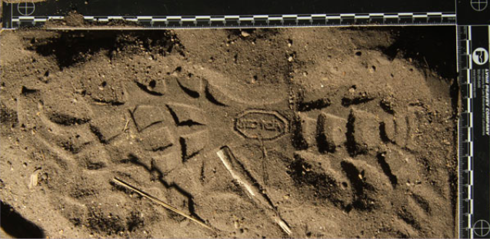
A visible print is a transfer of material from the shoe or tire to the surface. This type can be seen by the naked eye without additional aids. For example, bloody shoe prints left on flooring or tracks left by muddy tires on a driveway.

A plastic print is a three-dimensional impression left on a soft surface. This includes shoe or tire tracks left in sand, mud or snow.

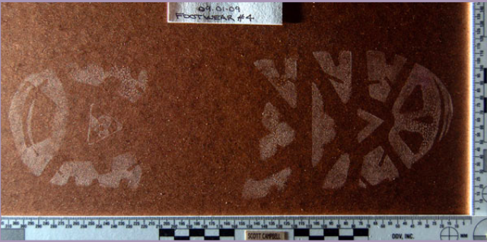
A latent print is one that is not readily visible to the naked eye. This type is created through static charges between the sole or tread and the surface. Examiners or investigators use powders, chemicals or alternate light sources to find these prints. Examples include shoeprints detected on a tile or hardwood floor, window sill, or metal counter, or tire tracks detected on road surfaces, driveways or sidewalks.
What are the different types of prints?
Q: How can a print left at a crime scene be matched to a possible suspect?
A: Turn the page to find out!
Matching Footprints
Below are two prints retrieved from a suspected murderer, #1 and #2 (they are two different copies of the same print). The prints were made from a shoe recovered from the suspect’s house. Forensic analysts are now attempting to mat ch these prints with one of three prints found at the crime scene. These three prints were made by the same model and size of shoe as the o ne recovered from the suspect’s house, so the class characteristics of the shoes match. Now they need to find as many individual characteristics as possible to match the suspect shoe to one of the crime scene prints. To do this:

- Circle as many small deformities in each print as you can.
- Compare the circled deformities in the crime scene prints with the suspect print.
- Begin numbering common deformities found in the two different prints like the example below.

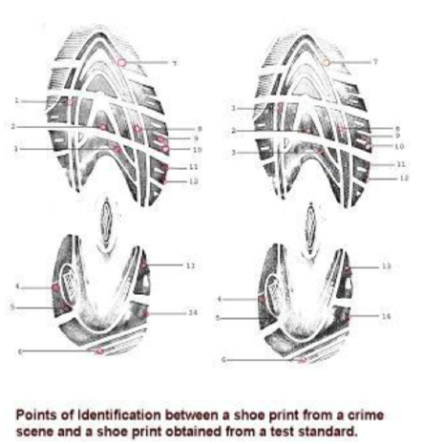

Suspect Prints – These are the same shoe. Different Darkness of ink sometimes brings out different features.
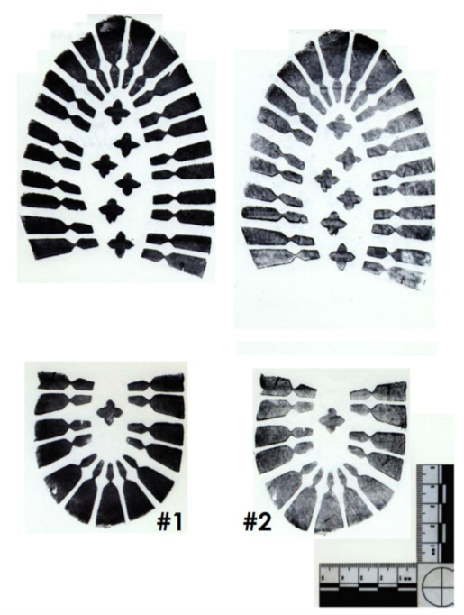

Crime Scene Prints
