Fingerprint Practice Exam - KEY

Part I: Fingerprint Pattern Identification (Images come from the right hand)
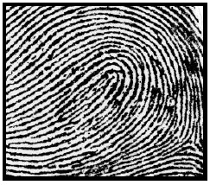
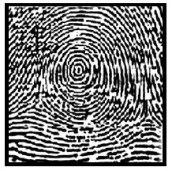
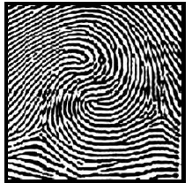
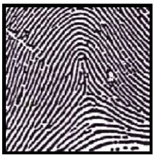

A B C D
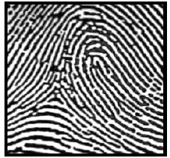
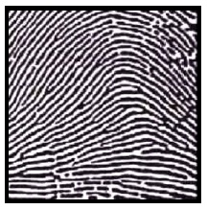
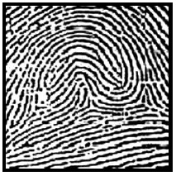
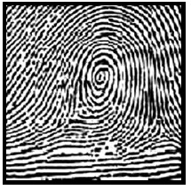

E F G H

- Fingerprint A is an example of a
- Double loop whorl (b) Tented Arch (c) Plain Arch (d) Radial Loop

- Fingerprint B is an example of a
- Double loop whorl (b) Tented Arch (c) Plain Arch (d) Radial Loop

- Fingerprint C is an example of a
- Ulnar Loop (b) Plain Whorl (c) Accidental Loop Whorl (d) Central Pocket Whorl

- Fingerprint D is an example of a
- Double loop whorl (b) Tented Arch (c) Plain Arch (d) Radial Loop – ULNAR ARCH – ADDED ANSWER

- Fingerprint E is an example of a
- Ulnar Loop (b) Plain Whorl (c) Accidental Loop Whorl (d) Central Pocket Whorl

- Fingerprint F is an example of a
- Ulnar Loop (b) Plain Whorl (c) Accidental Loop Whorl (d) Central Pocket Whorl

- Fingerprint G is an example of a
- Double loop whorl (b) Tented Arch (c) Plain Arch (d) Radial Loop

- Fingerprint H is an example of a
- Ulnar Loop (b) Plain Whorl (c) Accidental Loop Whorl (d) Central Pocket Whorl – ADDED ANSWER – RADIAL ARCH

Part 2: Ridge Characteristics

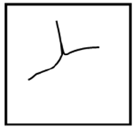
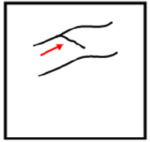
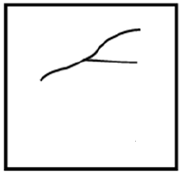
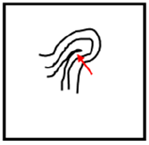

A B C D

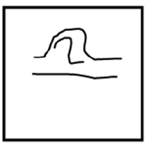
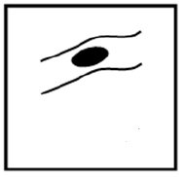
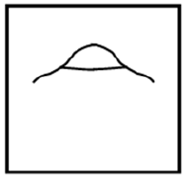
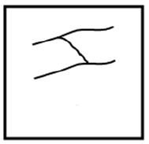

E F G H

- Ridge Characteristic A is an example of a
- Delta (b) Eye (c) Core (d) Specialty

- Ridge Characteristic B is an example of a
(a) Fork (b) Bridge (c) Hook (d) Dot

- Ridge Characteristic C is an example of a
(a) Delta (b) Eye (c) Core (d) Specialty

- Ridge Characteristic D is an example of a
(a) Fork (b) Bridge (c) Hook (d) Dot

- Ridge Characteristic E is an example of a
(a) Delta (b) Eye (c) Core (d) Specialty

- Ridge Characteristic F is an example of a
(a) Fork (b) Bridge (c) Hook (d) Dot

- Ridge Characteristic G is an example of a
(a) Delta (b) Eye (c) Core (d) Specialty

- Ridge Characteristic H is an example of a
(a) Fork (b) Bridge (c) Hook (d) Dot

Part 3 Fingerprints Basics

- Dactyloscopy is the study of fingerprint identification.
- True (b) False

- A fingerprint is an class characteristic
- True (b) False

- Prints may be collected by revealing them with a dusting of cyanoacrylate and then lifted with a piece of clear tape.
- True (b) False

- Some investigators use magnetic powder and UV lights to help them find latent prints on multi-colored or dark surfaces.
- True (b) False

- Fluorescent powder can also be used to reveal latent prints and works on shiny surfaces or plastic baggies or containers.
- True (b) False

- The Iodine fuming method (super glue method) is a procedure that is used to develop fingerprints on a variety of objects.
- True (b) False

- Ninhydrin is a chemical that bonds with the amino acids in fingerprints and will produce a blue or purple color. It works well on paper or cardboard surfaces.
- True (b) False

- The _______ Principle states that with contact between two items, there will be an exchange.
(a) Locard (b) Bertillon (c) Minutiae (d) Fingerprint

- The most common type of fingerprint pattern is the
(a) Arch (b) Loop (c) Whorl

- Which term refers to a print found at a crime scene?
- Evidence print (b) Latent print (c) Clue print

- The most common animal hair used to make fingerprint brushes come from a:
- Horse (b) Human (c) Giraffe (d) Camel

- A fork, core, delta and crossover are examples of:
(a) Fingerprints (b) Minutiae (c) AFIS (d) Whorls

- Hair samples can be tested for nuclear DNA whether or not the root is present.
(a)True (b)False

- The ______________ has fingerprints that are very similar to those from a human.
- Camel (b) Spongebob (c) Koala Bear (d) Dog

- AFIS is an acronym that stands for:
(a) Automated Fingernail Identification System
(b) Automated Fingerprint Identification System
(c)Automated Fingerprint Identification Service
(d) Automated Fingernail Identification System

- The main difference between a Plain Whorl and Central-Pocket Whorl is the position of its:
(a) Cores (b) Ridge Endings (c) Crossovers (d) Deltas

- When a Whorl does not fit into any particular category it is classified as:
- Occidental (b) Accidental (c) Specialty (d) Ulnar

Base your answers questions 34-39 on the following fingerprint diagram
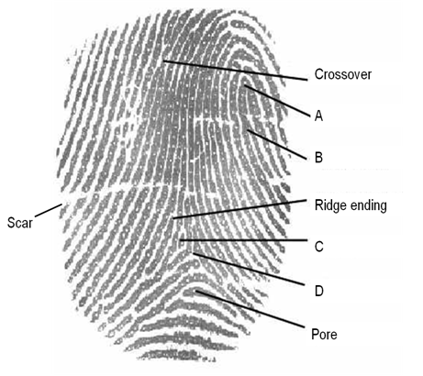

34. The fingerprint core is located at position:
(a) A (b) B (c) C (d) D

35. A delta is located at position:
(a) A (b) B (c) C (d) D

36. A fork (bifurcation) is located at position:
(a) A (b) B (c) C (d) D

37. An island is located at position:
(a) A (b) B (c) C (d) D

