Dusting Latent Fingerprints Lab

Background
We’ll begin with the oldest fingerprint development method, dusting. With the exception of using magnetic powers to treat recently-touched paper, dusting is used almost exclusively on nonporous surfaces, and can provide excellent results if it’s done skillfully. If not done skillfully, dusting can easily damage or destroy any latent fingerprints present, as we found out and you probably will, too. In this lab session, we’ll dust a glass slide, using dark dusting powder. We’ll then do a tape lift to preserve the fingerprints we’ve developed.

Before you get started, you need to create some specimens to be tested. You can increase the likelihood of having usable prints on your specimens by rubbing your forefinger against your nose or forehead and then carefully pressing your finger into contact with the surface, making sure not to smear the prints. Once you’re comfortable with this training-wheels version of developing prints by dusting, you will get a better idea of the highly variable quality of real latent fingerprint specimens.

Materials
- fingerprint brush
- fingerprint powder, black (in plastic cup – 1 per team)
- wipes
- index cards
- tape (packing or similar transparent)
- specimens (objects with fingerprints)
- paper towel
- glass/plastic slide

Procedure: Dusting Latent Fingerprints
- Gently wipe two of your fingertips along the side of your nose or forehead to collect extra grease.
- Gently press one fingerprint onto the middle of a glass slide.
- Hold the slide up to the light and record your observations below. BE CAREFUL NOT TO CONTAMINATE YOUR PRINT – hold the slide by the edge only.
__________________________________________________________________________________________________________________________________________________________________________________________________________________________________________________________________

- Place the slide with the fingerprint facing up on a piece of paper towel
- Dip the tip of the brush into the cup full of black powder, and tap the brush on the side of the cup to get rid of excess power. YOU DO NOT NEED A LOT FOR THIS TO WORK
- Use a circular, twirling motion to gently sweep the brush gently over the area to be treated, allowing the bristles to just barely contact the surface. Continue depositing powder lightly until the latent fingerprint begins to develop, concentrating on that area as it becomes clearer where the latent prints are on the surface
- When the ridges begin to appear, change the direction of motion to follow the direction of the ridges. Once the fingerprint is developed clearly, stop dusting immediately.
- Gently blow on the slide to remove any excess powder. MAKE SURE THE EXCESS POWDER STAYS ON THE PAPER TOWEL

Procedure: Lifting Developed Fingerprints
- Place the dusting slide directly on your desk
- Ask for a piece of tape from your teacher
- Carefully place the tape on the slide. Start placing the tape on the edge of the slide. Slowly lower the tape over the dusted print. DO THIS SLOW TO REDUCE THE CHANCE OF AIR BUBBLES
- Once the tape is completely covering the slide and there are no air bubbles, slowly remove the tape from the slide.
- Place the tape, with the lifted print on the white index card provided
- Fold the edges of the tape around the sides of the index card

THERE ARE SUMMARY QUESTIONS – BUT YOU MUST CLEAN UP YOUR AREA BEFORE THE SUMMARY QUESTIONS WILL BE DISTRIBUTED! ONCE A TEACHER SAYS YOUR DESK IS CLEAN YOU WIL RECEIVE THE QUESTIONS.

CLEAN UP PROCEDURE
- Place cup with black powder back in front
- Return bushes to the case in front
- Paper towels should go into the garbage
- Any remaining black powder on desks or hands should be wiped clean with the wipes provided
- Instructions for slide disposal will be written on the board. Check with teacher before cleaning up the slide

Dusting Latent Fingerprints Lab

Summary Questions

- Should dusting be the first or last method attempted to raise latent fingerprints?

- Is dusting better suited for porous or nonporous surfaces? Explain.

- How would you dust for prints on a dark surface?

- How would you dust for a print on a curved surface, like a bottle?

- Attach your transfer card to this lab!

How Does Fingerprint Powder Work? - Scientific American Article
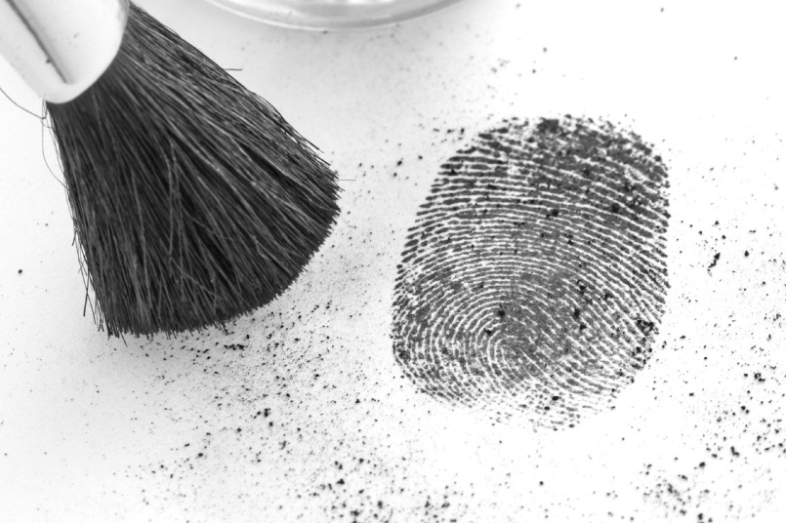
Christine Craig is a forensic scientist for the Commonwealth of Virginia and specializes in working with impressions. Jason Byrd is an assistant professor of forensic science and biology at Virginia Commonwealth University and the chairman of the American Board of Forensic Entomology. They provide the following explanation:

Fingerprint patterns and characteristics are formed before birth. They will remain unchanged until decomposition destroys them after death, or unless the dermal layer is injured, producing a scar. Fingerprints are unique to each individual--including identical twins--and have been used for over a century for identification and crime-solving purposes.
The skin found on the fingers, palms and soles of the feet of humans (and some primates) is known as friction skin. This skin is unique because it does not have hair follicles or oil glands, and because it is composed of ridges that are believed to be adapted for increased friction to help when handling various objects and walking. These so-called friction ridges are composed of rows of sweat pores, or eccrine glands, that constantly secrete perspiration. This perspiration--along with grease and oil transferred from other parts of the body--adheres to the friction skin and is transferred from the skin to other surfaces when contact is made with objects. The transferred outline of the friction ridges is what is known as a latent print.
Latent prints are not readily visible to the naked eye. As a result, these "hidden" prints must be "developed" in some way to increase their visibility and contrast. The most common method of developing latent prints on nonporous objects is to physically enhance them by applying fingerprint powder. Fingerprint powder is composed of many different ingredients that can vary greatly depending on the formula used. Most black fingerprint powders contain rosin, black ferric oxide and lampblack. Many also contain inorganic chemicals such as lead, mercury, cadmium, copper, silicon, titanium and bismuth. Fingerprint powder is applied by brushing it onto the surface and works by mechanically adhering to the oil and moisture components of the latent print. When the powder particles adhere to the grease or moisture forming the latent prints, it causes them to become visible. The developed latent prints are then readily observable and able to be collected, preserved and examined.
Questions
1. Do fingerprint patterns or characteristics ever change in a person’s life? Explain.

2. What makes friction skin so unique?

3. The black power used in the lab was graphite, the material found in pencil points. What are other chemicals that can be used to create fingerprint dusting powder?

4. How does fingerprint powder work?

