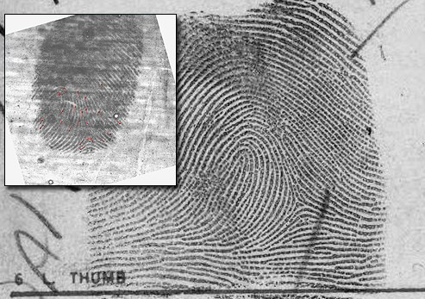
Case #1: The Death of Carroll Bonnet
A cold case is just that—an investigation of a crime, usually a violent one, where all leads have been exhausted and the trail has gone cold. But in recent years, the use of various technologies has begun heating up many of these cold cases, uncovering new leads for investigators and providing justice for victims.

One immediate technology example that comes to mind is automated fingerprint searching—more precisely, searches of latent prints of violent unknown perpetrators left at crime scenes. The FBI’s Integrated Automated Fingerprint Identification System (IAFIS), which houses known records for approximately 73 million criminal subjects, is used daily by local, state, tribal, and international law enforcement for current cases, but increasingly for help in solving cold cases as well. And once a year, the Bureau’s Criminal Justice Information Services Division recognizes an outstanding major case solved with help from IAFIS.

The 2012 Latent Hit of the Year Award was presented last month to two employees of the Omaha Police Department—Detective Douglas Herout and Senior Crime Laboratory Technician Laura Casey—for their efforts to identify the man responsible for a brutal murder more than 30 years ago.

The crime: In 1978, 61-year-old Carroll Bonnet was stabbed to death in his apartment. Police collected evidence, including latent fingerprints and palmprints from the victim’s bathroom (officers believed the killer was trying to wash off blood and other evidence before leaving the apartment). The victim’s car was then stolen.

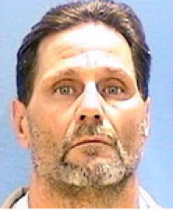
The investigation: The car was found in Illinois, but after collecting additional latent prints, investigators couldn’t develop any new leads. The crime scene evidence was processed, and latent prints recovered from the scene and the car were searched against local and state fingerprint files. Investigators also sent fingerprint requests to agencies outside Nebraska, but no matches were returned and the case soon went cold.

The re-investigation: In late 2008, the Omaha Police Department received an inquiry on the case, prompting technician Laura Casey to search the prints against IAFIS (which didn’t exist in 1978). In less than five hours, IAFIS returned possible candidates for comparison purposes. Casey spent days carefully examining the prints and came up with a positive identification—Jerry Watson, who was serving time in an Illinois prison on burglary charges

The case was officially re-opened and assigned to the cold case squad’s Doug Herout. Working with laboratory technicians and analysts, Herout reviewed the original evidence from the case, including a classified advertisement flyer with “Jerry W.” scribbled on one of the pages. Herout also discovered that Jerry Watson had lived only a few blocks from where the victim’s car was recovered.
And the discovery was made just in time—Watson was just days away from being released from prison.

Herout traveled to Illinois to question Watson and presented him with an order to obtain a DNA sample. Subsequent testing determined that Watson’s DNA matched DNA recovered at the crime scene, a finding that—combined with Watson’s identified prints—resulted in murder charges and a conviction. On October 17, 2011—33 years to the day that Bonnet’s body was discovered—his killer was sentenced to life in prison.
It’s yet another example of the vital role that technology plays in getting dangerous criminals off our streets.

https://www.fbi.gov/news/stories/30-year-old-murder-solved

Case #2: The Massachusetts Motel Murder

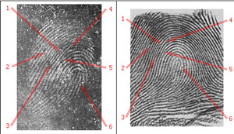
The word "latent" means "hidden" or "invisible." When fingerprints are involved, "latent prints" are those accidentally left behind by criminals during the commission of a crime. The story below, from the files of the FBI, details a cold case recently solved by a Massachusetts State Police Trooper using new database technology and latent fingerprints.

Every year, our Criminal Justice Information Services Division gives its Latent Hit of the Year Award to latent print examiners and/or law enforcement officers who solve a major violent crime using the Bureau's Integrated Automated Fingerprint Identification System, or IAFIS.

This year, we honor Massachusetts State Police (MSP) Trooper Christopher Dolan, a latent print examiner in the MSP's Crime Scene Services Section, for the role he played in identifying the killer in a 1983 cold case.
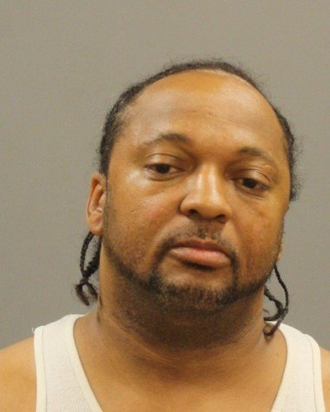
The victim, 29-year-old Rodney Wyman, and a co-worker had traveled from Connecticut to Malden, Massachusetts, to install windows at a construction site in the summer of 1983. On the night of August 22, the two men settled down in their motel suite to watch television. They heard a noise in a back room, and Wyman got up to check it out. As he approached the door, a gunman fired a fatal shot into Wyman's chest. The gunman, demanding money from Wyman's co-worker, brutally attacked the man and then began removing valuables from the room. But when he tried lifting the television set, a tamper alarm was activated, and two hotel employees rushed to the room. One of the employees saw a man exit the rear window of the suite and chased him, but the intruder escaped.

The motel room was processed by the MSP's Crime Scene Services Section (CSSS). More than 23 latent prints were recovered, and several were deemed of no value, and others were identified as those of the deceased victim and employees of the hotel. The remaining prints were searched against the Massachusetts Automated Fingerprint Identification System, which was relatively new at the time. There were no results produced, and eventually, the case went cold.

But 27 years later, the MSP, looking to apply newer investigative technologies to cold cases, requested a reassessment of the latent evidence from the Wyman homicide investigation. That task fell to Dolan, who first searched two latent images collected from the television set against the state AFIS, with negative results. He then requested a search of the FBI's IAFIS and, in less than 10 minutes, received a response containing possible candidates for comparison purposes. Dolan examined the evidence and positively identified the prints to the first candidate in the IAFIS response, Shawn Marsh.

Based on this identification, the MSP reopened the case. Investigators located Marsh and requested additional prints from him, which resulted in an additional match to palmprint evidence recovered from the crime scene. Marsh was indicted in September 2011, pled guilty in April 2013, and was sentenced to a lengthy prison term.
It turned out that some of Marsh's fingerprints had been available in the state AFIS at the time of the murder. However, the database was fairly new to the MSP, and those processing crime scene evidence at that time considered the prints of the right and left little fingers of limited value, so it was common practice to exclude them from the overall AFIS database in order to conserve resources. Why is that an important fact? Because the original latent prints lifted from the television set in the motel room crime scene came from a left little finger.

The full set of Marsh's fingerprints contained in IAFIS, which ultimately led to his identification, came from another arrest.

But the lesson was learned, and today, the Massachusetts State Police train law enforcement officers to collect prints from all 10 fingers when processing suspects.

http://news.hamlethub.com/milford/life/41177-cold-case-solved-using-fingerprints
Case #3: The Runaway and The Cigarette
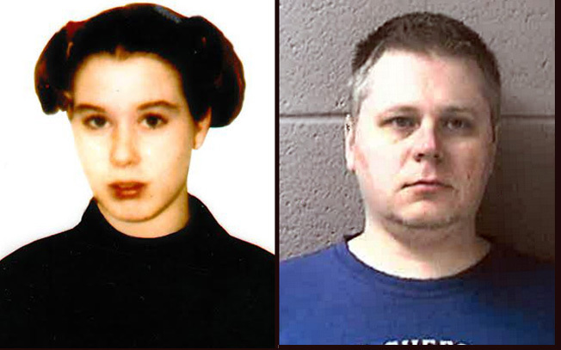

Fingerprints, stray cigarette helped solve 1997 killing, sheriff says
Amber Gail Creek, 14, was found dead in a Burlington marsh

Racine County Sheriff Christopher Schmaling on Tuesday identified James P. Eaton as the 36-year-old Illinois man authorities suspect killed Amber Gail Creek, a 14-year-old runaway girl from Illinois, in 1997. Credit: Racine County Sheriff’s Department
The 1997 killing of a 14-year-old girl whose body was found in a Racine County marsh has been solved 17 years later with old fingerprints and new DNA evidence unknowingly provided by the alleged killer, the sheriff said Tuesday.

Racine County Sheriff Christopher Schmaling identified the suspect as James P. Eaton, a 36-year-old Illinois man, and said he is being held on $1 million bail in the death of Amber Gail Creek, an Illinois runaway.

"Over the last 17 years we have dedicated thousands of investigative hours to bring this tragic and senseless murder to its resolution," Schmaling told reporters at a news conference. "Today that day is here."

The break in the case stemmed from fingerprints left on the black plastic bag used to suffocate the teen, Schmaling said, and investigators were able to track Eaton and pull DNA evidence off one of his cigarettes.

Eaton, a Palatine, Ill., resident, faces charges in Racine County of first-degree intentional homicide and hiding a corpse.
Schmaling, who did not take questions from reporters, said Amber's family has asked for privacy.

Amber ran away from a state-operated juvenile shelter in Chicago on Jan. 23, 1997. She attended a party at a motel in Rolling Meadows, Ill., the week of her death and was last seen leaving the party and getting into a luxury car with a man.

On Feb. 9, 1997, two men stumbled upon her body while they were searching for hunting sites at the Karcher Wildlife Refuge in the Town of Burlington.

She had been sexually assaulted, and her body was found posed with an upraised hand and the greeting "HI" written on the back of her hand, according to Journal Sentinel archives. She was found with a $5 price tag on her arm from a bookstore in the Schaumburg, Ill., area.

Investigators spent more than a year and a half examining more than 1,300 missing persons files before they identified her, and the case drew national attention at the time, including a profile on "America's Most Wanted" that aired Dec. 12, 1998.

Fingerprints taken from the plastic bag and DNA evidence from Amber's body initially yielded no matches, despite the help of the FBI and agencies around the country.

Then this year, through new fingerprint identification technology used by a crime lab in Oklahoma, authorities were able to match the prints found on the plastic bag to Eaton's prints, Schmaling said. Eaton had been fingerprinted in Illinois for past, minor offenses, but his name previously had not come up in the Amber Creek case.

After learning of the fingerprint match on Feb. 28, Racine County investigators conducted surveillance on Eaton for several days, and when he dropped a cigarette while waiting for a train in the Chicago area, they picked it up for DNA evidence.
It matched the DNA found on Amber's body, Schmaling said.

"Our sense of accomplishment is tempered by the pain and loss we know Amber's family continues to confront every day," Schmaling said. "Our thoughts and prayers remain with Amber's father, mother, other family and loved ones."

It wasn't clear whether Amber and Eaton knew each other or how they first would have come into contact. Eaton was 19 at the time of the killing.

http://archive.jsonline.com/news/crime/racine-county-officials-to-speak-about-arrest-in-1997-cold-case-killing-b99242991z1-254352521.html/

