FINGERPRINT ANALYSIS
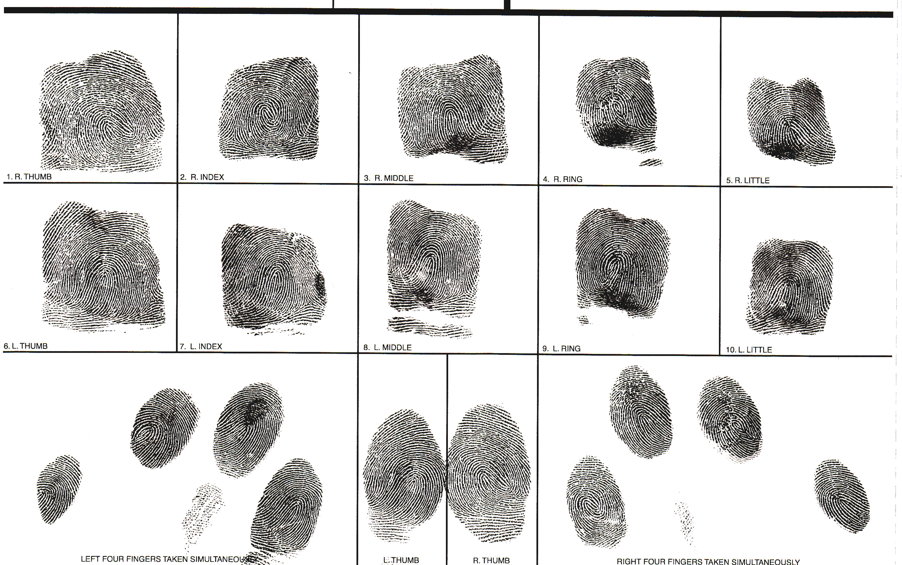
Directions: Below is an image of a fingerprint card. Each finger has been printer multiple times. For each finger, identify the pattern (loop, whorl, arch). Challenge yourself and try to identify the more specific pattern. Once the general pattern is identified, find as many different ridge characteristics as you can.

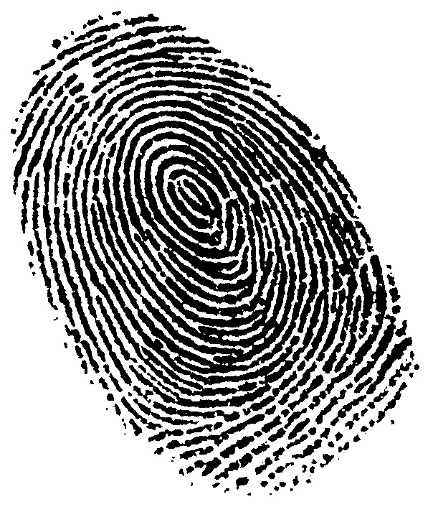
Directions: On this image of a fingerprint, identify as many ridge patterns as you can. Circle each new pattern and label it.

