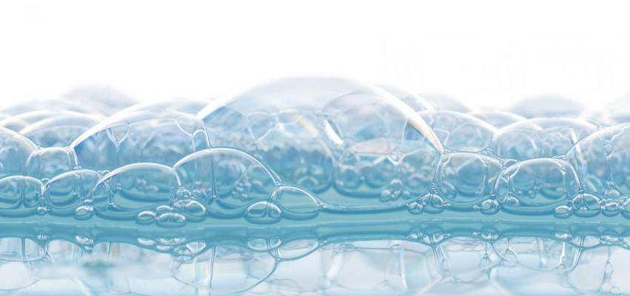
The Fighting Power of Soap:
A look into how soap production, Fight Club, and the Coronavirus are all related

Article Written By: Mark Hughes Cobb – March 22, 2020
https://www.tuscaloosanews.com/news/20200322/soap-emerges-as-weapon-in-fight-against-spread-of-coronavirus

Seems such a simple process to help combat the spread of coronavirus, many folks seem ready to reject it: Wash your hands for 20 seconds.
Shouldn’t we be dousing ourselves in bleach, gargling with saltwater, showering in Listerine?
To be absolutely spotlessly clear, every medical expert recommends the first paragraph’s application; no one except that one great-uncle who forwards everything can even begin to make a case for the latter.
But just plain old soap?
This is one of those cases where if it ain’t broke for several thousand years, don’t fix it. As long as you’ve got soap and water, you’ve got two of the best, longest-lived and most-proven tools for keeping your skin a healthy barrier.
It’s been around so long we can’t say exactly when people started recognizing the value of reacting alkali, such as sodium hydroxide, combined with naturally occurring fatty acids, to produce sodium salts that make water better able to remove foreign substances.
“When you put those molecules in water up against your hands, and agitate them, you break the bonds,” said Soapy Jones, owner of Tuscaloosa’s Left Hand Soap Co. The all-natural skin-products business originated one Christmas roughly 20 years ago, when she and a friend, Becky Hicks, both broke, decided to make soaps for gifts.
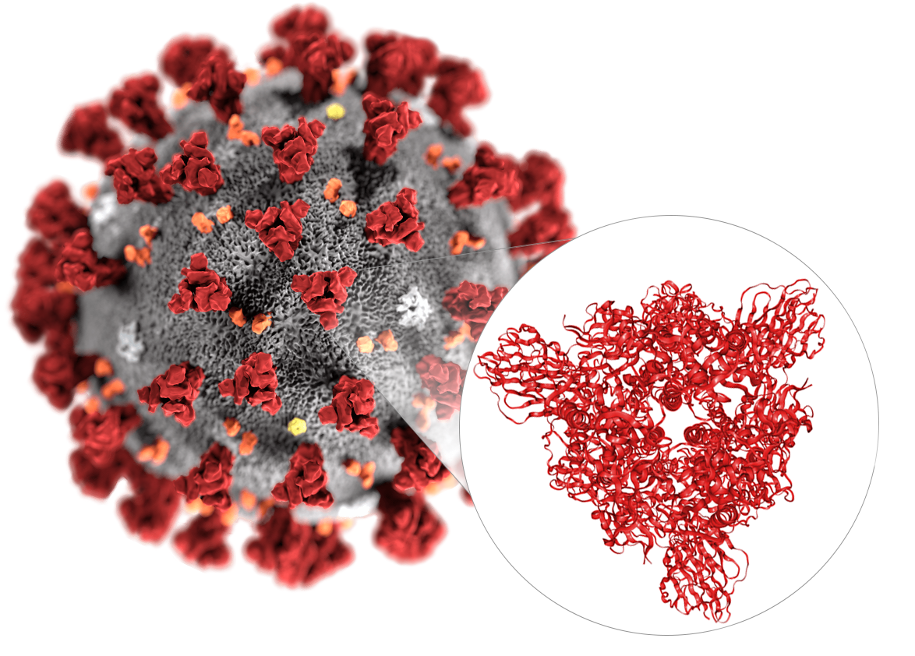
Jones had learned the craft watching her grandmother at work, back in Tennessee, where her father’s from. As gift-giving evolved into a home-based and later storefront business -- now at 2214 University Blvd., though like many ventures, with its doors closed for now -- she and her husband and business partner Erik Hanson learned more about saponification -- creating soap -- and its history.
“The story that’s told in ‘Fight Club’? That’s essentially true,” Jones said. “Clothes got cleaner downstream from where bodies burned.”
Roman legend says rain, following animal sacrifices on Mount Sapo, washed rendered fats, along with ashes from wood fires, down into the Tiber River. Lucky washing workers found the mixtures cleaned clothes more thoroughly.
Babylonian cylinders dating back to 2800 BCE contain instructions for saponification, though people were likely making soap for a thousand or more years before that. Purposefully-made soap’s been found in excavated tombs of Egyptian pyramids.
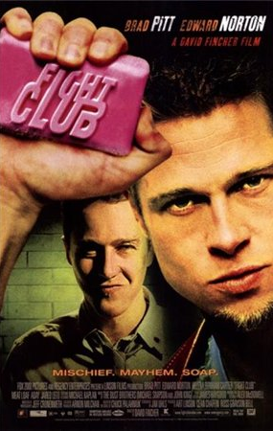
In the 1999 film “Fight Club,” based on the novel of the same name by Chuck Palahniuk, the character Tyler Durden dramatizes that history a bit, extrapolating that some of those fats were human: “The first soap was made from heroes’ ashes, like the first monkey shot into space. Without pain, without sacrifice, we would have nothing. Like the first monkey shot into space....”
Durden goes on to recount the accidental mixing, which is chemically true.
“The ingredients are fat, water -- or some sort of neutral liquid -- and lye, which is a base that is created by running salt water through wood ash,” Jones said. “You put all of that together, the river washes everything down, and soap starts to deposit itself on the side of the river.
“Many moons ago, that is how people figured out how to do it.”
And somewhat like the benefits of fire, also probably discovered by chance, soap has since been channeled and harnessed.
“Once we figured out what the ingredients were, putting it together became a predictable process. At this point, natural soap is made with animal or vegetable fat, a neutral liquid, and depending on the kind of soap you’re making, some version of lye.” Her company uses vegetable fat, which, Jones said, makes a cleaner soap.
For millennia, families made their own cleaning products. Soap didn’t become a widely available commercial product until the mid-19th century.
But why 20 seconds? What’s the magic there?
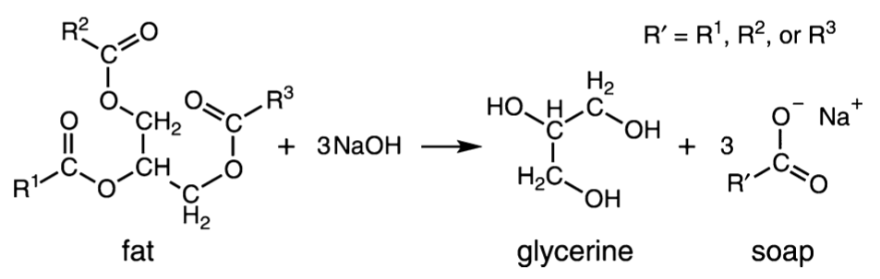
“Some of it is the amount of time you agitate,” she said, of current CDC recommendations for washing your hands at least 20 seconds. “The goal is not get rid of the most easily eradicated bacteria; the goal is get everything off that isn’t healthy.”
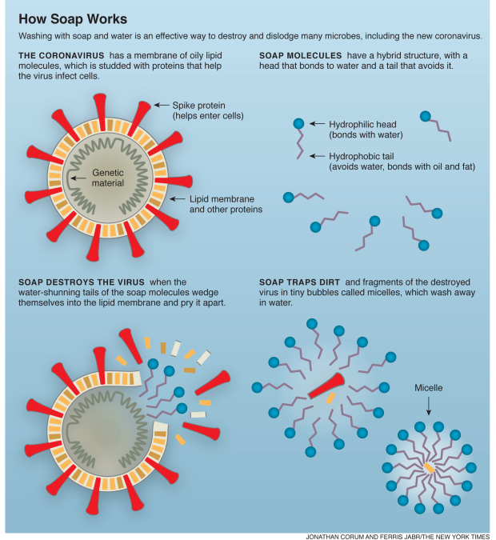
Also, when taking that kind of care, people are more likely to clean more thoroughly, hit the parts of the hands that are usually missed in a quicker rinse. “We always miss our thumbs...the bits between fingers, up against palm of your hands, you’re going to hit all those areas thoroughly.”
And while you’re at it, she adds, go ahead and hit the lower forearms, any parts of the body that might be coming into contact with surfaces where viruses might live, as, for example, when one’s typing at a computer.
Use running water, because standing water can be contaminated. Warm water is better than cold, but ultimately, the heat is a minor factor.
Hand sanitizers, which have flown off stores shelves, do OK in a pinch, when soap and water aren’t handy, but according to the CDC, they’re not as effective, because:
- Sanitizers do not get rid of all types of germs.
- Hand sanitizers may not be as effective when hands are visibly dirty or greasy.
- Hand sanitizers might not remove harmful chemicals from hands like pesticides and heavy metals.
There’s an additional timing to keep in mind, which either calls for more choruses of whatever song you’re crooning, or maybe adding an entirely new repertoire.
“It’s ideal for you not to touch anything for about 45 seconds afterward,” she said, giving skin the chance to fully react after cleansing.
“You can use paper towels, or a clean hand towel; reusable products are OK, as long as they’ve been cleaned.” Air-drying is OK, too, but air-dryers are less hygienic.
“When your skin tightens up, that’s when it’s most effective as a barrier. The skin as an organ, its job is to eradicate toxins and protect your inner bits from the world outside,” Jones said.
And another simple fix: Drink lots of water. It’s good for practically everything, and among those is keeping skin healthy and hydrated. Over washing, or washing with detergent-based soaps, can dry and crack the skin, and that’s not what you want at best of times.
“I am not a handwashing hipster,” Jones said, laughing, “though I was washing my hands before it was cool.
“But I welcome everyone to the fold. There’s no shame in this game. Come on down, and wash your hands ... from six feet away.”
Jones, who’s also a singer, uses a couple of different tunes in rotation for washing routines: The Beatles’ “Yellow Submarine,” and the beginning of the “Sweet Transvestite” sung by Dr. Frankenfurter in “The Rocky Horror Picture Show” are favorites, though she also challenges herself with Billy Joel’s rapid-rapped “We Didn’t Start the Fire,” just to see how many words she can fit in.
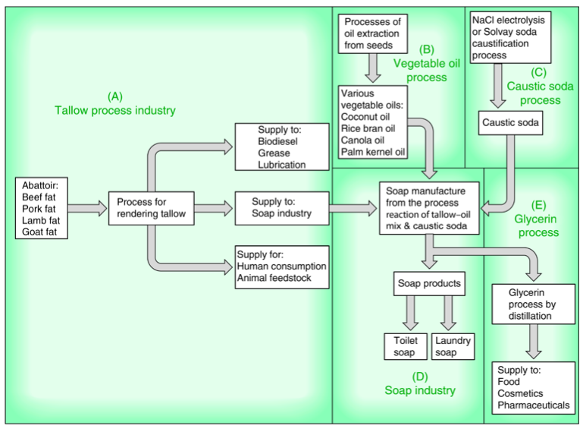
Link to the making soap scene in Fight Club
https://www.youtube.com/watch?v=t76dllHhcrw

The fighting power of soap Questions
Directions: Use your notes, the reading above, and your knowledge of chemistry, answer the following questions.
- Why is sodium hydroxide considered to be alkali?

- What is the name of the organic reaction that is used to make soap?

- What are the other types of organic reactions?

- What is the chemical formula for lye and why is it considered a base?

Base your answers to questions 5 and 6 on the image below.

- Name and circle the functional group found in the molecule of fat.

- Name and circle the functional group found in the molecule of glycerine.

- According to the diagram How Does Soap Work, what is a micelle?

- According to the diagram How Does Soap Work, the coronavirus as spiked proteins on the outside. Proteins are made of smaller building blocks called amino acids. What is name of the organic reaction that is used to make proteins?

- Ethanol is the main ingredient in hand sanitizer.
  - What is the molecular formula of ethanol?

  - What is the empirical formula of ethanol?

  - What is the structural formula of ethanol?

  - What functional group is present in ethanol? How can you tell just by looking at the name?

- According to the green flow chart on soap production, what are the three different starting materials that can be used to make soap?

