**Factors Affecting the Rates of Reaction**

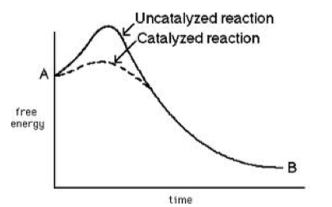

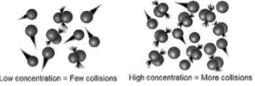

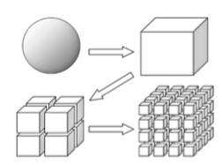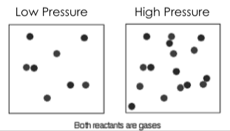

**Concentration**

* ____________________ concentration _________________ the reaction rate (speed)
* More particles increase chance of effective collisions

**Catalyst**

* ___________________ the rate of reaction by ____________________ the activation energy
* Is _________ consumed in the reaction

**Surface Area**

* ____________________ surface area _________________ the reaction rate (speed)
* Due to more exposed particles that can react (more effective collisions)

**Pressure**

* ____________________ pressure _________________ the reaction rate (speed)
* ____________________
* Due to an increase in concentration

**Temperature**

* ____________________ temperature _________________ the reaction rate (speed)
* Increases the _________________ effective collisions
* Reactants have ____________________ when colliding

**Background Info:**

* There are SIX Factors that affect the rate of reaction by changing the number if effective collisions that take place between particles
* The more effective collisions, the faster the reaction

**Type of Reactant**

* - ___________________ substances react ______________. They easily break into ________ when you dissolve them
* - ___________________ substances react ______________ - Requires more energy/time to break bonds