Entropy
YOYO: Looking at the gif of the dog sledding, make a prediction, which process is spontaneous, which is non-spontaneous. Write at least 2 complete sentences explaining your reasoning.
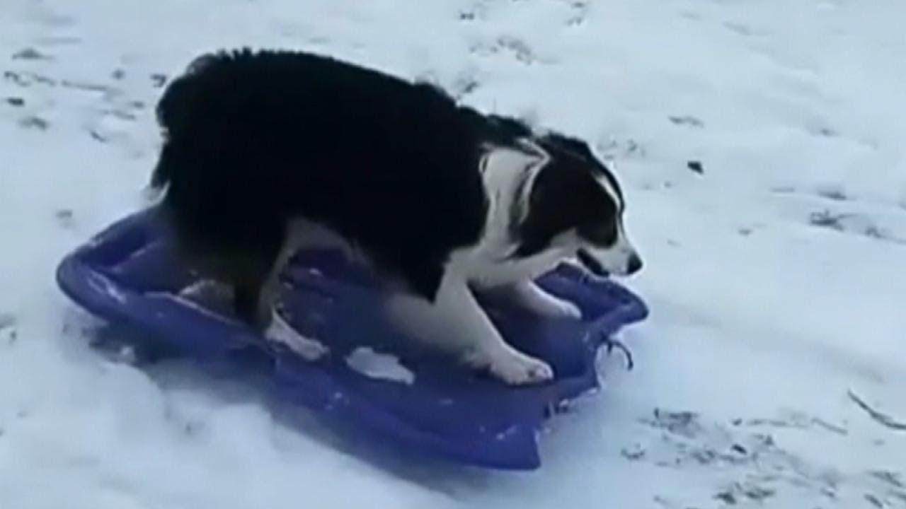
_______________________________________________________________
_______________________________________________________________
_______________________________________________________________ _______________________________________________________________
_______________________________________________________________
_______________________________________________________________

Spontaneous Reactions vs. Non-Spontaneous Reactions
- ___________________________________________ is one that is able to proceed without needing an outside source of energy (exothermic reaction)
- ___________________________________________ needs an input of energy. (endothermic reaction)

Spontaneous reactions happen when…
- _______________________________(lower enthalpy): exothermic reactions are favored
- Greater randomness, disorder
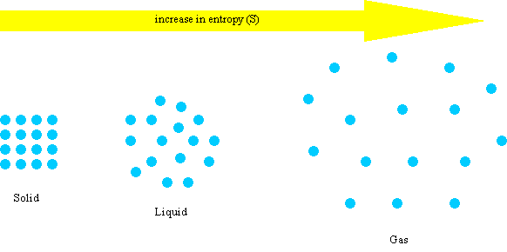
Entropy
- Entropy is the measure of _____________________________ _____________________________ _____________________________
- In nature _________________ entropy is favored.

Entropy Increases...
- When the ___________________________________________ increases during a reaction.
  - NaCl_{(s)} Na⁺_{(aq)} + Cl⁻_{(aq)}
- With an increase in ___________________________________________
- When a ____________________ is formed from a liquid or a solid.
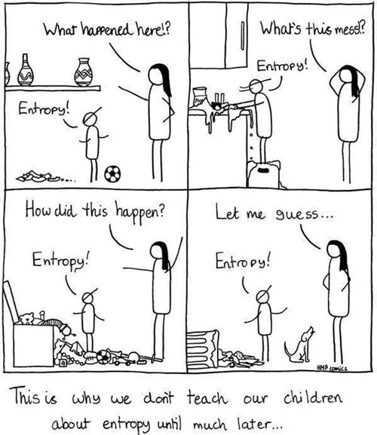Entropy Regents Questions
- Given the balanced equation representing a phase change:
C₆H₄Cl_{2(s)} + energy C₆H₄Cl_{2(g)}
Which statement describes this change?
  - It is endothermic, and entropy decreases.
  - It is endothermic, and entropy increases.
  - It is exothermic, and entropy decreases.
  - It is exothermic, and entropy increases
- The entropy of a sample of H₂O increases as the sample changes from a

  - gas to a liquid
  - gas to a solid
  - liquid to a gas
  - liquid to a solid

- Which 1-mole sample has the least entropy?

  - Br_{2(s)} at 266 K
  - Br_{2(l)} at 266 K
  - Br_{2(l)} at 332 K
  - Br_{2(g)} at 332 K

- A thermometer is in a beaker of water. Which statement best explains why the thermometer reading initially increases when LiBr(s) is dissolved in the water?
  - The entropy of the LiBr(aq) is greater than the entropy of the water.
  - The entropy of the LiBr(aq) is less than the entropy of the water.
  - The dissolving of the LiBr(s) in water is an endothermic process.
  - The dissolving of the LiBr(s) in water is an exothermic process.

- In terms of energy and entropy, systems in nature tend to undergo changes toward

  - higher energy and higher entropy
  - higher energy and lower entropy
  - lower energy and higher entropy
  - lower energy and lower entropy

More Entropy Practice
Reaction | Change in Entropy | Reasoning
Ag⁺(aq) + Cl⁻(aq) AgCl(s)
H₂O_{(l)} 2 H_{2(g)} + O_{2(g)}
CO_{(g)} + 3 H_{2(g)} CH_{4(g)} + H₂O_{(g)}
2 NaHCO_{3(s)} Na₂CO_{3(s)} + H₂O_{(g)} + CO_{2(g)}
CO_{(g)} + H₂O_{(g)} CO_{2(g)} + H_{2(g)}
CaCO_{3(s)} CaO_{(s)} + CO_{2(g)}
2NH_{3(g)} + CO_{2(g)} NH₂CONH_{2(aq)} + H₂O_{(l)}
H₂O_{(l)} H₂O_{(s)}

