Heat of Reaction (a.k.a Enthalpy)

YOYO: Directions: Read the claim. Write 1 sentence describing something you already know that relates to the claim below (Evidence) [HINT: the emoji to the right.] Then, write 2 sentences explaining how your evidence can be used to either support of claim stated below (Reasoning).

- Claim: Breaking bonds are considered to be endothermic processes and forming bonds are considered to be exothermic processes:
- Evidence:
  - ________________________________________________________________________
- Reasoning:
  - __________________________________________________________________________________________________________________________________________________________________________

Heat of Reaction
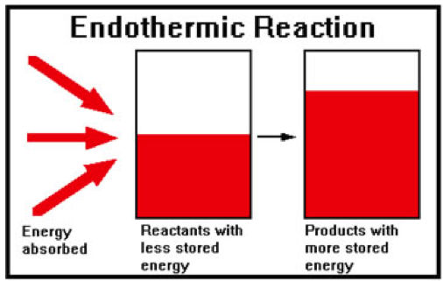
- ______________________________________________________________________________
- ΔH_{heat of reaction} = H_{products} – H_{reactants}
- ΔH = ________________________
Endothermic Reactions
- Heat is ________________ by _____________________
  - Energy is stored in chemical bonds of the products
  - _____________________
  - ____________________________________________
Endothermic Example A +B C
- If H_{A} = 40 kJ and H_{B} = 20 kJ, then the reactants have a total or 60 kJ
- If H_{C} = 110 kJ, then 50 kJ of heat must have been absorbed by the reactants.
  - (110-60 = 50kJ)
  - Rewritten: A + B + 50 kJ C
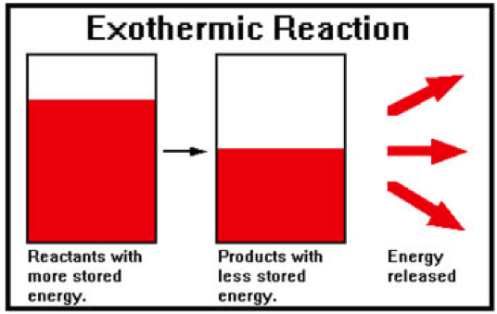
- Total energy on both sides are equal (law of conservation of energy)
Exothermic Reactions
- Heat is _______________ as a ___________________
  - _________________________
  - More stable reaction
  - Spontaneous
  - _____________________________________________
    - Energy is written as a product
Exothermic Example A + B C
- If H_{A} = 60 kJ and H_{B} = 40 kJ, then the reactants have a total of 100 kJ
- If H_{C} = 30 kJ, then 70 kJ of heat must be released as a product
  - (100-30 = 70)
  - Rewritten: A + B C + 70 kJ
- Total energy on both sides are equal (law of conservation of energy)
Table I: Heat of Reaction at 101.3 kPa and 298 K
- *The ΔH values are based on molar quantities represented in the equations. A minus sign indicates an exothermic reaction
- Two ways to write + ΔH (an ENDOTHERMIC REACTION)
  - N_{2(g)} + O_{2(g)} 2NO_{(g)} [ΔH +182.6 kJ]
  - 182.6 kJ + N_{2(g)} + O_{2(g)} 2NO_{(g)}
- Two ways to write - ΔH (an EXOTHERMIC REACTION)
  - CH_{4(g)} + 2O_{2(g)} CO_{2(g)} + 2H₂O_{(l)} [ΔH -890.4 kJ]
  - CH_{4(g)} + 2O_{2(g)} CO_{2(g)} + 2H₂O_{(l)} + 890.4 kJ

Question Scenarios Using Table I
- If the reaction in the question matches Table I exactly…just use the ΔH value given
- If the reaction in the question is OPPOSITE of Table I…change the sign of ΔH
- If the reaction in the question shows double the amount of each part of the reaction…double ΔH
- If the reaction in the question shows HALF the amount of each part of the reaction…half ΔH

Things to Remember:

- A reaction is exothermic if…
  - It releases heat
  - Heat is produced
  - ΔH is negative
  - Heat is written as a product
- A reaction is endothermic if…
  - It absorbs heat
  - Heat is added
  - ΔH is positive
  - Heat is written as a reactant

Question: What if the reaction is the opposite of what it says on Table I?
- What is the ΔH of the following reaction? Is this exothermic or endothermic?
  - 2H₂O_{(l)} 2H_{2(g)} + O_{2(g)}
  - Table I says: 2H_{2(g)} + O_{2(g)} 2H₂O_{(l)} [ΔH = -571.6]
- Answer: ___________________________________
  - ________________________________________________________________________

Sample Problems

- Given the reaction 2CO_{(g)} + O_{2(g)} 2CO_{2(g)} ΔH = -556.0 kJ
  - How much heat would be released is 4 moles of carbon monoxide were consumed by oxygen?
- Given the reaction 2H_{2(g)} + O_{2(g)} 2H₂O_{(l)} [ΔH = -571.6]
  - Calculate ΔH for the following reaction: H_{2(g)} + ½O_{2(g)} H₂O_{(l)}
NOT YOU

NOT YOU
YOU

