Tiny the Elephant Needs More Toothpaste
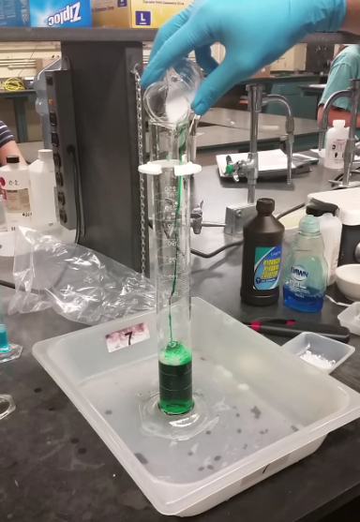
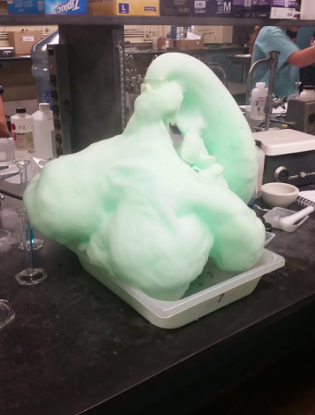

Demonstration/Photo Description
The prepared graduated cylinder contains dishwashing detergent, water, and food dye. Highly concentrated hydrogen peroxide (30% H₂O₂) will be added to start the reaction. Because the reaction rate is so slow, potassium iodide (KI) is added as a catalyst. As soon as the KI makes contact with the hydrogen peroxide, bubbles are rapidly formed and spill out of the graduated cylinder forming what looks like toothpaste made for elephants.
Directions: Answer the following 8 questions based on the demonstration and photo description.
Base your answers to questions 1 through 4 on the information below.
At standard pressure, hydrogen peroxide, H₂O₂, melts at – 0.4 °C, boils at 151 °C, and is very soluble in water. A bottle of aqueous hydrogen peroxide, H₂O₂ (aq), purchased from a pharmacy has a pressure-releasing cap. Aqueous hydrogen peroxide decomposes at room temperature, as represented by the unbalanced equation: ___H₂O₂(aq) ___H₂O(l) + ___O₂(g) + 196.0 kJ
- State, in terms of both melting point and boiling point, why H₂O₂ is a liquid at room temperature.

- State evidence that indicated that the decomposition of H₂O₂(aq) is exothermic.

- Explain why a hydrogen peroxide bottle needs a pressure-releasing cap.

- The decomposition equation above is unbalanced. Add the proper coefficients where needed to balance the equation.
___H₂O₂(aq) ___H₂O(l) + ___O₂(g) + 196.0 kJ
Base your answers to questions 5 and 6 on the diagram below.
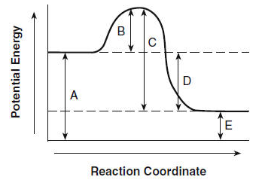
- Fill in the table below according to the diagram above.
Letter | Label
 | Potential Energy of Reactants
B
 | Activation Complex
D
E

- 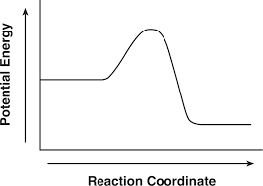Given the potential energy diagram above, determine whether the reaction is endothermic or endothermic. Explain your answer.

- On the diagram to the right, draw a line representing how the addition of catalyst would affect the reaction.
- Explain what a catalyst does and how it does works.

Base your answers to questions 9 and 10 on the information below.
Given the equation or a reversible CO_{(g)} + 2H_{2(g)} = CH₃OH_{(g)} + energy :
- Sketch a potential energy diagram of this reaction.

- State the effect on the rates of both the forward and reverse reactions if no catalyst is used in the system.

