Electrolytic Cells
YOYO: Compare and contrast the two images below. Note visible similarities and differences.
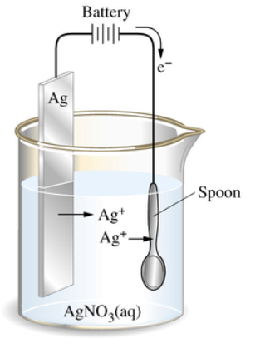
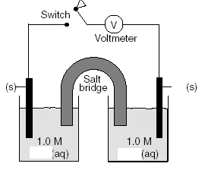
Figure 2
Figure 1
Similarities | Differences

Electrolytic Cell
- Reaction cannot occur spontaneously, so electricity is used to force the reaction to occur. In other words, _____________________________________ is converted to ________________________________ (opposite of voltaic cell)
- When electricity is used to force a chemical reaction to occur, the process is called ___________________________

Electrolytic Cell Cathode | Electrolytic Cell Anode
- Where _________________ are _____________  - The ________________________ electrode (opposite of voltaic)  - Electrode where _______________________ occurs (red cat) | - Where __________________ are _______________ _________________  - The ______________________ electrode (opposite of voltaic)  - Electrode when _________________________ occurs (an ox)
Electrolytic Cells: Uses
- To obtain pure elements such as sodium and chlorine by the electrolysis of molten salts.
  - Ex: 2 NaCl(l) 2Na(s) + Cl₂(g)
- To electroplate metals onto a surface. The material to be plated with a metal is the ______________________. The ____________________ is made of the metal used for the plating.

Compare and Contrast
 | Galvanic/Voltaic Cell | Electrolytic Cell
Flow of e- (Spontaneous or Forced)
(+) Electrode
(-) Electrode
Direction of e- Flow
Reduction Half Cell
Oxidation Half Cell

