Heating & Cooling Curve Practice
YOYO: Answer the following questions using your knowledge of chemistry and explain your reasoning.
- True or False: Boiling and melting happen at the same temperature.

- True or False: Freezing and melting happen at the same temperature.

- True or False: Temperature remains constant during a phase change.

The Heating Curve

F
E
D

C
B

A

- The state of matter represented by line AB is a _________________________
- The state of matter represented by line CD is a _________________________
- The state of matter represented by line EF is a _________________________
- The phase change represented from B C is called _________________________
- During the phase change represented by line BC, the temperature ______________________.
- The phase change represented from C B is called _________________________
- In order to go from a liquid to solid, heat must be _________________________
- When a solute such as salt is added to a solvent such as water, the freezing point _________________
- Circle One: If the freezing point is lowered, the new temperature is (hotter/colder) than the original freezing temperature.
- True or False: The freezing point and the melting point occur at the same temperature. ____________
- The phase change represented from D E is called _________________________
- In order to go from a liquid to a gas, heat must be _________________________
- During the phase change represented by line DE, the temperature _________________________
- When a solute such as salt is added to a solvent such as water, the boiling point _________________
- Circle One: If the boiling point is elevated/higher, the new temperature is (hotter/colder) than the original boiling temperature.
- The phase change represented from E D is called _________________________
- In order to go from a gas to a liquid, heat must be _________________________
- The phase change from a solid directly to a gas is known as _________________________
- The phase change from a gas directly to a solid is known as _________________________
- Temperature is the measure of average ___________ _____________.
- If Kinetic energy increases, P.E stays the ____________.
- If Kinetic energy stays the same, P.E _______________.
- In segment AB, the temperature ___________, therefore the kinetic energy ____________, the P.E stays the ________.
- In segment BC, at 0 °C, the phase change that happens is ____________, the temperature ____________________, therefore the kinetic energy ________________, the P.E ______________.
- In segment CD, the temperature goes from 0 °C to 100° C, the K.E _____________, the P.E _______________.
- In segment DE, the phase change that happens at 100 °C is _____________, the temperature ___________, kinetic energy ______________, Potential energy ________________.
- In segment EF, the temperature ____________, K.E ________, P.E _______________.
The Cooling Curve
- A cooling curve is obtained when a substance cools down and changes state.
- The cooling curve is the ________________ of the heating curve. The temperature is ______________, therefore the kinetic energy is also ____________________.
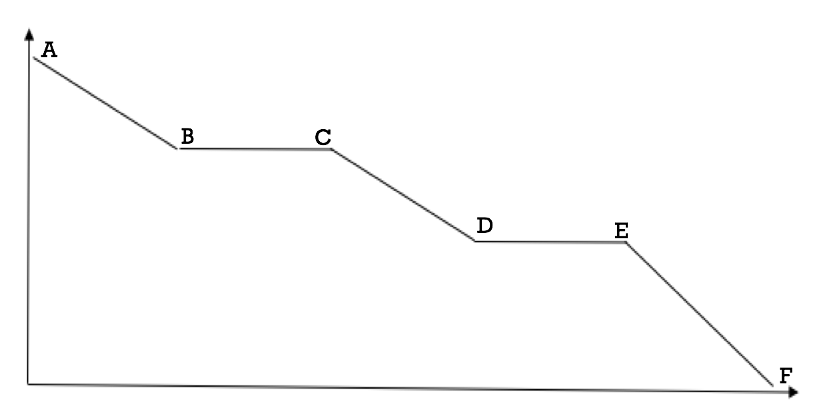

- The state of matter represented by line AB is a _________________________
- The state of matter represented by line CD is a _________________________
- The state of matter represented by line EF is a _________________________
- The phase change represented from B C is called _________________________
- During the phase change represented by line BC, the temperature ______________________.
- The phase change represented from C B is called _________________________
- In order to go from a liquid to solid, heat must be _________________________
- The phase change represented from D E is called _________________________
- To go from a liquid to a solid, heat must be _________________________
- During the phase change represented by line DE, the temperature _________________________
- The phase change represented from E D is called _________________________
- In order to go from a solid to a liquid, heat must be _________________________
- The phase change from a gas directly to a solid is known as _________________________
- The phase change from a solid directly to a gas is known as _________________________
- Temperature is the measure of average ___________ _____________.
- If temperature of a gas is decreases, K.E __________, P.E stays the ____________.
- If Kinetic energy stays the same, P.E _______________. ** This is the opposite of the heating curve.
- In segment AB, the temperature ___________, therefore the kinetic energy ____________, the P.E stays the __________.
- In segment BC, at 100° C, the phase change that happens is ____________, the temperature ____________________, therefore the kinetic energy ________________, the P.E _____________________.
- In segment CD, the temperature goes from 100 C to 0° C, the K.E _____________, the P.E ______________________.
- In segment DE, the phase change that happens at 0 °C is _____________, the temperature ___________, kinetic energy ______________, Potential energy ________________.
- In segment EF, the temperature ____________, K.E ________, P.E ______________________.

