Concentration: Units and Calculations – Part 1
(Molarity)

YOYO: Answer the following questions using Table G.
- What type of solution will contain 60 g of NaCl in 100 g of H₂O at 65 °C? __________________
- How many grams of HCl can be dissolved in 100 grams of water at 90 °C ________________
- What is the max amount of KNO₃ that can be dissolved in 100 g of H₂0 at 40 °C? ___________

But first…some vocab
- _______________________: a measurement of the amount of solute that is dissolved in a given quantity of solvent
- _____________________________________: a solution containing a large about of solute
- __________________________________: a solution that contains a small amount of solute
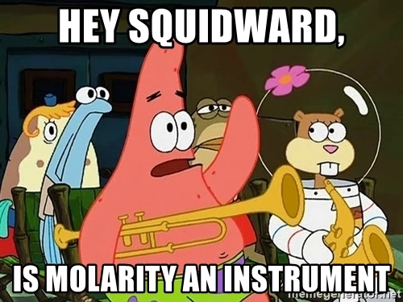
Units of Concentration (Table T)
- There are multiple ways to express the amount of solute in solution (concentration)
  - ____________________________________________
  - ____________________________________________
  - ____________________________________________
  - ____________________________________________

Molarity (M)
Table T Equation:

Molarity Practice
- What is the molarity of 1.5 liters of an aqueous solution that contains 5.2 moles on lithium fluoride, LiF? | - What is the molarity of a solution containing 20 moles of NaOH in 500 milliliters of solution?
- How many total moles of KNO₃ must be dissolved in water to make 1.5 liters of a 2.0 M solution? | - What is the molarity of a solution that contains 4.5 moles of NaOH in 0.50 liter of solution?
- What is the total number of moles of NaCl(s) needed to make 3.0 liters of a 2.0 M NaCl solution? | - What is the total number of moles of NaI(s) needed to make 1.0 liter of 0.010 M solution?
- What is the total number of moles of HI in 0.500 liters of 1.00 M HI? | - What is the total number of liters in a 5.2M solution with 2.1 moles of NaCl.
- What is the molarity of a solution contains 13.4 moles of LiOH in 500 milliliters of solution? | - What is the total number of moles of sodium phosphate in 22.1 milliliters of 1.00 M Na₃PO₄?
- Challenge Question: What is the total number of grams of KCl (formula mass = 74.6) in 1.00 liter of 0.200 molar solution? (Hint: Determine the number of moles first using the molar mass) | - Challenge Question: What is the total number of grams of NaI(s) needed to make 1.0 liter of 0.010 M solution? (Hint: Determine the number of moles, then convert to grams)
Concentration: Units and Calculations – Part 2
(Mass Percent of Solute/Parts per Million (ppm)/Percent by Volume)
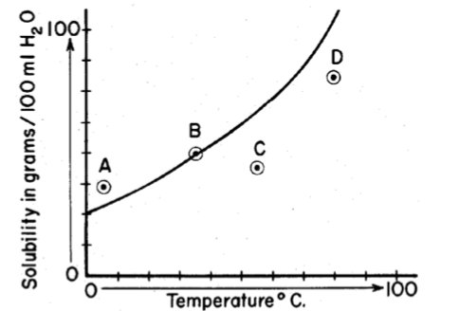
YOYO: Base your answer to the following question in the diagram to the right which represents the solubility curve of salt X. The four points on the diagram represent four solutions of salt X. Which point represents the most concentrated solution of salt X. Explain your answer.

- A
- B
- C
- D

_______________________________________________________
_______________________________________________________
_______________________________________________________

Mass Percent of Solute
Table T Equation: | - Example: In a solution prepared by dissolving 24 g of NaCl in 176 g of solution, what is the % by mass of NaCl in solution?

Parts Per Million (PPM)
Table T Equation: | - Example: In the United States and Canada, drinking water cannot contain more than 5 x 10⁻⁴ mg of mercury per 1x 10³ mg of sample of solution. In parts per million what would that be?

Percent by Volume
Equation: | - Example: If a 10 mL of propanone is diluted with water to a total solution volume 200 mL, what is the percent by volume of propanone in the solution?
All Types of Concentration Practice
- A 200 mL sample of a solution contains 4.0 moles of NaOH. What is the molarity? | - If 0.002 grams of PbCl₂ are dissolved in 2.0L of water, how many parts per million are dissolved?
- A polar solvent is prepared by mixing 27.5 mL of propanone with 222.5 mL of water. What is the percentage by volume of propanone in the mixture? | - If 19 mL of alcohol are dissolved in 31 mL of water, what is the percentage by volume of alcohol?
- What is the molarity of 750 mL of a solution that contains 13.2 mol of dissolved CuSO₄? | - If 15 g of KNO₃ are dissolved in 235 g of water, what is the percentage of solute by mass?
- An aqueous solution has 0.0070 gram of oxygen dissolved in 1000. grams of water. Calculate the dissolved oxygen concentration of this solution in parts per million. | - How many moles of NaCl are needed to prepare 500 mL of a 0.400M solution?
- How many moles of solute are contained in 0.2 L of a 1M solution? | - A bottle of the antiseptic hydrogen peroxide H₂O₂ is labeled 3.0% (v/v). How many ml of H₂O₂ are there in a 400.0 mL bottle of this solution?

