The Combined Gas Law Equation
YOYO: Use Table A on your reference table and your knowledge of chemistry to answer the following questions.
- What is standard pressure? Standard temperature?

- What unit of temperature must be used when completing gas law questions?

- What are the three variables studied in the combined gas law equation?

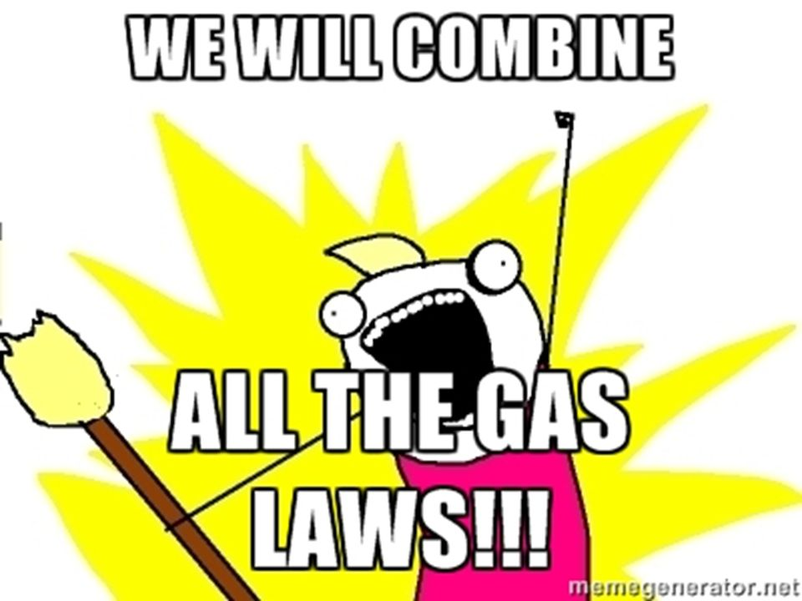
- What is the relationship between volume and pressure?

- What is the relationship between volume and temperature?

- What is the relationship between temperature and pressure?

Important Combined Gas Law Info
- All three gas laws can be combined into one equation, hence the name “Combined Gas Law” and the formula according to Table T is:
The Combined Gas Law Equation
- When working on a gas law question:
  - Write down all the variables given in the question
    - Sometimes all 3 variables are used in the question and sometimes only 2 are used
  - You can ignore a variable if it is not stated in the question, or if the question says it is kept constant
  - Plug in values into the equation and solve for the missing piece
  - Make sure temperature is in KELVIN!
  - When it says STP, look at Table A on the Reference Table for the values

Example #1: A gas occupies 1.00 L at standard temperature. What is the volume at 330.0 °C?
Knowns & Unknowns Plug Values into Equation
P₁ = ______ P₂ = ______
V₁ = ______ V₂ = ______
T₁ = ______ T₂ = ______
Example #2: If a gas in a closed container is pressurized from 15 atm to 16 atm and its original temperature was 200 K, what is the final temperature of the gas?
Knowns & Unknowns Plug Values into Equation
P₁ = ______ P₂ = ______
V₁ = ______ V₂ = ______
T₁ = ______ T₂ = ______
Example #3: A container holds 500. mL of CO₂ gas at 742 torr. What will be the volume of the CO₂ gas if the pressure is increased to 795 torr?
Knowns & Unknowns Plug Values into Equation
P₁ = ______ P₂ = ______
V₁ = ______ V₂ = ______
T₁ = ______ T₂ = ______
Example #4: A rigid cylinder with a movable piston contains a sample of gas. At 300. K, this sample has a pressure of 240. kilopascals and a volume of 70.0 milliliters. What is the volume of this sample when the temperature is changed to 150. K and the pressure is changed to 160. kilopascals?
Knowns & Unknowns Plug Values into Equation
P₁ = ______ P₂ = ______
V₁ = ______ V₂ = ______
T₁ = ______ T₂ = ______
Practice Time: Use the models to help you answer these questions.

- A cylinder with a movable piston contains a sample of gas having a volume of 6.0 liters at 293 K and 1.0 atmosphere. What is the volume of the sample after the gas is heated to 303 K, while the pressure is held at 1.0 atmosphere?

- A rigid cylinder contains a sample of gas at STP. What is the pressure of this gas after the sample is heated to 410 K?

- 1,400.0 L of N₂ gas at a pressure of 1.25 atm has its pressure changed to 17.5 atm at constant temperature. What will be its new volume at the pressure?

- H₂ gas occupies a volume of 400.0 mL at 27.0⁰C. Find the volume it will occupy if the temperature is increased to 57.0⁰C at constant pressure?

- A sample of gas occupies a volume of 50.0 milliliters in a cylinder with a movable piston. The pressure of the sample is 0.90 atmosphere and the temperature is 298 K. What is the volume of the sample at STP?

- A rigid cylinder with a movable piston contains a 2.0-liter sample of neon gas at STP. What is the volume of this sample when its temperature is increased to 30°C while its pressure is decreased to 90. kilopascals?

- A 220.0-mL sample of helium gas is in a cylinder with a movable piston at 105 kPa and 275 K. The piston is pushed in until the sample has a volume of 95.0 mL. The new temperature of the gas is 310. K. What is the new pressure of the sample?

