Calculating Heat Energy (q = mCΔT)
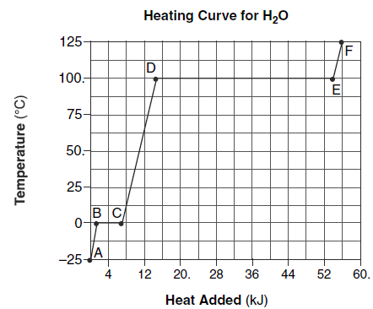
YOYO: Answer the questions below based on the diagram.
- Circle One: This is a (heating/cooling) curve.
- AB - KE: ______________ and PE: _________________
- BC - KE: ______________ and PE: _________________
- CD - KE: ______________ and PE: _________________
- DE - KE: ______________ and PE: _________________
- EF - KE: ______________ and PE: _________________
- The boiling point of the compound is ____________
- The melting point of the compound is ____________
- The freezing point of this compound is ____________
- True or False: There is no thing as “cold.” Cold is just the absence of heat. ____________

Law of Conservation of Energy
- In any chemical or physical process, energy is neither created nor destroyed, it can be changed from one type of energy to another

Types of Energy

But first…some vocab
- _____________________ Process: Energy is ______________________ in a chemical reaction from the system to the surrounding – the system becomes ________________
- _____________________ Process: Energy is _______________________ in a chemical reaction by the system from the surrounding – system becomes ____________________
- _______________________________________: the amount of heat it takes to raise the temperature of 1 gram of the substance
  - Specific heat of water = 4.18 J/g•C (Table B)
    - 4.18 joules is needed to raise 1 gram of water 1 ºC
The Equation

What do the symbols represent?

- q =_______________
  - + q = ____________________
  - – q = ____________________
- m = _______________
- C = ___________________________
- ΔT = change in ____________ (T_{final} – T_{initial})

Relating Back to the Heating/Cooling Curve
- The q = mCΔT is used ONLY when temperature is changing (when a substance either a solid, liquid, or gas) – (the slant part of the graph).
- During phase changes (the flat line), there are 2 other equations we will discuss tomorrow

q = mCΔT

- How many kilojoules of heat are absorbed when 1000 grams of water is heated from 18 ºC to 85 ºC  CIRCLE ONE:  This is an ENDOTHERMIC/EXOTHERMIC process because the heat is ABSORBED/RELEASED | - The temperature of a 95.5 grams of copper increases from 25 ºC to 48 ºC when copper absorbs 849 J of heat. What is the specific heat of copper?  CIRCLE ONE:  This is an ENDOTHERMIC/EXOTHERMIC process because the heat is ABSORBED/RELEASED
- 300 grams of ethanol at 10 °C is heated with 14640 Joules of energy. What is the final temperature of the ethanol? The specific heat of ethanol is 2.44 J/g·°C.  CIRCLE ONE:  This is an ENDOTHERMIC/EXOTHERMIC process because the heat is ABSORBED/RELEASED | - How many joules of heat energy are released when 50.0 grams of water are cooled from 70 ºC to 60 ºC?  CIRCLE ONE:  This is an ENDOTHERMIC/EXOTHERMIC process because the heat is ABSORBED/RELEASED
- How much heat is absorbed when 500. g of copper, C = 0.385 J/g•C, goes from 25.0ºC to 35.0 ºC?  CIRCLE ONE:  This is an ENDOTHERMIC/EXOTHERMIC process because the heat is ABSORBED/RELEASED | - How much heat is released when 150. g of iron cools from 525ºC to 100^{O}C? (C = 0.44 J/g•C)  CIRCLE ONE:  This is an ENDOTHERMIC/EXOTHERMIC process because the heat is ABSORBED/RELEASED
- A 50.0 g block of glass (C = 0.50 J/g•C) absorbs 333 joules of heat energy. How much does the temperature of the glass rise?  CIRCLE ONE:  This is an ENDOTHERMIC/EXOTHERMIC process because the heat is ABSORBED/RELEASED | - 225 grams of water at 45 °C is heated with 189940 Joules of energy. What is the final temperature of the water?  CIRCLE ONE:  This is an ENDOTHERMIC/EXOTHERMIC process because the heat is ABSORBED/RELEASED

